1. **Describe the features of the propagation of radio waves**

The influence of the radio wave propagation medium imposes a limitation on the wavelengths used in various radio communication systems. The influence of external factors on radio waves with different wavelengths is not equally affected. Therefore, it is advisable to consider the properties of radio waves in the ranges within which the waves exhibit approximately the same properties.

Radio Regulations - an international treaty that establishes the regulatory framework for the use of radio frequencies and satellite orbits. A Radio Regulations is being developed by the International Telecommunication Union.

The International Telecommunication Union (ITU) is the United Nations specialized body, an international organization within which governments and the private sector coordinate global telecommunication networks and services. The ITU includes: ITU-R Radiocommunication Sector (ITU-R) and Telecommunication Development Sector (ITU-D), Telecommunication Standardization Sector - ITU-T. Standards ITU-T covers almost the entire field of telecommunications.

In accordance with the Radio Regulations, it is customary to divide the radio range into separate bands, guided by the decimal principle. Figure 1 shows the frequency ranges and their applications.

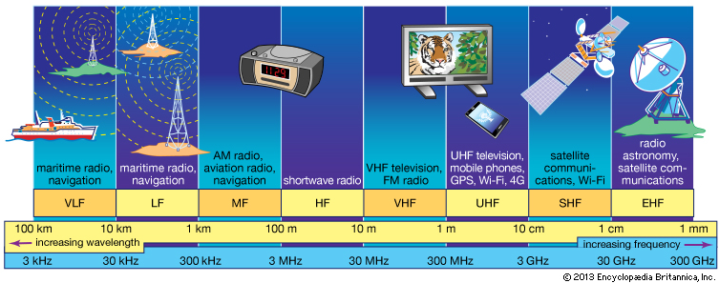

Figure 1.1 - Radio frequency ranges

An essential feature of the propagation of radio waves in terrestrial conditions is the dependence of the propagation characteristics on the wavelength. The propagation of radio waves along the earth's surface depends on its topography and physical properties. The most important electrical parameters of the soil are its electrical conductivity and permittivity. These characteristics determine the parameters of reflected and refracted waves at the interface between two media. The electrical conductivity of the soil also determines the energy loss during the propagation of waves along the Earth's surface.

An equally important influence on the propagation of radio waves in near-Earth space is played by the Earth's atmosphere (the gaseous shell of the Earth). According to the complex of physical features, the atmosphere is usually divided into three characteristic layers: the troposphere, stratosphere and ionosphere.

Figure 1.1 shows the simplified structure of the Earth’s atmosphere, and table 1.3 shows the main methods of propagation of radio waves.

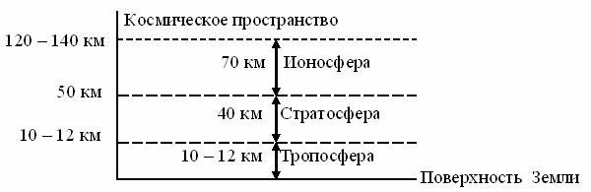

Figure 1.2 - The structure of the Earth’s atmosphere

The troposphere is the lower layer of the atmosphere, located from the surface of the Earth to heights of the order of 10 - 20 km. The properties of the troposphere are determined by a mixture of gases (nitrogen, oxygen, etc.) and water vapor. With altitude, the temperature and air pressure, as well as the water vapor content in the troposphere decreases. Thus, the troposphere is heterogeneous in its electrical properties.

The stratosphere - an atmosphere layer lying above the troposphere, extends to heights of the order of 60 - 80 km. The density of gases in the stratosphere is much lower than in the troposphere. The electrical properties of the troposphere are practically unchanged, and radio waves propagate in it in a straightforward and almost lossless manner.

The ionosphere is the upper layer of the ionized atmosphere surrounding the Earth (up to heights of the order of several thousand kilometers). Under the influence of cosmic radiation and ultraviolet rays of the sun, electrons are knocked out of the gas atoms that make up the atmosphere, resulting in the formation of positive gas ions and free electrons. Ionized gas has electrical conductivity and is able to change the propagation characteristics of electromagnetic waves. The higher the concentration of free electrons, the stronger they affect the propagation of radio waves.

Figure 1.3 shows the main propagation paths of radio signals

**УКВ**

**Ионосфера**

**КВ, СВ, ДВ**

**УКВ ,** **КВ**

**СВ, ДВ, СДВ**

**1**

**2**

**3**

**4**

**5**

**6**

*θ0*

**Мертвая зона**

**Тропосфера**

Figure 1.3 - The main modes of propagation of radio waves.

Four types of waves are distinguished by the propagation method: direct, surface (terrestrial), tropospheric and spatial (ionospheric).

Within the line of sight, signals of all ranges propagate, in Figure 1.3 line 5.

Radio waves propagating in the immediate vicinity of the Earth’s surface, partially enveloping the convexity of the globe due to diffraction, are called surface or earth waves. Figure 1.3 shows the trajectory of the surface wave of signals at medium, long, and super long waves (NE, LW, SDE) by curve 6. It is known from the physics course that diffraction is observed when the size of the obstacle is commensurate with the wavelength. In this case, the ball segment is an obstacle. The height of the latter depends on the distance between the correspondents, therefore it is clear that the longer the working wavelength, the greater the distance it can propagate due to diffraction. Diffracting around the spherical surface of the Earth, the surface wave is partially absorbed by semiconducting earth, the degree of absorption of which depends on the structure of the soil (sand, clay, stones, etc.) and its moisture content. The atmosphere of the Earth has little effect on the propagation conditions of this wave. Ranges are used in marine and terrestrial radio navigation systems.

Radio waves propagating over long distances and even enveloping the globe as a result of multiple reflections from the ionosphere and the earth's surface (in the wavelength range longer than 10 m, NE and LW ranges), are called spatial, or ionospheric waves. In Figure 1.3, curves 2.4.

Radio waves propagating over considerable distances (up to 1000 km) due to scattering on inhomogeneities of the troposphere, as well as due to the phenomenon of tropospheric refraction, are called tropospheric waves. Note that the troposphere affects only electromagnetic waves, the length of which is less than 10 m, of HF radio waves. In Figure 1.3, curve 3.

UHF, microwave and EHF radio waves propagate into outer space, bypassing the ionosphere. These radio frequency ranges are used in direct visibility radio communication systems, in satellite and space systems.

Total losses on any radio link are the sum of the main losses and additional ones. The main losses are determined by the attenuation of the signal in free space due to the divergence of the rays due to the spherical wave front. Additional losses are determined by losses in the propagation medium as a result of absorption, scattering of wave energy by the inhomogeneities of the medium, changes in the initial polarization of the wave under the influence of a magnetic field, etc.

When waves propagate shorter than 3 ... 4 cm (f> 7 ... 10 GHz) in the Earth's atmosphere, the greatest contribution is attenuation in water vapor and oxygen contained in the atmosphere and in atmospheric formations (rain, fog, wet snow).

1. **Describe the classification of the radio system**

Radio communication systems can be classified according to various criteria: by the type of transmitted messages; on the occupied spectrum of radio frequencies; by the nature of the transmitted signals; throughput, etc.

1. **Explain and describe the general principles of building RRL**

The purpose of the lecture: To study the type of RRL stations, frequency plans.

Types of RRL stations, frequency shift, multi-barreled work, span.

Radio relay communication lines are based on the principles of multiple signal relaying. There are two types of microwave links:

- tropospheric microwave links based on the principle of distant tropospheric propagation (DTR),

- direct-line radio-relay lines, which are a chain of transceiver stations located at stable communication distances within the line-of-sight of antennas (the name comes from the English “relay”).

б)

а)

20-30km (50km)

250 km

Figure 3.1- Organization Principles:

a) RRL radio-relay lines of direct visibility (RRL);

b) tropospheric radio relay lines (TRL).

 DTR occurs due to reflection and scattering of radio waves by turbulent and layered inhomogeneities of the troposphere. features, the distance between stations is chosen more often within 200 ... 400 km. Due to the significant attenuation of signals on the spans, it is necessary to significantly increase the energy potential of the system. The use of powerful transmitters, large antennas significantly reduces the possibility of using TRL. In the future, we will consider direct line of sight radio links that are widely used at present.

The combination of technical means and the medium for the propagation of radio waves to provide radio-relay communication forms a radio-relay communication line. Transceiver stations are called radio relay stations (RRS).

The line-of-sight distance (span length) is the distance between adjacent RRS, which can be determined by an approximate formula for the case of a smooth spherical earth's surface:

R0,км ≈ 3,57× (√h1 +√h2),

where h1 and h2 are the antenna suspension heights in meters.

The most common antenna mount heights are 20 ... 80m. This ensures a line of sight from 30 to 60 km.

For RRL operation in accordance with the recommendations of ITU-R F-series, frequency bands in the ranges: 7; 8; 10; 11; 12; 13; fourteen; fifteen; eighteen; 23; 27; 31; 38; 55 GHz.

Functional radio relay stations are divided into:

- terminal (OPC), carry out the input and allocation of the transmitted information of the transmitted information, and provides information distribution to consumers (telecentre, long-distance telephone exchange, company office);

- intermediate (PRS), the transmitted signals are relayed at an intermediate frequency, if necessary, it is possible to extract TV signals or part of the telephone group spectrum;

- nodal (URS), here the transmitted information is re-accepted with the ability to enter and highlight information to consumers, it also provides for branches or intersections of the RRL.

Stations are arranged in a zigzag pattern - this allows eliminating interference from stations located three to five spans with existing plans for the distribution of radio frequencies.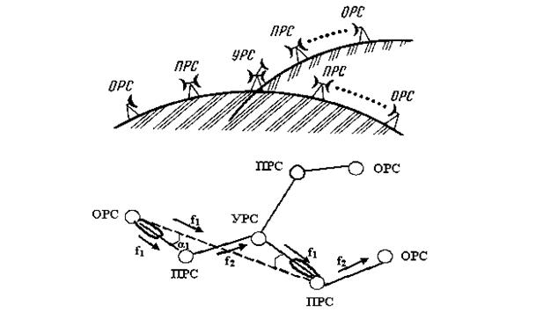

Figure 3.2 - Diagram of a radio relay communication line

Terminal stations are installed at the extreme points of the communication line and contain modulators and transmitters in the direction of signal transmission and receivers with demodulators in the direction of reception. In Figure 3.2, terminal stations are designated OPC1 and OPC4. For transmission and reception, one antenna is used, connected to the transmission and reception paths using an antenna splitter (duplexer).

Modulation and demodulation of signals is carried out at one of the standard intermediate frequencies (70 - 1000 MHz). Modems can work with transceivers using different frequency ranges. The transmitters are designed to convert the intermediate frequency signals into the microwave operating range, and the receivers are designed for the inverse conversion and amplification of the intermediate frequency signals.

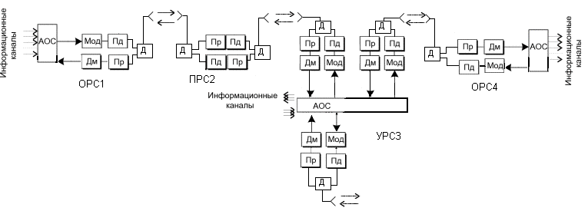

Figure 3.3 - Block diagram of a radio relay communication line

Intermediate stations are located at a line of sight and are intended for receiving signals, amplifying them and transmitting them over the communication line. Reception and transmission of signals at intermediate stations should be carried out at different frequencies to eliminate spurious connections in transceivers. The difference between the transmit and receive frequencies is called the shift frequency (fsdv) or duplex frequency spacing (FTX-RX).

Also, to eliminate the influence of the signal from the transmitter on the received signal during operation, a duplexer is installed on one antenna.

 Nodal stations perform both the functions of intermediate stations and the functions of input and output of information. Therefore, they are installed in large settlements or at the points of intersection (branch) of communication lines.

The gap between the terminal station and the nearest nodal or between nodal stations is called the RRL section or section, and the set of transceiver equipment forms the RRL trunk.

Frequency plans for RRL, designed to reduce the effect of the transmitted signal on the received, when working with one antenna on the reception and transmission, and address the issue of electromagnetic compatibility with other radio communication systems.

2-frequency and 4-frequency systems are applied.

    Figure 3.4 - Used frequency plans:

Transmission f1B

ПРС

Receiver f1H

Transmission f1B

Receiver f1H

Transmission f2B

ПРС

Receiver f2H

Transmission f2B

Receiver f2H

a) dual frequency; b) four-frequency.

The 2-frequency system (Figure 3.4 a) is economical in terms of using the frequency band, but requires the use of antennas with good protective properties (at frequencies above 10 GHz, parabolic antennas with additional screens - collars are used). On the RRL when using a two-frequency plan, there is a repetition of transmission frequencies over the span, as indicated in Figure 3.2. Moreover, in order to reduce mutual interference between RRS operating at the same frequencies, the stations are arranged in a zigzag pattern relative to the direction between points.

Moreover, if a station receives a signal at a frequency f1 and transmits at a frequency f2, then neighboring stations receive at a frequency f2, and transmit at a frequency f1. This pair of frequencies, corresponding to the ITU-R two-frequency frequency plan, forms a radio frequency trunk.

The 4-frequency system (Figure 3.4 b) allows for simpler and relatively cheap antennas, but it is rarely used, only in very complex electromagnetic environments.

To increase economic efficiency and throughput, multi-barrel radio relay systems are used, in which at each station several transceivers operate with different frequencies through a common antenna-feeder path.

Table 3.1 provides an example of carrier frequencies for RRL trunks in accordance with ITU-R Recommendation in the 17 GHz band.

ITU-R Recommendation F385

- duplex frequency spacing (Tx-Rx) 161MHz;

- spacing between the trunks 7 MHz.

Table 3.1 - Carrier frequencies for RRL trunks in accordance with ITU-R Recommendation in the 17 GHz band.

|  |  |  |
| --- | --- | --- |
| trunk | f н, MHz | f в, MHz |
| 1 | 17428 | 17589 |
| 2 | 17435 | 17596 |
| 3 | 17442 | 17603 |
| 4 | 17449 | 17610 |
| 5 | 17456 | 17617 |
| … | … | … |
| 19 | 17554 | 17715 |
| 20 | 17561 | 17722 |

Each trunk of the station has a standard designation, for example: 2ВН, where 2 is the trunk number, В- means reception at the upper frequency, Н- transmission (radiation) at the lower frequency. A set of equipment on the other side of the span will have the designation 2HB, respectively.

When combined to work on one antenna, the odd or even trunks are combined, in order to increase the difference between the frequencies of the combined trunks.

Modern systems use flexible frequency plans. The separation of the frequency channels in such cases is determined by the throughput (the speed of the DRL) and the type of modulation. Most often, the working frequency spacing is 3.5; 7; 14 or 28 MHz.

In order to increase the reliability of communication lines, various redundancy methods n + 1 are used. Where n is the number of workstations for which 1 standby trunk is used. The number of redundant shafts may vary depending on the reliability requirements of the transmission system. Often simple single-barrel communication systems without redundancy are built, given the high reliability of modern equipment.

1. **Describe the principles of construction of equipment of radio relay stations**

The large and medium capacity RRL transceiver equipment is equally suitable for transmitting multichannel telephony signals and transmitting television signals. Only the terminal equipment of telephone and television trunks is different.

Modern microwave equipment very often consists of indoor and outdoor modules connected by one or more cables. Cable lengths can be several hundred meters.

Internal module, access node containing input and output interfaces for source digital streams, modems and monitoring and control devices. The input and output interfaces can be electrical (EI) or optical (OI), and some types of equipment contain both interfaces or they are installed on request.

In the interfaces, the signals received via cables from the equipment for multiplexing digital streams are matched, the codes are converted (quasi-ternary to NRZ and vice versa) and the clock frequency is allocated (in input devices).

The main signal processing before modulation and after demodulation is carried out in the respective digital processors.

 In the transmitting part of the internal module, the digital processor performs the following operations:

interleaving of code sequences (to protect against long packet errors);

Error Correction (FEC) using convolutional or block correction codes;

scrambling (to improve the statistical properties of digital signals);

the formation of digital streams in-phase (I) and quadrature (Q) channels for subsequent multilevel modulation.

In a digital-to-analog converter (DAC), multi-level signals are generated from the digital streams of I and Q channels in accordance with the applied modulation type. For example, with 4FM modulation, 2-level signals are used, and with 16KAM - four-level signals. These signals enter the modulator (MD), where they control the oscillations of the intermediate frequency. The service signal modulator (MDSS) adds to the traffic signal service signals allocated in the external unit, necessary to control its operation.

The modulated intermediate frequency signal passes through a coaxial cable to an external unit through a filtering device (UV). Previously, the intermediate frequency signal is additionally modulated by various overhead information and digital system control data.

In the receiving part of the internal module, operations are performed that are opposite to those performed in the transmitting part. The input signal of the receiving part receives an intermediate frequency signal from an external unit via a coaxial cable. To eliminate mutual influences in the cable, the signals of the intermediate frequency of transmission and reception are selected different (for transmission - 300 - 800 MHz, for reception, most often, 70 MHz).

The central core and the braid of the same cable are supplied with power (20 - 80 V DC) to the external equipment module.

The external module contains a transmitter and a receiver and is mounted on the antenna mount in the immediate vicinity of the antenna or docked to it.

The transmitter converts the intermediate frequency signal into the operating frequency range and provides the necessary output radiation power. In this example of a structural diagram, the transmitter path begins with a service communication demodulator, in which signals are allocated to control the operation of an external module and control its parameters. The main intermediate frequency signal is fed through a powerful IF amplifier (MUCH) to the input of a frequency converter, consisting of a mixer (SM) and a master oscillator. Oscillations of the master oscillator are formed in the block of heterodyne frequencies.

The signal obtained during the conversion process, consisting of the carrier frequency of the master oscillator and two side bands, is fed through a band-pass filter (PF) to the microwave amplification unit (UHF). The bandpass filter extracts one of the sidebands from the converted signal. Typically, in modern equipment, a controlled attenuator is installed in front of the UHF, designed to control the radiated power of the transmitter. Often this attenuator provides the adaptive power control system of the transmitter (ARMP), depending on the propagation conditions of the signal on the track.

To improve the linearity of the amplitude characteristic of the transmitter, distortion compensators for the third harmonic are used, which can be installed in the IF path (PsK) or in the microwave path (LNZ).

 The signal from the output of the transmitter passes to the antenna through blocks of separation filters (RF), performing the following functions:

- Separation of signals of different radio frequencies during multilateral operation;

- ensuring the operation of receivers and transmitters through one antenna;

- separation of signals of different polarizations with co-channel frequency plans;

- Ensuring harmonization of receivers, transmitters and antennas.

The receiver converts the signal from the operating frequency range to the intermediate frequency and amplifies this signal to the desired level.



Figure 4.2 - NEC PASOLINK outdoor unit

Figure 4.2 shows the Pasolink radio relay outdoor unit. The parabolic antenna has a diameter of 45 cm and is connected to the transceiver unit directly without a waveguide. Elements for mounting the module to the antenna mount are located on the antenna unit and have alignment devices in the vertical and horizontal planes. The transmitter-receiver unit can be easily disconnected from the antenna unit for replacement, adjustment and maintenance. Larger diameter antennas (0.6 and 1.2 m) can be connected to the transceiver.

The external unit is connected to the indoor unit located in the room with a coaxial cable. Modern modem equipment is an easily transforming complex that operates under the control of a central or local computer.

.

The internal unit (IDU) contains the baseband signal processing units, including multiplexing, switching, and all user interfaces.

An example of the spectrum of a group signal of a telephone trunk is shown in Figure 4.4.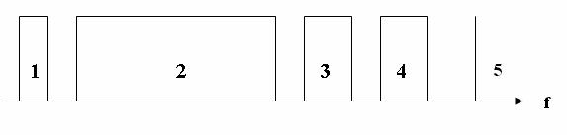

Figure 4.4 - Linear spectrum of a group signal of a telephone trunk:

1 - CC (intercom signals, in the lower part of the group spectrum a separate narrow-band channel); 2 - MTFS (multi-channel telephone message); 3, 4 - SZV1, SZV2 (sound broadcasting signals 1, 2);

5 - PS (pilot signal); f is the frequency

Pilot signal - allows you to control the acceptable signal level when deciding on the use of a backup channel.

1. **Write about the purpose of the external unit in the PPC**

The external module contains a transmitter and a receiver and is mounted on the antenna mount in the immediate vicinity of the antenna or docked to it.

The transmitter converts the intermediate frequency signal into the operating frequency range and provides the necessary output radiation power. In this example of a structural diagram, the transmitter path begins with a service communication demodulator, in which signals are allocated to control the operation of an external module and control its parameters. The main intermediate frequency signal is fed through a powerful IF amplifier (MUCH) to the input of a frequency converter, consisting of a mixer (SM) and a master oscillator. Oscillations of the master oscillator are formed in the block of heterodyne frequencies.

The signal obtained during the conversion process, consisting of the carrier frequency of the master oscillator and two side bands, is fed through a band-pass filter (PF) to the microwave amplification unit (UHF). The bandpass filter extracts one of the sidebands from the converted signal. Typically, in modern equipment, a controlled attenuator is installed in front of the UHF, designed to control the radiated power of the transmitter. Often this attenuator provides the adaptive power control system of the transmitter (ARMP), depending on the propagation conditions of the signal on the track.

To improve the linearity of the amplitude characteristic of the transmitter, distortion compensators for the third harmonic are used, which can be installed in the IF path (PsK) or in the microwave path (LNZ).

 The signal from the output of the transmitter passes to the antenna through blocks of separation filters (RF), performing the following functions:

- Separation of signals of different radio frequencies during multilateral operation;

- ensuring the operation of receivers and transmitters through one antenna;

- separation of signals of different polarizations with co-channel frequency plans;

- Ensuring harmonization of receivers, transmitters and antennas.

The receiver converts the signal from the operating frequency range to the intermediate frequency and amplifies this signal to the desired level.



Figure 4.2 - NEC PASOLINK outdoor unit

Figure 4.2 shows the Pasolink radio relay outdoor unit. The parabolic antenna has a diameter of 45 cm and is connected to the transceiver unit directly without a waveguide. Elements for mounting the module to the antenna mount are located on the antenna unit and have alignment devices in the vertical and horizontal planes. The transmitter-receiver unit can be easily disconnected from the antenna unit for replacement, adjustment and maintenance. Larger diameter antennas (0.6 and 1.2 m) can be connected to the transceiver.

The external unit is connected to the indoor unit located in the room with a coaxial cable. Modern modem equipment is an easily transforming complex that operates under the control of a central or local computer.

1. **Write about the purpose of the indoor unit in the PPC**

Internal module, access node containing input and output interfaces for source digital streams, modems and monitoring and control devices. The input and output interfaces can be electrical (EI) or optical (OI), and some types of equipment contain both interfaces or they are installed on request.

In the interfaces, the signals received via cables from the equipment for multiplexing digital streams are matched, the codes are converted (quasi-ternary to NRZ and vice versa) and the clock frequency is allocated (in input devices).

The main signal processing before modulation and after demodulation is carried out in the respective digital processors.

 In the transmitting part of the internal module, the digital processor performs the following operations:

interleaving of code sequences (to protect against long packet errors);

Error Correction (FEC) using convolutional or block correction codes;

scrambling (to improve the statistical properties of digital signals);

the formation of digital streams in-phase (I) and quadrature (Q) channels for subsequent multilevel modulation.

In a digital-to-analog converter (DAC), multi-level signals are generated from the digital streams of I and Q channels in accordance with the applied modulation type. For example, with 4FM modulation, 2-level signals are used, and with 16KAM - four-level signals. These signals enter the modulator (MD), where they control the oscillations of the intermediate frequency. The service signal modulator (MDSS) adds to the traffic signal service signals allocated in the external unit, necessary to control its operation.

The modulated intermediate frequency signal passes through a coaxial cable to an external unit through a filtering device (UV). Previously, the intermediate frequency signal is additionally modulated by various overhead information and digital system control data.

In the receiving part of the internal module, operations are performed that are opposite to those performed in the transmitting part. The input signal of the receiving part receives an intermediate frequency signal from an external unit via a coaxial cable. To eliminate mutual influences in the cable, the signals of the intermediate frequency of transmission and reception are selected different (for transmission - 300 - 800 MHz, for reception, most often, 70 MHz).

The central core and the braid of the same cable are supplied with power (20 - 80 V DC) to the external equipment module.

The internal unit (IDU) contains the baseband signal processing units, including multiplexing, switching, and all user interfaces.

An example of the spectrum of a group signal of a telephone trunk is shown in Figure 4.4.

Figure 4.4 - Linear spectrum of a group signal of a telephone trunk:

1 - CC (intercom signals, in the lower part of the group spectrum a separate narrow-band channel); 2 - MTFS (multi-channel telephone message); 3, 4 - SZV1, SZV2 (sound broadcasting signals 1, 2);

5 - PS (pilot signal); f is the frequency

Pilot signal - allows you to control the acceptable signal level when deciding on the use of a backup channel.

1. **Write how to design RRL**

The purpose of the lecture: to consider the stages of RRL design, to make a reasonable choice of technical characteristics of RRL equipment

The construction of a line-of-sight RRL begins with the design of a communication line.

Design can be divided into the following stages:

1) determination of operating frequencies (permission, EMC assessment);

2) route selection (station locations, terrain accounting, availability of power supply, etc.).);

3) determination of the height of the antenna suspension (construction of the span profile);

4) equipment selection (technical specifications, maintenance);

5) check the stability of communication (implementation of standards for errors);

6) analysis of the results.

If the project is approved by the customer proceed to the installation of equipment and commissioning.

The frequency of the signal determines the maximum span that can be achieved when the transmitter power is limited. The higher the frequency, the greater the attenuation in free space and the effect of rain on the propagation of the radio signal.

Currently, the following frequency bands are widely used for RRL:

7-8 GHz (the average length of the span of RRL is 30-40 km, the antennas have a high gain with diameters of about 1.5-2.5 m, weak influence of hydrometeors (rain, snow, fog, etc.), but in this frequency range is a very complex electromagnetic environment, there are many RRL and difficult to obtain permission for these frequencies);

10.7-11.7, 12.7-13.2 GHz (span length of 15-30 km, antenna have small dimensions (0.6 m) and weight, which provides a relatively inexpensive antenna supports, increasing the impact of the hydrometeors, adverse pleasant electromagnetic environment);

14.5-15.35, 17.7-19.7 GHz (span length reaches 20 km, typical parabolic antennas have diameters of 0.45; 0.6, the propagation of signals is strongly influenced by hydrometeors, electromagnetic environment is calm). The attenuation in rain can be 1-12 dB / km at a rainfall intensity of 20-160 mm / h.

21.2-23.6 GHz 25.25-27.5 GHz (average span 15 km, antennas have a diameter of 0.3; 0.6 m, attenuation in the rain 3-24 dB / km, range zones are allowed to be used in satellite communication systems, so the calculations must take into account the possibility of interference).

The frequencies above are rarely used, as the span length is not more than 10-12 km and strong attenuation in hydrometeors and atmosphere.

Taking into account the above information, the operating frequencies of the equipment are selected and, knowing the average length of the span, the locations of the station are selected on a topographic map. The masts on which the antennas will be placed are placed on the hills, so that there are no obstacles (hills, buildings, forest) within the line of sight of the neighboring stations.

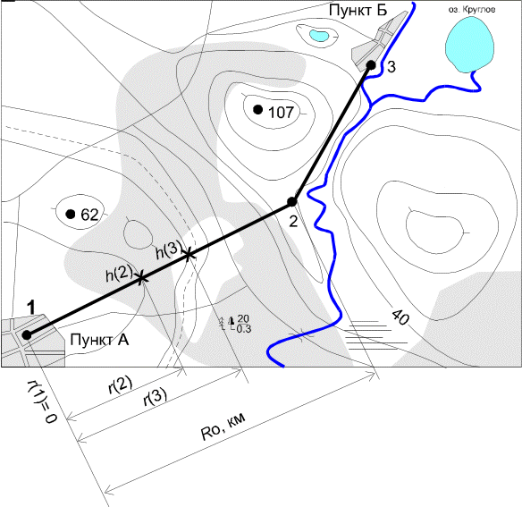

Figure 5.1-RRL Route on the topographic map

1. **Write how to determine the heights of the antenna supports**

The main part of the transmitter energy is distributed in the direction of the receiving antenna within the minimum Fresnel zone, which is an ellipsoid of rotation, at the edges of the major axis of which the transmitting and receiving antennas are installed. The radius of the minimum Fresnel zone at any point of the span can be determined by the formula:

,m (5.1)

where - is the relative coordinate of the highest elevation point on the span;

R0-span length, m;

λ-wavelength, m;

Rj - distance to the obstacle point, m.

In the atmosphere, due to its inhomogeneous structure and the change in the refractive index with height, the curvature of the trajectories of radio waves occurs, called refraction. The phenomenon of refraction has a significant impact on the propagation of radio waves within the line of sight of RRL antennas. The nature of refraction in spherical-layered planetary atmospheres is determined by the altitude gradient of the refractive index of the atmosphere, which is defined as g= dN/dh, where N is the refractive index of the atmosphere.

Random changes in the vertical gradient of the refractive index of the atmosphere lead to the curvature of the trajectory of the radio beam, which in some cases may touch the earth's surface, and thus there are diffraction effects that reduce the level of the received signal. Due to ground obstacles, even complete loss of mutual visibility of antennas (lack of communication) is possible.

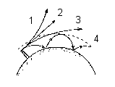

Figure 5.2-radio beam trajectories at different refraction:

1) g>0 negative refraction; 2) g=0 no refraction;

3); g<0 positive refraction

4) the emergence of the Earth - ionosphere waveguide channel.

Therefore, when designing the RRL, it is important to ensure sufficient clearance of the route by selecting the heights of the antenna suspension.

Span refers to the crossed, if the height of the earth's surface irregularities Δhj ≥ 2H0.

0

2

4

6

8

10

12

14

16

R, км

h2, м

h1,м

H0

ΔH(g+σ)

Zj

Y

S

M

O

D

C

R0, км

Rj, км

A1

A2

rП

Figure 5.2-RRL flight Profile (vertical section of the terrain passing through the antenna installation sites)

The following designations were adopted:

A1, A2-receiving and transmitting antennas RRL;

h1,h2 – the height of the suspension antennas;

CD, MO, SY-elevation of the terrain;

M-critical point (top of the obstacle);

Zj – the real curvature of the Earth, which can be determined by the approximate formula

,m (5.2)

where R0 – span length, km;

a = 6370 km-radius of the Earth;

H(0) - clearance on the span in the absence of refraction, m;

ΔH (ĝ+σ) - the average value of the change in the lumen due to refraction, existing for 80% of the time (ĝ, σ-respectively, the average value and standard deviation of the vertical gradient of the dielectric permittivity of the troposphere), m;

H (ĝ +σ) - the gap in the span, existing for 80% of the time, which is usually chosen to be H0.

m (5.3) m.            (5.4)

After selecting the radio path and the locations of antenna supports, building a profile of the span taking into account the relief and curvature of the earth. Taking into account by examining the terrain, the height of vegetation and buildings, you can begin to determine the height of the suspension antennas. Additional constructions are performed on the calculated values of H0 , and H (0).

On the profile of the flight from the critical point M is postponed to the scale value H(0) and through the upper point of the segment H (0) spend the beam connecting the antenna.

The height of the antenna suspension is determined by formulas, if the beam passes horizontally, in cases of complex terrain, the height of the antenna suspension is determined by the figure in accordance with the scale.

h1 = ON+OM+H(0) – CD, m, (5.5)

h2 = ON+OM+H(0) – SY m (5.6)

The calculation of the suspension height of the antennas except the few exceptions are common for both analogue and digital radio relay lines. For radio relay line of sight defined criteria for the quality of communication in accordance with the rules of ITU-R. design Tasks – to check the conformity of parameters of the designed RL these criteria.

1. **Write how to calculate the stability of communication for digital RRL**

The purpose of the lecture: to get acquainted with the method of calculating the stability of digital RRL.

Error quality indicators (BER) and availability indicators (ar availability factor) are commonly used as setting parameters when designing digital rrls. The use of a quality indicator depends on the length of downtime:

- when downtime is less than 10s, the cause of fading is multipath propagation and the standards used in this case are error quality indicators (more stringent);

- with a longer duration of downtime (causes: rain, equipment failures) use standards for readiness (softer).

As a rule, manufacturers of RRL equipment set the value of the threshold signal power at the input of the receiver Rprm.min at BER=10ⁿ (n=-5 and n=-6).

The readiness factor (AR) is defined as the proportion of time that a tract is ready during the observation period (for example, 1 year). Another value is the unavailability factor (UR), with AR+UR=1.

The total availability factor is

AR=1 - [(T1+T2-TV) / TE], (6.1)

where T1 and T2 are the time of unavailability in one and the other direction;

TV-time of unavailability for both directions simultaneously;

Te-evaluation time period (≥1 year).

In accordance with ITU recommendations, the standards for the availability of high-quality digital RRL (GEC - length 2500km) are set in the range of 99.5-99.9%. In practice, the value of 99.7% is often used, the unavailability will be 0.3%. Linear extrapolation is used to determine the unavailability factor for shorter lines. For example, for a 250km line UR=0.03%.

The fading reserve characterizes the ability of the system to maintain the required level of the received signal when the signal propagation conditions deteriorate during the RRL flight.

*Ft = SG+GПРД+ GПРМ –L0-2η,* dB, (6.2)  
where SG-coefficient of the system, dB;

*η*-signal attenuation in antenna-feeder path (2*η* ≈5dB);

Lo-attenuation of radio waves in free space, dB;

GПРД, GПРМ -gain transmitting and receiving antennas, respectively, dB.

Attenuation of the signal in the path of radio waves in dB

Описание: image052 ,

(6.3)

where *LДОП* -additional signal attenuation due to inhomogeneities of the real propagation medium (accounting for attenuation in gases, water vapor contained in the atmosphere).

Attenuation in free space is determined by taking into account the wavelength and span length according to the following formula:

 дБ, (6.4)

where λ is the wavelength, m.

Since radio relay systems most often use parabolic mirror antennas, the antenna gain is determined by:

, db

(6.5)

where q is the utilization factor of the antenna opening (0.7-0.9);  
DA-antenna diameter, m.

If the antenna suspension heights are chosen correctly, then the link stability is evaluated by performing an inequality

Описание: image040  (6.6)

T∑ - the total probability (percentage of time) of deterioration of communication quality due to deep fading of the signal for the entire route crrl,

ТДОП- allowable probability of deterioration this DRRL in accordance with the regulations. We consider this question for one span, as for RRL consisting of n spans the probability of deterioration of communication quality is determined respectively, where n is the number of spans.

The total likelihood of deterioration of communication quality on the RRL due to the deep fading of the signal at one of the bays is determined by three factors: the screening obstacles, the minimum Fresnel zone t0, the interference at the point of receiving the direct ray and rays reflected from stratified inhomogeneities in the troposphere TINT, attenuation due to rain etc.

, %  (6.7)

Each of the terms in the formula is determined on the basis of relevant ITU Recommendations based on statistics specific to different climatic regions.

The time of deterioration of communication caused by subrefraction of radio waves is carried out according to the following procedure for each flight.

The average value of the lumen on the span is determined:

H(g)=H(0)+DH(g) = H(0)-(Ro2/4)*g*k*(1-k), m

The relative lumen:

P(g)= H(g)/Ho

To determine the width of the obstacle on the span profile, a straight parallel radio beam is carried out at a distance of Du = H0 from the top of the obstacle and the distance between the points of intersection of this line and the relief determines the rP , km as shown in figure 5.2. Then the relative radius of the obstacle is calculated

I= rP /R0 .

The parameter μ, characterizing the sphere approximating the obstacle is calculated by the formula:



where l- is the obstacle radius, m;

- the relative coordinate of the highest point of relief on the span.  
 The value of the relative lumen P (g0), at which deep fading of the signal occurs, caused by screening the obstacle of the minimum Fresnel zone:  
  
R(g0)= (V0-Vmin)/V0 ,

where V0 is the minimum attenuation factor at H (0)=0, determined from figure 2.15 /1/ by the known value of m ;  
 Vmin = - Ft /2 -the minimum allowable attenuation factor, dB.

Then the coefficient A (6.8) and parameter y (6.9) are calculated):  
  
 (6.8)



Parameter ψ :  
ψ = 2,31А(р(g)-p(g0)). (6.9)

According to the graph figure 2.16 / 1 / is determined by the То(ψ), %.  
Consider the second term in the formula (6.7) the percentage of time of bond instability due to fading due to multipath propagation of Тинт.

 , %

where Ft-fading margin (6.2), dB;

R0-span length, km;

f-frequency, GHz;

K-coefficient, taking into account the influence of climate and terrain;

Q-coefficient that takes into account the slope of the radio path;

B=0.89; C=3.6-coefficients taking into account regional effects, according To recommendation P. 530 ITU-R for Kazakhstan.

The pH values represent the percentage of time with a vertical refractive gradient *dN/dh* ≤ -100 N -units / km. According to ITU-R Recommendation P. 453 for Kazakhstan .

The CLat and CLot coefficients for Kazakhstan are 0.

;

where - slope of the radio path, mrad,

h1, h2-antenna suspension heights, m.

Calculation of the time of deterioration of communication due to rain.

According to ITU Recommendations the territory of the globe is divided into 16 climatic zones according to the average intensity of rains. Zones are indicated by Latin letters. Kazakhstan belongs to zone E, for which the intensity of precipitation (exceeded for 0.01% of the time) R0,01 = 22 mm/h.

To estimate the attenuation of the signal in the rain, the effective length of the rain path is calculated:

dЭ = r∙Ro, km  
where r=1/[1+(R0/d0)]- velocity factor,  
 d0 = 35∙ exp(-0,015∙R0,01)- reference distance.

Attenuation of electromagnetic waves in the rain depends on the frequency and polarization of the signal, linear attenuation in the rain is determined by the formulas:  
γV = kV *R0.01 αV,db/km;

γН = kН *R0.01 αН , db/km,

where α and k - regression coefficients for horizontal (H) and vertical (V) polarization.  
  
Regression coefficients are given in reference tables for different frequencies. The attenuation on the trace that is exceeded for 0.01% of the time is defined by the expression:  
A0,01 = γ ∙ dЭ , db.

The attenuation that is exceeded for another percentage of time T in the range 0.001-1% can be determined from the equation:

AT /A 0,01=0,12∙T[exp(-0,546-0,043∙lgT)]. (6.10)

Based on this equation, we obtain an expression to determine the percentage of time of bond instability due to rain



If A 0,01/Ft <0,154023, to obtain the actual value must be taken As 0,01/Ft = 0,155.

After calculating T∑ according to formula 6.7, this value is compared with the allowable percentage of the bond instability time, which is determined by the formula:

 (6.12)

where L is the length of the RRL route in km;

2500 km- is the length of the hypothetical reference RRL line.

 (6.13)

If the inequality 6.13 is satisfied, the communication on the radio relay line is stable and the design is carried out correctly. If the inequality does not hold, then the communication on the radio relay line is not stable.

It is necessary to analyze and identify the reason for the communication failures and make changes to the project that eliminate this reason.

To reduce the impact of rain, you can change the frequency range, that is, use a frequency lower than it was. But this is difficult, since the frequencies are allocated taking into account the electromagnetic situation in the design area and it is sometimes impossible to obtain other frequencies. In this case, it is necessary to either reduce the length of the span, or increase the diameter of the antennas, which will improve the energy characteristics of the span.

Changing the height of the antenna suspension will reduce the impact of interference and subrefraction.

1. **Describe the hierarchy of digital signals.**

Hierarchy of digital signals. Synchronous Digital Hierarchy (SCI: eng. SDH-Synchronous Digital Hierarchy) is a technology of transport telecommunication networks. The standards define the characteristics of digital signals, including the structure of frames (cycles), multiplexing method, hierarchy of digital speeds and code patterns of interfaces.

Interface standardization determines the ability to connect different equipment from different manufacturers. The SDH system provides universal standards for network node interfaces, including standards at the digital speed level, frame structure, multiplexing method, line interfaces, monitoring and control. Therefore, SDH equipment from different manufacturers can be easily connected and installed in one line, which best demonstrates system compatibility.

The SDH system provides standard levels of information structures, that is, a set of standard speeds. The base rate is STM-1 155.52 Mbit/s.the Digital rates of the higher levels are determined by multiplying the STM-1 flow rate by 4, 16, 64, and so on, respectively: 622 Mbit/s (STM-4), 2.5 Gbit/s (STM-16), 10 Gbit/s (STM-64), and 40 Gbit / s (STM-256).

Linear (optical) interfaces operate using universal standards. The linear signal is only scrambled (scrambled (eng.))- encrypted, there is no excess code insertion. The scrambling standard is universal. Therefore, both receive and transmit should use standard scrambler and descrambler. The purpose of scrambling is to make the probability of a "1" bit and a "0" bit close to 50% to facilitate the extraction of the clock signal from the line signal. Since the line signal is only scrambled, the line rate of the SDH signal corresponds to the standard signal rate on the SDH electrical interface. Thus, the optical power consumption of transmitting lasers remains unchanged, however, their heat dissipation is reduced (since the possibility of following a large number of "1" in a row is excluded), which increases their resource. Another reason why scrambling is used is a long sequence of "1" ("0") automatic gain control loop is perceived as increasing (decreasing) the input signal level, which can lead to incorrect gain control.

All information in the SDH system is transmitted in containers. A container is structured data that is transferred in the system. If the PDH system generates traffic to be transmitted over the SDH system, the PDH data is first structured into containers, and then a header and pointers are added to the container, resulting in a synchronous STM-1 transport module. Over the network, STM-1 containers are transmitted in the SDH system of different levels (STM-n), but in all cases, the disbanded STM-1 can only stack with another transport module, i.e. there is multiplexing of transport modules.

Plesiochronous digital hierarchy (PDH, Plesiochronous Digital Hierarchy) is a digital method of data and voice transmission based on time division of the channel and pulse code modulation (PCM) signal representation technology.

In technology, the PDH is input signal the basics-tion digital channel (BCC), and the output forms the data stream with the speed of n × 64 kbit/s. To the group of proteins that carry a payload, are added auxiliary group of bits needed to implement the procedures of synchronization and phasing, error control (CRC), with the result that the group becomes a cycle.

In the early 80's was developed 3 such system (in Europe, North America and Japan). Despite the same principles, the systems used different multiplexing factors at different levels of hierarchies. A description of the interfaces and multiplexing levels is given in recommendation G. 703.

Table 7.1-Multiplexing Levels

|  |  |  |  |  |  |  |  |  |  |
| --- | --- | --- | --- | --- | --- | --- | --- | --- | --- |
| Уровень цифровой иерархии | Американский стандарт (Tx) | | | Японский стандарт (DSx) Jx | | | Европейский стандарт (Ex) | | |
| Обозначения | Скорости передачи, кбит/с | Количество каналов по 64 кбит/с | Обозначения | Скорости передачи, кбит/с | Количество каналов по 64 кбит/с | Обозначения | Скорости передачи, кбит/с | Количество каналов по 64 кбит/с |
| 1, первичный | T1 | 1544 | 24 | DS1, J1 | 1544 | 24 | E1 | 2048 | 30 |
| 2, вторичный | T2 | 6312 | 96 | DS2, J2 | 6312 | 96 | E2 | 8448 | 120 |
| 3, третичный | T3 | 44736 | 672 | DS3, J3 | 32064 | 480 | E3 | 34368 | 480 |
| 4, четвертичный | T4 | 274176 | 4032 | DS4, J4 | 97728 | 1440 | E4 | 139264 | 1920 |

1. **Describe the methods of modulation of signals in digital RRL (DRL)**

In digital systems, a discrete change in the control oscillation modulated parameters of the carrier will change abruptly. In this case, instead of the term "modulation", the term "manipulation" is used, and the oscillation itself is called manipulated.

Amplitude-manipulated signal has the form of a sequence of radio pulses with a rectangular envelope figure 7. 1 (a).

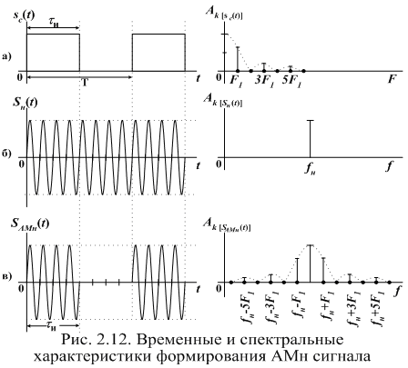

b)

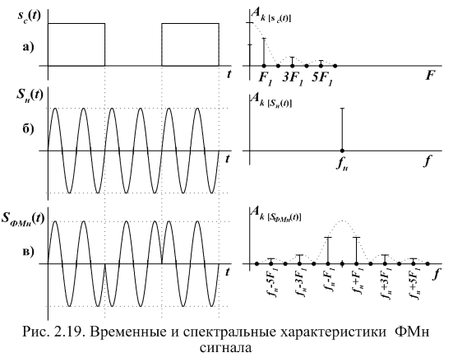

Figure 7.1-Time and spectral characteristics of the formation: a) AM signal; b) FM signal

The simplest is the binary FMN (PSK-phase Shift Keying), in which the phase change of the carrier oscillation occurs in a jump at certain moments of the primary signal at 0 or 180o; while its amplitude and frequency of the carrier remain unchanged. The time charts are shown in figure 7.1.

Distinguish FSK: with gap phases without gap phases. A General view of the FM signal with phase discontinuity can be represented as the sum of two AM signals with different carrier frequenciesОписание: image003 and Описание: image004 . Technically, this type of manipulation is realized with the help of two generators, which are controlled by a key under the influence of an information signal. The formation of the FM signal with phase discontinuity is shown in figure 7.2 (b).

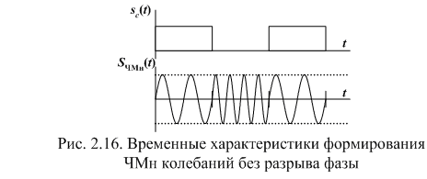

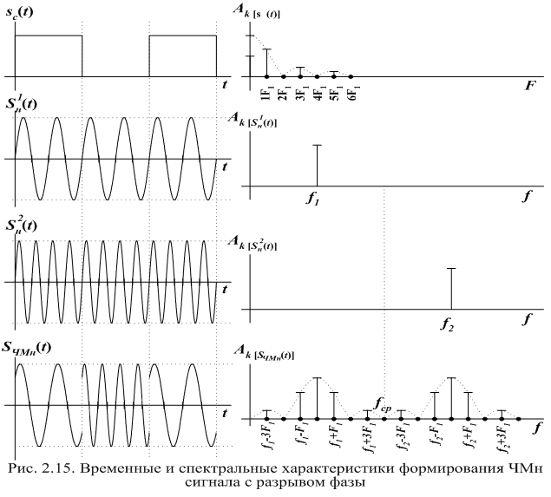

Figure 7.2-Time characteristics of FM signal generation:

without gap phases; b) break phase

Quadrature amplitude manipulation (QAM, eng. Quadrature amplitude modulation (QAM) — manipulation, which changes both the phase and the amplitude of the signal, which allows you to increase the amount of information transmitted by one state (readout) of the signal.

Formation of M-level QAM radio signal can be realized by m - level balanced amplitude manipulation of quadrature oscillations of one frequency and addition of the received AM radio signals. The most common 16-level QAM. Possible variants of the QAM-16 are shown in figure 7.3. Figure 7.3 shows the number of possible values of the amplitude of the radio signal QAM-16 is 3, and the phase 12. QAM allows you to maximize the use of bandwidth.

[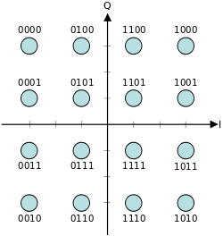](http://ru.wikipedia.org/wiki/%D0%A4%D0%B0%D0%B9%D0%BB:16QAM_Gray_Coded.svg)

Figure 7.3-signal constellation of 16-position QAM signal

1. **Write about coding and signal processing in digital RRL (DRL)**

In digital systems, a discrete change in the control oscillation modulated parameters of the carrier will change abruptly. In this case, instead of the term "modulation", the term "manipulation" is used, and the oscillation itself is called manipulated.

Amplitude-manipulated signal has the form of a sequence of radio pulses with a rectangular envelope figure 7. 1 (a).



b)



Figure 7.1-Time and spectral characteristics of the formation: a) AM signal; b) FM signal

The simplest is the binary FMN (PSK-phase Shift Keying), in which the phase change of the carrier oscillation occurs in a jump at certain moments of the primary signal at 0 or 180o; while its amplitude and frequency of the carrier remain unchanged. The time charts are shown in figure 7.1.

Distinguish FSK: with gap phases without gap phases. A General view of the FM signal with phase discontinuity can be represented as the sum of two AM signals with different carrier frequenciesОписание: image003 and Описание: image004 . Technically, this type of manipulation is realized with the help of two generators, which are controlled by a key under the influence of an information signal. The formation of the FM signal with phase discontinuity is shown in figure 7.2 (b).





Figure 7.2-Time characteristics of FM signal generation:

without gap phases; b) break phase

Quadrature amplitude manipulation (QAM, eng. Quadrature amplitude modulation (QAM) — manipulation, which changes both the phase and the amplitude of the signal, which allows you to increase the amount of information transmitted by one state (readout) of the signal.

Formation of M-level QAM radio signal can be realized by m - level balanced amplitude manipulation of quadrature oscillations of one frequency and addition of the received AM radio signals. The most common 16-level QAM. Possible variants of the QAM-16 are shown in figure 7.3. Figure 7.3 shows the number of possible values of the amplitude of the radio signal QAM-16 is 3, and the phase 12. QAM allows you to maximize the use of bandwidth.

[](http://ru.wikipedia.org/wiki/%D0%A4%D0%B0%D0%B9%D0%BB:16QAM_Gray_Coded.svg)

Figure 7.3-signal constellation of 16-position QAM signal

1. **Describe the satellite communications system**

The principle of organizing a satellite communication and broadcasting system is quite simple: with the help of a booster rocket an artificial satellite (AES) is launched into a given orbit around the Earth, on board of which a transceiver (radio relay) is placed, earth stations (AP) with parabolic antennas are installed on the Earth and with devices for continuous guidance on the satellite antenna. Signals at fixed frequencies sent from an earth station are received and amplified by an artificial satellite radio relay and, after being converted to other frequencies, are emitted by an artificial satellite antenna in the direction of the correspondent earth stations, where they are received, amplified and converted until a message is highlighted. A simplified satellite communication line is shown in Figure 8.1.

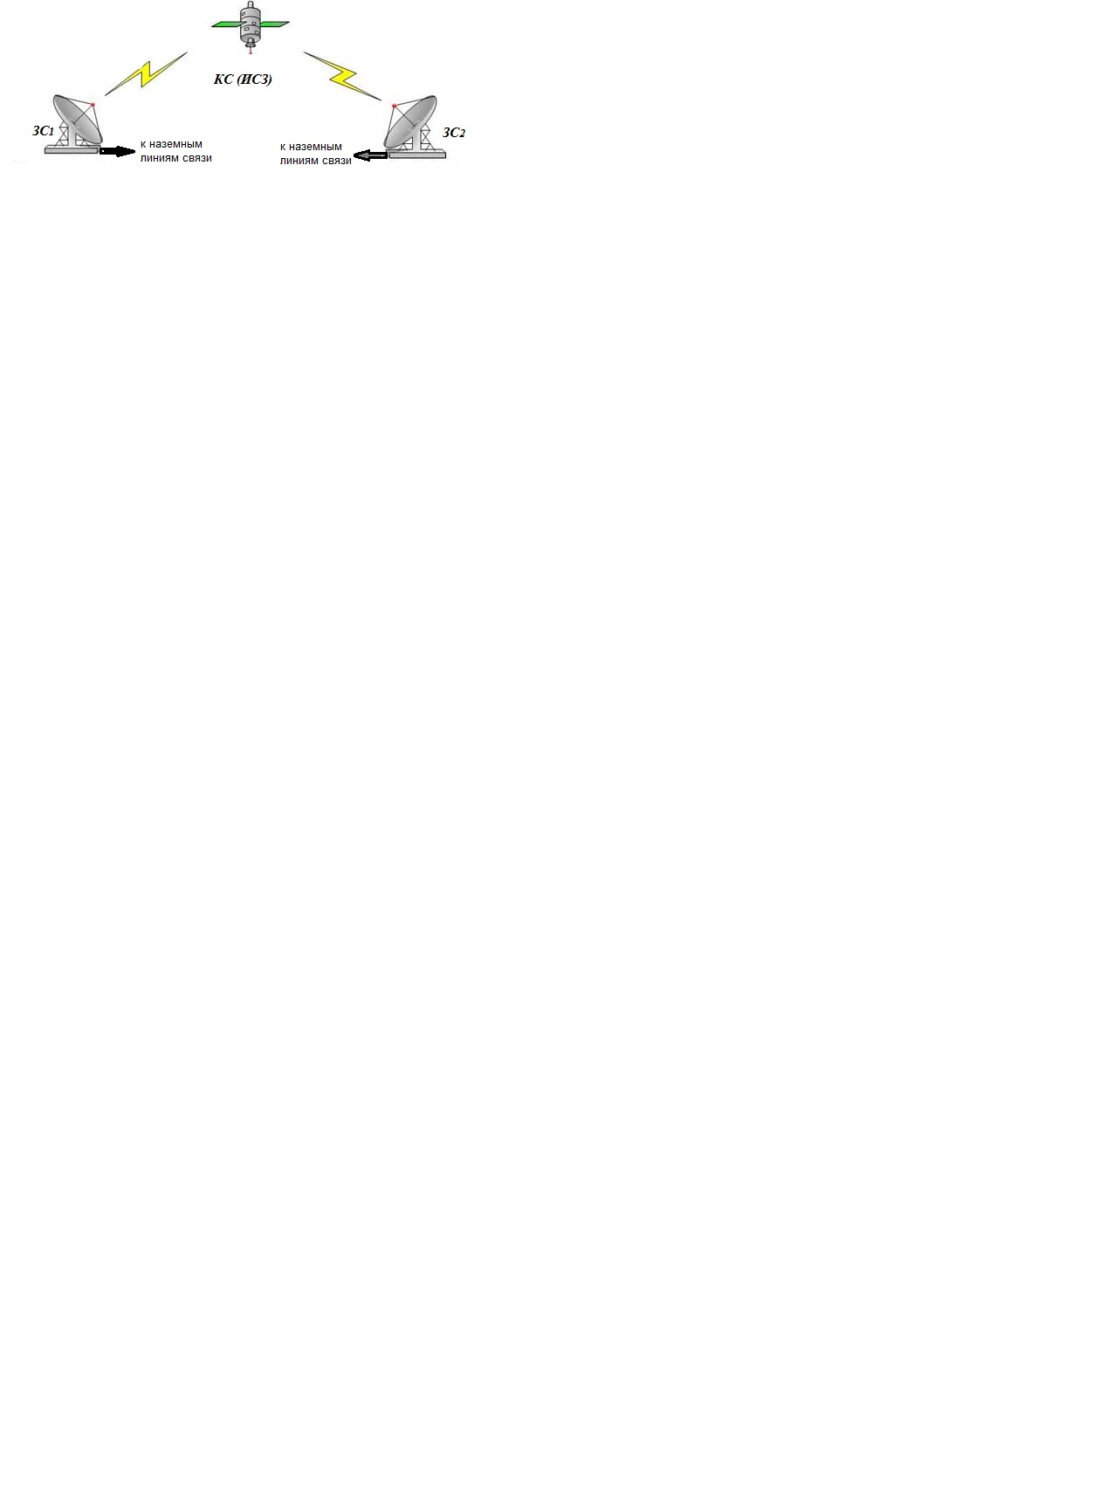

Figure 8.1 - Satellite communication line

The main components of a satellite communications system:

- the space segment of the satellite communications system consists of satellites and ground equipment, providing the functions of tracking, telemetry and transmission of telecommands (TTC) and the material and technical supply of satellites.

- earth segment. The term "earth segment" refers to the part of a satellite communications system that is formed by earth stations used to transmit and receive any kind of communications traffic signals transmitted to and from the satellite and forming a junction with terrestrial networks.

Often in satellite systems there is a subscriber segment formed by equipment designed for direct reception of SS signals by consumers of transmitted information. For example, automobile satellite terminals, telephones, individual satellite television receivers, etc.

The configuration of SS systems depends on the type of artificial Earth satellite, the type of communication and the parameters of earth stations. For the construction of SS systems, the satellite is mainly used, orbits are located at different heights. The satellites orbits differing in shape and height are shown in Figure 8.1: a high elliptical orbit (VEO), geostationary orbit (GSO) and low altitude orbits (IEE), medium altitude orbits (ATS). Each type of satellite has its own advantages and disadvantages.

1. **Write the basic principles for building satellite communications**

The principle of organizing a satellite communication and broadcasting system is quite simple: with the help of a booster rocket an artificial satellite (AES) is launched into a given orbit around the Earth, on board of which a transceiver (radio relay) is placed, earth stations (AP) with parabolic antennas are installed on the Earth and with devices for continuous guidance on the satellite antenna. Signals at fixed frequencies sent from an earth station are received and amplified by an artificial satellite radio relay and, after being converted to other frequencies, are emitted by an artificial satellite antenna in the direction of the correspondent earth stations, where they are received, amplified and converted until a message is highlighted. A simplified satellite communication line is shown in Figure 8.1.



Figure 8.1 - Satellite communication line

The main components of a satellite communications system:

- the space segment of the satellite communications system consists of satellites and ground equipment, providing the functions of tracking, telemetry and transmission of telecommands (TTC) and the material and technical supply of satellites.

- earth segment. The term "earth segment" refers to the part of a satellite communications system that is formed by earth stations used to transmit and receive any kind of communications traffic signals transmitted to and from the satellite and forming a junction with terrestrial networks.

Often in satellite systems there is a subscriber segment formed by equipment designed for direct reception of SS signals by consumers of transmitted information. For example, automobile satellite terminals, telephones, individual satellite television receivers, etc.

The configuration of SS systems depends on the type of artificial Earth satellite, the type of communication and the parameters of earth stations. For the construction of SS systems, the satellite is mainly used, orbits are located at different heights. The satellites orbits differing in shape and height are shown in Figure 8.1: a high elliptical orbit (VEO), geostationary orbit (GSO) and low altitude orbits (IEE), medium altitude orbits (ATS). Each type of satellite has its own advantages and disadvantages.

1. **Describe the parameters of the orbit in the satellite communications system**

Orbit is the trajectory of the motion of an artificial Earth satellite. After the satellite is put into orbit, rocket engines are turned off, and the satellite, like any celestial body, moves by inertia and under the influence of gravitational forces, the main one of which is Earth’s gravity. This factor determines the shape of the satellite’s trajectory, in communication systems, circular figures 8.1 a) and elliptical orbits, figure 8.1 b) are used, characterized by their apogee height (the orbit point closest to the Earth’s surface and perigee (the most distant orbit point). parabolic and hyperbolic orbits.

An important characteristic of the satellite’s orbit is the inclination of its plane to the plane of the Earth’s equator, characterized by the angle i between these planes. Inclination distinguish equatorial (*i* = 0), polar (i = 90 °), oblique (0 <i <90 °, 90 ° <i <180 °) orbits.

1. **Describe the types of orbits in the satellite communications system**

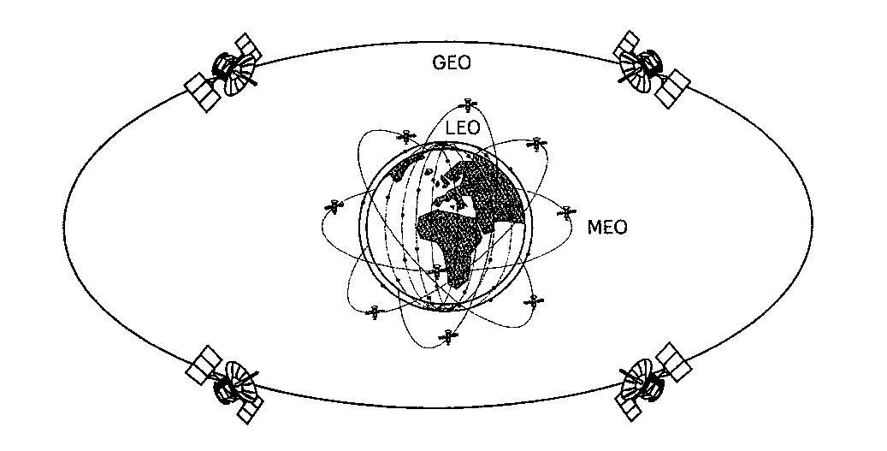

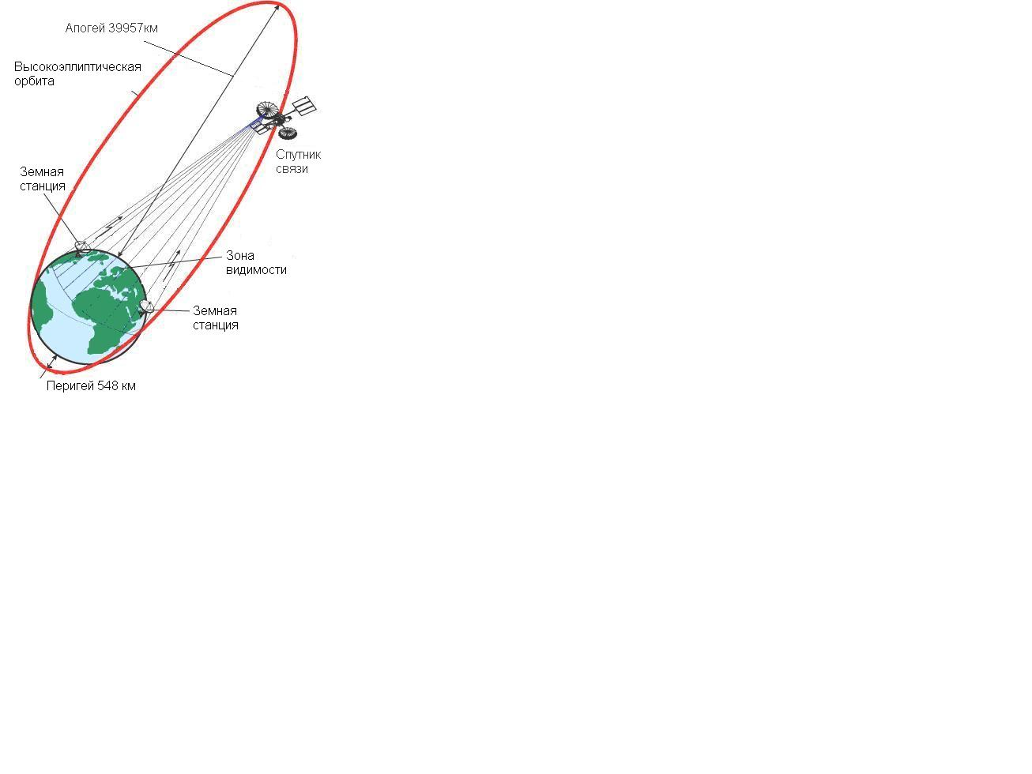

Figure 8.1 - Types of satellite orbits

a) circular low (LEO), mid-high (MEO), geostationary (GEO);

b) highly elliptical orbit

The most important parameter of the orbit is the revolution period T, defined as the time between two successive passage of the satellite through the same point in the orbit.

Low Earth Orbit (LEO) - with circular orbits with a height of 700 - 2,000 km. A satellite in low orbit is in the line of sight from a certain point on the earth's surface for only 8-12 minutes. Therefore, to ensure continuous communication, a large number of satellites (several dozens of satellites weighing up to 500 kg) are needed, which would interact using gateway stations or inter-satellite communications. To cover a large area of ​​the Earth with communications, such systems use orbits lying in different planes. Examples of systems: Globalstar, Iridium, Teledesic, "Signal", "Messenger".

Medium Earth Orbit (MEO) - with circular orbits 5,000 to 15,000 km high. With such orbits, the visibility time of one repeater satellite can be several hours, therefore, in the mid-orbit constellation, 9-12 satellites weighing up to 1,000 kg are sufficient. The propagation delay of the signal is about 130 ms and allows the use of such systems for radiotelephone communications. Examples of MEO systems are: Odyssey, ISO.

Geostationary (GEO - Geostationary Earth Orbit) - with circular equatorial orbits with a height of 35,875 km. In this case, the satellite’s period of revolution around the Earth is 24 hours. That is, the satellite is always above a certain point on the Earth. The advantage of such systems is the ability to cover the entire earth's surface with a small number of satellites (from three). The main disadvantages are the long duration of the propagation of the radio signal (delay of radio signals, echo), the large attenuation of the signal, it is impossible to discuss the polar regions. Examples of such systems are: Yamal (for digital television), as well as the geostationary grouping of the Inmarsat, Intelsat systems.

Highly Elliptical Orbit (HEO) - with elongated elliptical orbits with a perigee radius of about 500 kilometers and an apogee radius of about 40,000 km. An example of a satellite with NEO is the Molniya type satellites with a rotation period of 12 hours, an inclination of 63 °, an apogee height of 40 thousand km above the northern hemisphere, and 500 km of perigee. The motion of the satellite in the apogee region is slowed down, while the radio visibility is 6 ... 8 hours. The advantage of this type of satellite is the large size of the service area while covering high-latitude subscribers. The disadvantage of VEO is the need for tracking antennas for a slowly drifting satellite and their reorientation from a setting satellite to an ascending one, in addition, the Doppler effect is quite pronounced.

1. **Describe the main characteristics of space stations.**

The space platform is the basic part of the spacecraft, on which the payload (airborne relay complex) is located, the power subsystem and the airborne control system that ensures the normal functioning of the spacecraft during orbital flight for the entire period of its active existence.

*The onboard control* complex consists of several subsystems. One of them provides the correct orientation and stabilization of the satellite position in space. It is known that the effective mode of operation of solar panels and radio lines depends on the orientation of the solar panel (they should always be oriented to the Sun) and antenna systems (always directed to the Earth).

Also, the onboard control system contains a telemetry system. The telemetry and telecontrol system is designed to monitor and control the operating modes of all CS systems and transmit this information to the GS. The information transfer speed on command and telemetric radio links usually ranges from several hundred bits to 100 kbit / s.

Important functions are performed by the *thermoregulation subsystem*, which ensures the maintenance of the thermal regime of the payload (satellite equipment) within specified limits. The usual operating temperature range of on-board equipment is from -200 till +500С.

The main characteristics of the platform are its mass and dimensions, the power of the onboard power supply system and the period of active existence.

There are propulsion systems on board any satellite that stabilize its position in orbit by commands from the operator from the Earth. The life of a satellite is generally limited by the life of the batteries and the amount of fuel for correction engines that it can take on board.

Depending on the type of satellite, its life span is from 7 to 12 ... 15 years. After this period, on the remnants of fuel at the command of the Earth, the satellite is dumped into the ocean.

A complex of relay equipment that a spacecraft puts into orbit is called a payload or an airborne relay.

The structure of the airborne relay complex (BRTC) is determined by its purpose, or the extent of coverage of the territories, the method of processing information on board the CS, the number of relay channels, the speed of information exchange, as well as selected technical solutions and technologies used.

The type of antennas used at the CS depends on the satellite’s orbit and its on-value. And yet, parabolic antennas are most often used, since they are broadband, have a high GA gain, and allow you to form the main lobe of the radiation pattern of different widths.

1. **Explain and describe the structure of space and earth stations**

The space platform is the basic part of the spacecraft, on which the payload (airborne relay complex) is located, the power subsystem and the airborne control system that ensures the normal functioning of the spacecraft during orbital flight for the entire period of its active existence.

*The onboard control* complex consists of several subsystems. One of them provides the correct orientation and stabilization of the satellite position in space. It is known that the effective mode of operation of solar panels and radio lines depends on the orientation of the solar panel (they should always be oriented to the Sun) and antenna systems (always directed to the Earth).

Also, the onboard control system contains a telemetry system. The telemetry and telecontrol system is designed to monitor and control the operating modes of all CS systems and transmit this information to the GS. The information transfer speed on command and telemetric radio links usually ranges from several hundred bits to 100 kbit / s.

Important functions are performed by the *thermoregulation subsystem*, which ensures the maintenance of the thermal regime of the payload (satellite equipment) within specified limits. The usual operating temperature range of on-board equipment is from -200 till +500С.

The main characteristics of the platform are its mass and dimensions, the power of the onboard power supply system and the period of active existence.

There are propulsion systems on board any satellite that stabilize its position in orbit by commands from the operator from the Earth. The life of a satellite is generally limited by the life of the batteries and the amount of fuel for correction engines that it can take on board.

Depending on the type of satellite, its life span is from 7 to 12 ... 15 years. After this period, on the remnants of fuel at the command of the Earth, the satellite is dumped into the ocean.

A complex of relay equipment that a spacecraft puts into orbit is called a payload or an airborne relay.

The structure of the airborne relay complex (BRTC) is determined by its purpose, or the extent of coverage of the territories, the method of processing information on board the CS, the number of relay channels, the speed of information exchange, as well as selected technical solutions and technologies used.

The type of antennas used at the CS depends on the satellite’s orbit and its on-value. And yet, parabolic antennas are most often used, since they are broadband, have a high GA gain, and allow you to form the main lobe of the radiation pattern of different widths.

1. **Describe the composition and purpose of the ground segment**

 The purpose of the lecture: to get acquainted with the composition and purpose of the ground segment, schemes of earth stations, the principles of construction of VSAT systems

Figure 10.1 shows a functional block diagram of a satellite communications system, the three components of its segment are highlighted. The ground segment includes gateway earth stations, monitoring and control stations of the communication network.

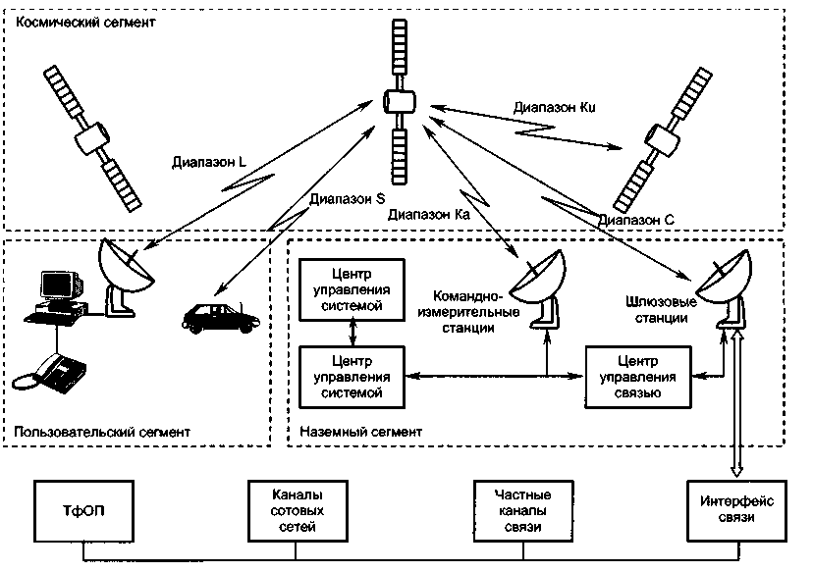

Figure 10.1 - Composition of a satellite communications system

An earth station (AP) is the terminal transmitting and receiving link of a communication link through a satellite. The general construction of the AP is shown in Figure 10.2. The station consists of the following main subsystems:

-antenna system;

-low noise receiver amplifiers;

-transmitter power amplifiers;

- communication equipment (frequency converters and modems);

-sealing / decompression equipment;

- equipment for connection to a land communication network;

-auxiliary equipment (control and monitoring equipment, measuring equipment, service channel equipment);

-power supply equipment (network power supply with redundancy and uninterruptible power supplies);

-general-purpose infrastructure (all premises, buildings and structures).

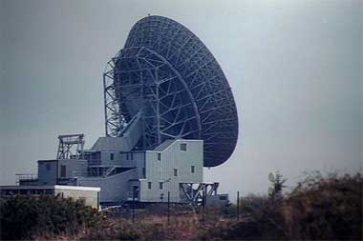

Figure 10.2 - Gateway earth station

Most gateway stations are transceivers.

Antenna system AP. The diameter of the antenna can be from about 33 m to 3 m or less. Earth station antennas are used simultaneously for reception and transmission and should have the following characteristics:

- high gain for transmission and reception, for which the reflectors must be large compared to the wavelength and have high efficiency;

- low level of generated interference (for transmission) and low sensitivity to interference (for reception), as a result of which the radiation pattern of the antenna should have a low level outside the main beam (small side lobes);

- high polarization purity of radiation;

- low sensitivity of the receiving path to thermal noise due to ground radiation and various losses.

1. **Describe the block diagram of the earth station**

The antenna beam should maintain its direction to the satellite under any external conditions and regardless of the satellite’s residual movement: (in the case of an INTELSAT system standard A antenna with a diameter of 30 m, the angular accuracy should be about 0.015 °). Therefore, even in systems operating with geostationary CS, an automatic tracking device is required that controls the drive mechanisms of the antenna.

Low noise amplifiers. In order to receive a very weak signal from a satellite, the earth station antenna must be connected to a receiver with very low intrinsic thermal noise. Thus, a low-noise amplifier is always a preliminary amplifier of the microwave receiving paths of a satellite communication station. It should be placed as close as possible to the antenna feeder diplexer in order to avoid additional noise due to losses in the waveguide. A low-noise amplifier is usually broadband: one amplifier simultaneously amplifies all carriers coming from the receive port of the antenna diplexer. Typically, a backup amplifier is also installed (1 + 1 redundancy). Recent advances in field effect transistors based on gallium arsenide (GaAs) have led to the creation of simpler and cheaper transistor amplifiers. In modern LNAs operating in the C and Ku bands (bandwidth from 500 MHz to 1 GHz), the equivalent noise temperature is 50-150 K, and the gain is 30-40 dB.

The most important element of the transmitter is the amplifier. The order of magnitude of the required power at the transmitter output is 1 W or less for a telephone channel and 1 kW for a television carrier. At the output of the power amplifier (if necessary, amplifications up to 0.5-3 kW) are used either klystrons or traveling wave tubes (TWT). The main advantage of klystrons is high stability and low noise level, while TWT provides a large (compared with them) bandwidth. In amplifiers with a power of 0.5-1 kW, TWT is usually used, and in more powerful (1-3 kW) klystrons.

The composition of the terminal equipment depends on the purpose of the earth station and the type of information transmitted. For data networks, these can be packet collectors / parsers, packet switches, etc. In telephone communication systems, this includes modems, encoders and decoders, switches and automatic telephone exchanges.

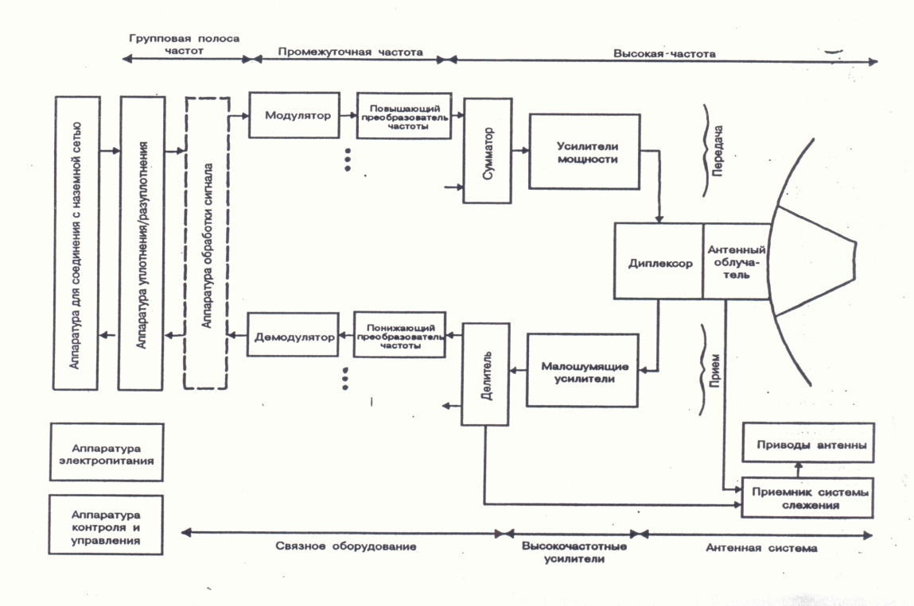

Figure 10.3 - Block diagram of a typical earth station

Trunk equipment is designed to interface earth stations with terrestrial communication lines and user equipment.

Thanks to progress in the field of microelectronics and radio engineering, small-sized and relatively inexpensive earth stations, called the VSAT (Very Small Aperture Terminal), have appeared on the world market. Basically, VSAT terminals have mirrored parabolic antennas with a diameter of up to 2.4m.

21. Explain and describe the principles of construction of VSAT systems

Thanks to progress in the field of microelectronics and radio engineering, small-sized and relatively inexpensive earth stations, called the VSAT (Very Small Aperture Terminal), have appeared on the world market. Basically, VSAT terminals have mirrored parabolic antennas with a diameter of up to 2.4m.

Currently, VSAT networks are used to exchange information between earth stations (AP), to connect remote subscribers with data networks, as well as in information collection and distribution systems. The use of equipment such as VSAT is especially effective in remote areas where the organization of other types of communication is difficult. The structure of the VSAT satellite network is shown in Figure 10.3.

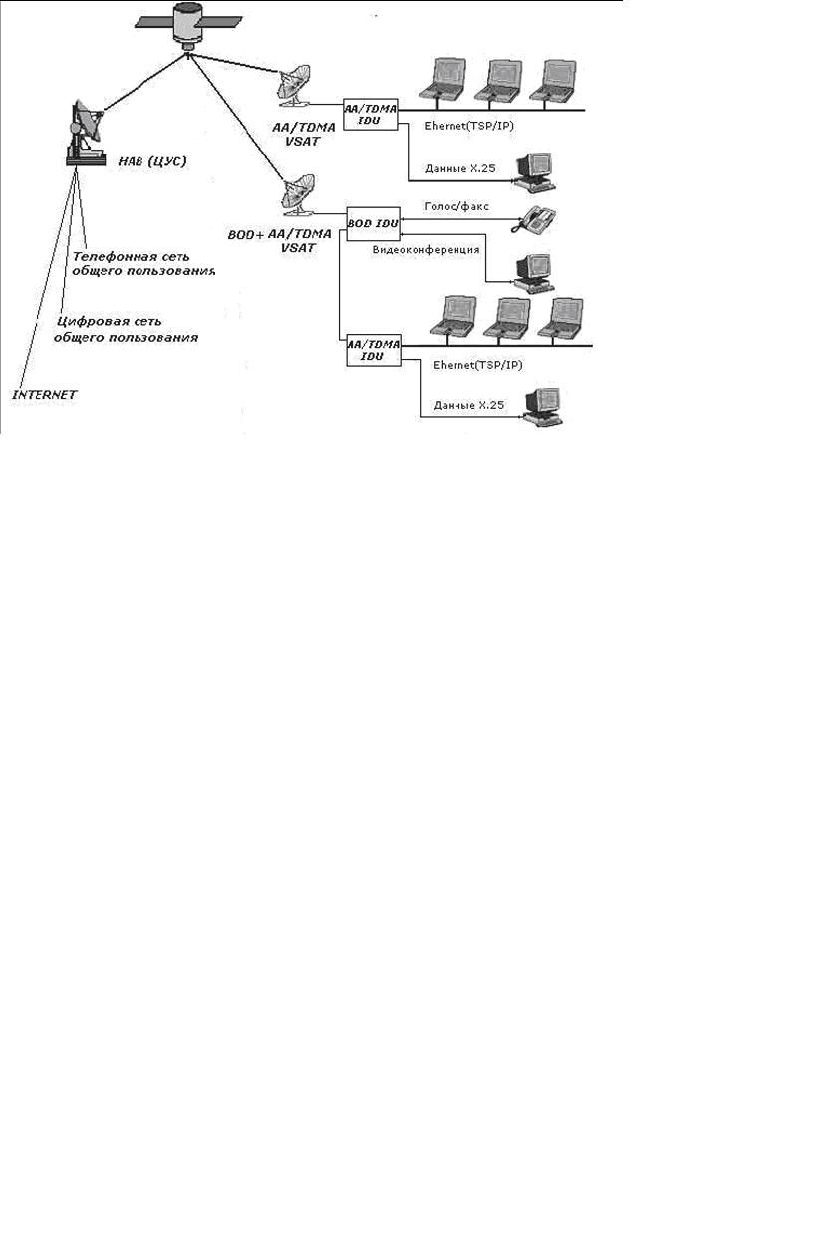

Figure 10.2 - The structure of the satellite network VSAT

22 Write about the energy calculation of the satellite communication line.

The purpose of the calculation: to determine the values ​​of the transmitter power of the earth transmitting station RPRDZS and the transmitter power of the on-board repeater RPRDKS, at which the satellite channel reliably operates in the conditions of interference and does not contain excessive energy reserves.

Also, during the calculation, it is necessary to determine the power of the transmitted signal to ensure the necessary signal-to-noise (C / N) ratio at the receiver input.

A satellite communication line is conditionally divided into two sections: an uplink from an AP to an SC and a downlink from an AP to an AP.

Before starting the calculation, we determine the frequency ranges, multiple access methods and the use of the frequency band, the mode of operation of the repeater, the types and parameters of modulation used, service areas and other source data.

Consider one section of a satellite line consisting of a transmitting and receiving device, an antenna path and a propagation path, as shown in Figure 11.1.

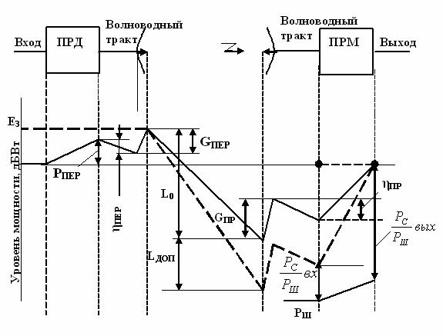

Figure 11.1 - Block diagram and level diagram of one section of a satellite link

When matching the wave impedances of the antenna, path elements and the receiver, the signal power at the receiver input



where d is the distance between the transmitting and receiving antennas, m;

            λ is the wavelength, m;

       RPRD - transmitter power, W;

       GPRD, GPRM - gain of the transmitting and receiving antennas, dB;

       PRD, PFP - transmission coefficient of waveguide paths;

       LDOP - additional signal attenuation.

Signal energy attenuation in free space - decrease in power flux density when moving away from the emitter



where λ is the wavelength;

d is the slant range (distance between the transmitting and receiving antennas).

The distance between the transmitting and receiving antennas for satellite systems operating with geostationary satellites is determined by the formula 8.1. For systems. Working with spacecraft in non-geostationary orbit, the distance will change when the satellite moves and there are various calculation methods [4].

Having expressed the transmitter power from equation (11.1), we obtain a formula that allows you to determine the necessary transmitter power from a given value of the signal power at the receiver input.

The signal power at the input of the receiver, which must be obtained for high-quality signal reception, is expressed in terms of the signal-to-noise ratio at the input of the receiver and the total noise power. Then the formula for calculating the power of the transmitter AP takes the form:



where is the noise power of the receiving system, 0K;

k is the Boltzmann constant;

TΣ is the equivalent noise temperature of the entire receiving system, taking into account internal and external noise, 0K;

Δf is the equivalent noise band of the receiver, Hz;

a = 5 - safety factor for the line up.

For the "down" line, the equation for calculating the power of the transmitter KS:



Additional signal attenuation takes into account attenuation in atmospheric gases, precipitation, and other causes of signal attenuation.

Another important issue considered in the design of satellite communications systems is the electromagnetic compatibility of satellite and terrestrial communications systems.

Mutual interference arising from the sharing of common sections of frequency bands can be divided into internal and external. In RRL, intra-system interference is caused by interfering signals from neighboring trunks, signals received from the opposite direction due to the back lobes of the antenna radiation pattern, signals from stations spaced three intervals apart, etc. Sources of external interference are neighboring RRL, CCC, SSB, signals radar stations using common frequency bands.

To reduce interference in terrestrial systems from satellite emissions, the maximum signal power flux density developed at the Earth's surface is limited to W.

W (dBW / m²) must satisfy the following conditions:

-W = W0 at ε ≤ 5 °,

-W = W0 + 0.5 (ε - 5 °) at 5 ° <ε ≤25 °,

-W = W0 + 10 at 25 ° <ε ≤90 °, where ε is the elevation angle;

Frequency dependent:

-W0 = - 152 dBW / m² for 3.4-7.75 GHz;

-W0 = - 150 dBW / m² for 10.7-11.7 GHz;

-W0 = - 148 dBW / m² for 12.2-12.75 GHz;

-W0 = - 115 dBW / m² for 17.7-19.7 GHz and 31-40.5 GHz.

W is determined within the conditional control frequency band: 1 MHz for the ranges 17.7-19.7; 31-40.5 GHz and 4 kHz for the rest (lower frequency).

23. Write about electromagnetic compatibility in a satellite communications system

EMC (electromagnetic compatibility) of geostationary-satellite communications networks sharing the same frequency bands.

The administration intending to create an MSS should not earlier than 6 years and no later than 2 years before the planned launch date of the system send to the Radiocommunication Bureau for publication information about the MSS being created. The administration of the existing MTS sends its comments to the notifying administration if it considers that its existing services may be subject to unacceptable interference.

Both parties must find a mutually acceptable solution in the coordination process. The need for coordination is calculated by the method described below in Appendix 29, Volume 2 of the ITU Radio Regulations, 1990.

The scheme for evaluating the interfering influence when calculating the need for coordination is shown in Figure 11.2. We consider systems working with geostationary satellites.

**КС1**

**КС2**

α1

α2

θ1

θ2

d1

d2

d3

d4

θg

Действ. система 1

Проектируемая система 2

**ЗС1**

**ЗС2**

Figure 11.2 - Scheme for assessing the interfering effect of CCC

The following notation is used in the figure: d1 ... d4 - distance between stations; θ1, θ2 - topocentric angles in the case of CS; α1, α2- exocentric angles in CS; θg is the geocentric angular separation between the satellites.

The influence of the designed system on the existing one is estimated by the increment of the noise temperature of the existing system. This increment consists of two terms ΔTЗС and ΔTКС.

It is more convenient to use for calculating formulas in which values ​​are expressed in decibels.

ΔTZS = SBR2 + GBR2 (α2) + GZS1 (θ1) -k-Lp ↓, dBK,

ΔTKS = SЗC2 + GКС1 (α1) + GЗС2 (θ2) -k-Lp ↑, dBK.

where SBR2, SZC2 are the spectral power densities of BR2 and ZS2 in technical specifications, as a rule, are indicated in dBW / Hz;

      LР ↑ - attenuation of interfering signals along the propagation path in the upward section, dB;

GЗС2 (θ2), GЗС1 (θ1) —gain antennas antenna gain of the designed and existing systems, depending on the topocentric angles θ, dB;

     GBR1 (α1), GBR2 (α2) - gain antennas of the CS of the existing and designed systems, depending on exocentric angles α, dB;

k– Boltzmann constant (-228.6), dB.

Attenuation in free space is determined by the following formula:

Lp = Lo = 20 (log f + log d) + 32.45 [dB],

where f is the frequency, MHz;

      d - distance, km.

The distance is calculated by the formula 8.1.

Reference formulas for calculating the gain of AP antennas depending on the angle, taking into account the side lobes of the antenna pattern:

For DA / λ ≥ 100

G (θ) = Gmax - 2.5 * 10-3 (θ DA / λ), dB

for 0 <θ <θm;

G (θ) = G1, dB for θm <θ <θr;

G (θ) = 32 - 25 logθ, dB, for θr <θ <480;

G (θ) = -10, dB, at 480 <θ <1800,

where DA is the diameter of the antenna, m;

      θ is the angle (in degrees), measured from the axis of the antenna, equal to θt.

      G1 = 2 + 15lg (DA / λ) - antenna gain in the direction of the maximum of the first lobe, dB;

    θm = (20 λ / DA) Gmax-G1 - width of the first lobe, degrees.

θr = 15.85 (DA / λ) -0.5, degrees.

For DA / λ <100

G (θ) = Gmax - 2.5 * 10-3 (θ DA / λСР), dB at 0 <θ <θm;

G (θ) = G1, dB for θm θ <100λ / DA;

G (θ) = 52 - 10 log DA / λav – 25lgθ, dB at 100λ / DA θ <480;

G (θ) = -10, dB at 480 θ <1800

The topocentric angle at earth stations is determined by the following formula:



θ2 is defined in a similar way.

Then we translate the increment of noise temperature into kelvin using the relations:

ΔTЗС = 10 ΔTзс (dB) / 10, 0K;

ΔTKS = 10 ΔTx (dB) / 10, 0K.

The total increment of the noise temperature of the entire system is calculated.

ΔT∑ = γΔTKS / + ΔTЗС / Y, 0К

where γ is the transmission coefficient of the satellite communication line;

Y is the attenuation coefficient of the interfering signal due to polarization mismatch (1 for coinciding polarizations, 4 for circular polarizations with the opposite direction of rotation, and 1.4 in other cases).

It is believed that the effect is not significant and coordination between systems is not required if the relative increment of the noise temperature of the existing system does not exceed 6%. This is determined by the inequality:

∆Т∑ / TСЛС ≤ 6%,

where TSLS is the noise temperature of the existing satellite system.

24. Explain and describe the EMC of geostationary-satellite communications networks

The administration intending to create an MSS should not earlier than 6 years and no later than 2 years before the planned launch date of the system send to the Radiocommunication Bureau for publication information about the MSS being created. The administration of the existing MSS sends its comments to the notifying administration if it considers that its existing services may be subject to unacceptable interference. Both parties must find a mutually acceptable solution in the coordination process. The need for coordination is calculated by the method described below in Appendix 29, Volume 2 of the ITU Radio Regulations, 1990.

### КС1

### КС2

α1

α2

θ1

θ2

d1

d2

d3

d4

θg

Действ. система 1

Проектируемая система 2

### ЗС1

### ЗС2

Figure 6.2 - Assessment scheme for the interfering effect of the designed CCC2 on the current CCC1

The calculation method is based on the notion that when exposed to interfering signals, the effective noise temperature of the system undergoing interference increases.

According to this method, the apparent relative increase in the noise temperature of the existing ∆Т∑ / Т∑ line due to the influence of interfering signals created by the designed system is calculated and compared with a threshold value of 6%.

Let us evaluate the interfering influence of the designed system 2 (see Figure 5.2) on the current system 1, therefore, we will be interested in receiving paths in system 1, and transmitting paths in system 2. The following notation is used in the diagram:

d1 ... d4 - distances between stations;

θ1, θ2 are topocentric angles;

α1, α2- exocentric angles;

g is the geocentric angular separation between the satellites.

γ is a coefficient numerically equal to the transmission coefficient of the path from the output of the receiving antenna KS1 to the output of the receiving antenna ZS1 (usually less than 1);

25. Write about the satellite communications of the Republic of Kazakhstan “KazSat”

KazSat is the first spacecraft for Kazakhstan, with the launch and operation of which the implementation of space programs of the Republic began.

Pre-launch preparation of the components of the launch vehicle, upper stage and spacecraft at the cosmodrome was carried out by specialists of the state space research and production center named after M. V. Khrunichev (hereinafter-GKNPTs them. M. V. khrunicheva) and the Italian firm "Alcatel Alenia Spazio Italia". The onboard relay complex of the KazSat satellite was manufactured by Alcatel Alenia Spazio Italia with the use of advanced satellite technologies.

The Russian side, which has a temporarily free orbital frequency resource in geostationary orbit at the time of the launch of the KazSat satellite, provided the Kazakh side with a coordinated orbital frequency resource on a temporary basis (for the lifetime of the satellite in orbit, but not more than 15 years).

The KazSat satellite was successfully launched into geostationary orbit on June 18, 2006 from the Baikonur cosmodrome «proton» launch site in the presence of the presidents of Russia and Kazakhstan.

"KazSat" will provide modern types of telecommunication services in the most remote regions of Kazakhstan and other countries. It is also planned to lease satellite communication channels to operators of the CIS countries. "KazSat" - is designed for 864 MHz. Thus, Kazakhstan has a resource for the transfer of operators to the local satellite.

26. Describe the technical appearance and main characteristics of “KazSat-103”

More than 15 foreign and domestic companies, including the leading manufacturers of onboard telecommunications equipment - Boeing, Alcatel Alenia Spazio Italia, ComDev-participated in the creation of The KazSat space system.

The Khrunichev State Research and Production Space Center carried out the creation of the space system «KazSat» based on a small communication and television spacecraft in a geostationary orbit of 103 degrees East longitude belonging to the Russian Federation. Construction of the ground control complex (GCC) and monitoring system (SMS) is carried out on the territory of Kazakhstan. General view of the spacecraft "Kazsat" is shown in figure 7.1. Its main characteristics are shown in table 7.1. The block diagram of the onboard relay complex of small spacecraft MKA " Kazsat "is shown in figure 7.2, the frequency plan" Kazsat " in table 7.2, the results of EIRP calculations and q-factor of the onboard relay complex according to simulation data in table 7.3

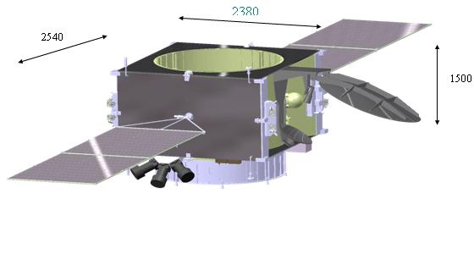

Figure 7.1 – Appearance of “Kazsat” space system.

The spacecraft "Kazsat", placed in geostationary orbit, carries out communication and television broadcasting through 12 transponders, covering the entire territory of the Republic of Kazakhstan and part of neighboring States.

Table 7.1-Main characteristics of "Kazsat" spacecraft

|  |  |
| --- | --- |
| The parameters of the working orbit: |  |
| - orbit type: | Geostationary |
| - inclination: | 0 deg.; |
| - longitude of the standing point (range) | 103º e.l.; |
| " dry " mass | 695 kg |
| Flipping the stock xenon | 60 kg |
| Period of active existence | 10 years |
| Technical resource | 12,5 years |
| Number of relay trunks | 12 |
| The frequency range of the onboard relay complex | Ku |
| The bandwidth of trunks onboard relay complex | 72 MHz |
| Payload mass | 110 kg |
| Rated power consumption of the payload | 1300 W |
| The accuracy of control of the situation and bring you to the point of standing: |  |
| – in longitude | ±0,05 deg. |
| – in latitude | ±0,05 deg. |
| The accuracy of the spacecraft when working onboard relay complex | 0,1 deg. |

KazSat is intended for organization of TV and radio broadcasting channels, telephone communication, data transmission, broadband Internet access, creation and development of VSAT networks, creation of departmental and corporate communication networks, provision of multimedia services package.

7.2 Ground control complex

Navigation of the KazSat satellite will be carried out in the ground-based spacecraft control complex (GCC), which is located one hundred kilometers from Astana in the city of Akkol, Akmola region. The total area of the GCC is 6 916 sq km, while the most up-to-date equipment corresponding to the world standard. The GCC consists of three main divisions – the monitoring center, the control center and the payload Department.

Ground control complex (GCC) and communication monitoring system on the territory of the Republic of Kazakhstan provide the solution of problems of control, control and maintenance of the specified characteristics of the spacecraft at the stage of its regular operation.

27. Write about the loss due to refraction and inaccuracy of pointing the antennas in the satellite communication system

Refraction is the curvature of the signal path as it passes through the atmosphere (ionosphere and troposphere).

Ionospheric refraction (in degrees) can be determined by the formula:

from which it follows that it is inversely proportional to the square of the frequency and becomes negligible at f > 5 GHz. Tropospheric refraction is frequency independent. For a standard atmosphere at small elevation angles, the constant (regular) component of tropospheric refraction (in degrees)*.*

Full refraction shown in figure 5.16.

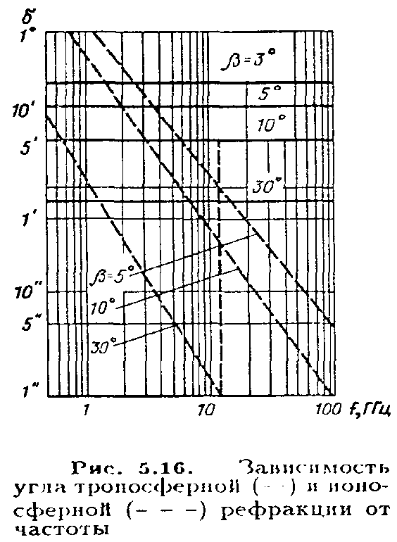With automatic guidance antennas but the maximum incoming signal refraction effect is virtually eliminated. Another component of losses-due to the inaccuracy of pointing antennas of earth stations on the satellite-is determined by the angular deviation of the axis of the main lobe of the radiation pattern from the true direction of the satellite, as well as the width and shape of the lobe. Usually use one of the following approximations of the shape of the diagram within the main part of the main lobe: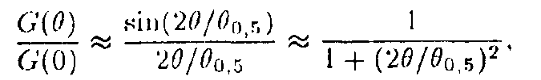

Where **- is the width of the antenna pattern in terms of half power. Then loss of guidance



In modern guidance systems, antenna control is usually carried out on two axes (for example, azimuthal and angular). The angular error of guidance on each of the axes can be represented by the sum of the three components:

Where **-angular error due to imperfections of the mechanical part of the system (backlash gears and mirror deformations); — fluctuation error due to the influence of noise in the tracking channels;  - dynamic (speed) error due to the movement of the antenna during tracking.;

The first component depends on the design of the antenna and is usually specified in the passport data; its statistics are not given; the second is calculated by the expected signal-to-noise ratio in the reception channels and has a Gaussian distribution with parameters ; the third depends on the speed of the relative movement of the satellite relative to the ground point where the antenna is located, and can be determined by solving the equation



where kc is the transmission coefficient of the tracking channel; v is the speed of the satellite in space; r is the unit radius vector; d is the distance to the satellite (inclined range).

This equation is solved in the calculation of target designations for earth stations of the system**, so it is enough to carry out statistical processing of these target designations for several earth stations of the system. The results of such processing performed for the “Molniya-3” and “Ekran” satellites show that the highest velocities of “Molniya” satellites do not exceed 0.2 deg/s, and for geostationary satellites they are less. The distribution  is close to Gaussian, respectively the probability density of the angular guidance error in each plane



Expressions (5.15) and (5.16) allow to calculate the value and probability density of the guidance error for each of the axes. The total error of guidance in the picture plane is determined by a known rule

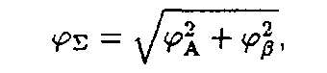

and the error probability density obeys Rayleigh's generalized law

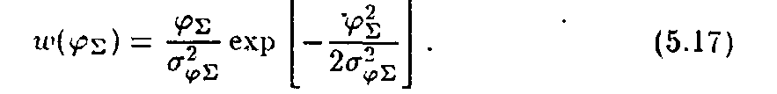

28. Explain and describe the basic definitions and classifications in a satellite communications system

The principle of organizing a satellite communication and broadcasting system is quite simple: with the help of a launch vehicle, an artificial Earth satellite (AES) is launched into a given orbit around the Earth, on board of which a transmitter-receiver unit (radio relay) is placed, earth stations are installed on Earth with parabolic antennas and with devices for continuous guidance on the satellite antenna. Signals at fixed frequencies sent from an earth station are received and amplified by an artificial satellite radio relay and, after conversion to other frequencies, are emitted by an artificial satellite antenna in the direction of correspondent earth stations, where they are received, amplified and converted until a message is allocated.

We give definitions of the basic concepts related to Satellite Communication Systems (SCS), guided by the “Radio Regulations” [1], GOST and the established practice of applying the terms.

***Space radio communication*** - radio communication in which space stations located on a satellite or other space objects are used.

A ***space station*** (SS) is a station located on an object that is located outside the main part of the Earth’s atmosphere (either located there or intended for output), for example, on an artificial satellite.

***Earth station*** (ES) - a radio communication station located on the earth's surface (or in the main part of the earth’s atmosphere) and intended for communication with space stations or with other earth stations through space stations or other space objects, for example, passive (reflective) satellites. Unlike earth stations, stations of terrestrial radio communication systems that are not related to space communication systems or radio astronomy are called terrestrial.

***Satellite communications*** - communications between earth stations through space stations or passive satellites. Thus, satellite communications is a special case of space radio communications.

***Satellite line*** - a communication line between earth stations with the help of one satellite, in each direction includes the Earth – Space section (Figure 1.1) (“line up”) and the Space – Earth section (“line down”) .

Space station

**ES**

**ES**

**ITS**

**ITS**

Космическая станция

ЗС

ЗС

МТС

МТС

Космическая станция

ЗС

ЗС

МТС

МТС

Космическая станция

ЗС

ЗС

МТС

МТС

Космическая станция

ЗС

ЗС

МТС

МТС

Космическая станция

ЗС

ЗС

МТС

МТС

Космическая станция

ЗС

ЗС

МТС

МТС

Космическая станция

ЗС

ЗС

МТС

МТС

Космическая станция

ЗС

ЗС

МТС

МТС

Figure 1.1 - Satellite line

***Satellite broadcasting*** - the transmission of broadcasting programs (television and sound) from transmitting earth stations to receivers through a space station - an active repeater. Thus, satellite broadcasting is a special case of satellite communication, characterized by the transmission of a certain class of one-way (simplex) messages received simultaneously by several ACs or by a large number of receiving stations (circular transmission).

Earth stations are connected to switching nodes of communication networks (for example, with a international telephone station - ITS), sources and consumers of television and sound broadcasting programs using landlines, or are installed directly at information consumers.

Depending on the type of earth stations and the purpose of the system, according to the Radio Regulations, the following communication services are distinguished:

- fixed satellite service (FSS) is a radio communication service between earth stations with a given location when one or more satellites are used. These ES stations located at fixed points on the surface of the Earth are called FSS earth stations. The fixed-satellite service also includes feeder links (lines for delivering programs to the space station) for other space radiocommunication services, for example, for broadcasting satellite or satellite mobile services.

The main signals transmitted through the FSS communication lines are the signals of telephony, data, telegraphy, facsimile, television and sound programs.

The communication lines down which the signals of the last two mentioned transmission modes are directed are excluded from the FSS if they are directly received by the general public, since then they belong to the broadcasting-satellite service (BSS).

FSS systems are designed to provide communication between stationary users. Initially, they were deployed exclusively for the organization of highways and regional (zone) communications. Such systems based on VSAT terminals are used in electronic commerce networks, exchange of banking information, wholesale bases, trading depots, etc.

The most significant commercial fixed-line systems include Intelsat, Intersputnik, Eutelsat, Arabsat and AsiaSat;

- mobile satellite service (MSS) - between mobile spacecraft (or between mobile and fixed spacecraft) with the participation of one or several space stations (depending on the location of the mobile spacecraft, land, sea, air mobile satellites are distinguished services).

Initially, mobile ground stations were developed as special-purpose systems (sea, air, automobile, and rail) and were aimed at a limited number of users. The first generation mobile CCCs were built using geostationary spacecraft with direct (transparent) transponders and had low bandwidth.

MSS subsystems were created mainly for networks having a radial or radial-node structure with large central and base stations, which provided work with mobile ground stations. The flows in the networks with the provision of channels on demand were small, therefore, they mainly used single- or small-channel ground stations. Typically, such networks were intended to create departmental and corporate communication networks with remote and mobile objects (ships, airplanes, cars, etc.), to organize communications in government agencies, in disaster areas, and in emergency situations.

At present, the division of MSS systems by types of information transmitted on the radiotelephone communication network (Inmarsat-A, -B and -M, AMSC, MSAT, Optus, AceS) and data transmission systems (Inmarsat-C, Omnitracs, Euteltracs, Prodat )

Of all MSS systems, the most powerful orbital group belongs to the Inmarsat international system;

- broadcasting-satellite service (BSS) - a radio communication service in which the signals of space stations are intended for direct reception by the population. In this case, both individual and collective reception is considered direct; in the latter case, the broadcast program is delivered to individual subscribers using a particular terrestrial distribution system — cable or over-the-air — with a low power transmitter. Note that the term "broadcasting" combines television and sound broadcasting. The broadcasting-satellite service defined in this way does not include all types of satellite broadcasting systems, but only those that are designed to receive relatively simple and inexpensive receiving installations with a quality sufficient for the subscriber, but often lower than it is required from the main lines for the submission of programs to terrestrial broadcasting stations.

Currently, all broadcasting systems are built on the basis of satellites in a geostationary orbit.

The following frequency ranges are allocated for RCC systems: C (4/6 GHz), Ku (11/14 GHz).

Table 1.1 shows the international names of the frequency ranges used in satellite communication and broadcasting systems and the services in which these frequencies are applied.

  Table 1.1 - Frequency ranges for satellite communications

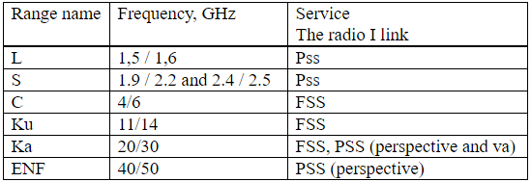

Frequency sharing and interference. Many frequency ranges according to the ITU Frequency Allocation Table and the notes thereto are allocated to several services. This means that these frequency ranges are shared.

The ITU Radiocommunication Regulation defines three categories of allocations: primary, authorized and secondary services. Primary and authorized services have equal rights, with the exception that when preparing frequency plans, the primary service will have priority over the choice of frequencies over the authorized service. Secondary services are not entitled, compared with primary or authorized services, with respect to the possibility of transmitted or received harmful interference. They can only claim protection from other secondary services, the frequencies for which are allocated later. When the frequency range is allocated to one service, it is necessary that the interference between different networks of this service does not exceed the allowable limits. When a band is shared between two or more services, similar methods are used to ensure that stations in secondary services do not interfere with stations in primary services and that interference between stations in services with equal status distributions does not exceed acceptable limits.

Depending on the type of information transmitted, there are distinguished universal multifunctional systems whose AP exchanges different types of information (such as Intelsat, Orbit, Canadian CCC Tel-esat, etc.), and specialized ones for the transmission of one type or not - several homogeneous types of information (for example, the Ekran satellite-based broadcasting system, NTV-Plus for the circular distribution of television and sound broadcasting).

According to the covered territory, location and affiliation of the AP, the management structure of the CCC can be divided into:

- international, which includes stations of various countries; such systems can be global (with worldwide coverage) or regional.

An example of an international global system is Intersput-nick.

International regional systems include such systems as Evtelsat (Europe and North Africa), Arabsat (Arab countries) and others;

- national, all APs of which are located within one country, including zone ones, all APs of which are located within one of the zones (regions) of the country, and departmental (business, company) systems, APs of which belong to one department ( organizations, the company) and transmit only business information and data in the interests of the agency (Bank of Russia Dedicated Satellite Communications Network “Banker”).

29. Describe the principles of building a communication line and broadcasting in a satellite communication system

The main components of a satellite communications system:

- the space segment of the satellite communications system consists of satellites and ground equipment, providing the functions of tracking, telemetry and transmission of telecommands (TTC) and the material and technical supply of satellites.

- earth segment. The term "earth segment" refers to the part of the satellite communications system, which is formed by earth stations used to transmit and receive any kind of communication traffic signals transmitted to and from the satellite and forming a junction with terrestrial networks.

There are currently four major satellite communications network technologies. All of them have their own advantages and disadvantages, and not one of them is universal. To improve the efficiency of work in many modern networks, several technologies are successfully combined at the same time. The main difference between them is the method of using the satellite transponder resource.

Consider these technologies:

- SCPC (Single Channel Per Carrier) is actively used to build small networks with heavy traffic. Each SCPC that implements SCPC has a dedicated constant segment of the capacity of the satellite transponder and maintains a constant connection. The main advantage of this technology is that it guarantees the necessary transmission capacity of the satellite communication channel, and the main disadvantage is the lack of the ability to dynamically redistribute the relay resource between network nodes;

- DAMA (Demand Assigned Multiple Access) provides a satellite relay resource on demand. In networks with DAMA technology, the communication channel is allocated to the user only for the duration of the communication session, which significantly saves the resources of the satellite repeater. The channel structure in this network is similar to the SCPC channel structure. Some implementations of DAMA technology provide the ability to establish connections with different bandwidths for different communication sessions. DAMA is ideal for creating telephone networks with a fully connected topology. The relay resource is distributed by the central station of the network, which can be considered the main disadvantage of the technology, since the functioning of the entire network depends on the state of one station;

- TDMA (Time Division Multiple Access) provides multiple stations with dynamic access to a common channel with time division. Unlike DAMA technology with its sufficiently long connection setup time, such access is provided much faster. However, TDMA network ZSSs are quite expensive, since any of these stations - even with the smallest traffic - must transmit data at a rate equal to the total bandwidth of the time-shared channel. In TDMA networks, a central control station is generally absent;

- TDM / TDMA (Time Division Multiplexing / Time Division Multiple Ac-cess) - a combined network technology with a star topology. In the TDM / TDMA network, the central AP communicates with user stations using one or more fixed TDM channels (with time multiplexing), and user stations access the central AP via TDMA channels. Since all user stations directly interact only with the central MSS, it becomes possible to use rather low-power stations, compensating for the lack of their energy using a large diameter antenna and a powerful transmitter at the central MSS. Due to this imbalance of station parameters, it is possible to significantly reduce the cost of projects with a large number of user stations. The mandatory presence of a central AP (performs the function of a network hub) determines the high requirements for its availability - because the functioning of the entire network depends on the state of this station.

In a TDM / TDMA network, data transmitted between any two user stations passes twice through a relay satellite (“double hop”). In this case, a significant (1-2 s) signal delay occurs, which makes this network less suitable for the use of telecommunication applications that are sensitive to such delays.

Support for the core technologies discussed above is implemented in many modern satellite communications hardware. Very often it makes sense to apply several technologies at the same time on the same network. For example, a combination of TDM / TDMA and DAMA technologies can be recommended for building a large-scale corporate telecommunications infrastructure. The latter of them will provide telephone and facsimile communication, make it possible to organize audio and video conferencing, while using the TDM / TDMA subnet, it will be possible to transmit data.

Satellite transmission systems are characterized by a specific combination of signal processing in the group frequency band, compression, modulation and multi-access.

Multiple access is the ability of several earth stations to transmit their signals simultaneously to the same satellite transponder, which allows any earth station located in the corresponding coverage area to receive signals sent by several earth stations.

And also, the signal sent by one earth station to the repeater can be received by several earth stations located in the corresponding coverage area.

Consider multiple access according to the type of sharing of the repeater. Three main categories correspond to this approach: frequency division multiple access (FDMA), where each station has its own carrier frequency; time division multi-station access (TDMA), where all stations use the same carrier frequency and time division bands; Code Division Multiple Access (CDMA), where all stations are simultaneously, sharing a single band, and the signals are differentiated by code combination.

Of all the methods of multiple access, frequency division multiple access (FDMA) is most widely used in satellite communication systems. FDMA works by issuing different frequencies for each respective earth station, so that the satellite resources are shared between them. This system is currently used for international communications. The harmful effect of such a system is that many signals pass through the satellite’s repeater at the same time, resulting in noise caused by intermodulation between these signals due to the non-linearity of the repeater. In order to reduce intermodulation interference, it is necessary to maintain the output power level at the output much lower than the saturation point. This is called "power reduction." In addition, the transmit power at the output of each earth station must be precisely controlled.

FDMA can be introduced with various modulation-multiplexing methods, such as ChRK-FM (frequency division of channels - frequency modulation), VRK-FMn (time division of channels - phase manipulation) and OKN (one channel per carrier). The most widely used method is ChRK-FM, in which the carrier signals are modulated in frequency by a group-band signal obtained by the frequency combination of channels. The OKN method for each telephone channel uses its own carrier signal of a radio frequency with modulation of FMN and FM; It is suitable for earth stations with a relatively small number of channels.

The use of digital methods such as VRK-FMN and error correction coding, instead of frequency modulation in systems with FDMA, provides an increase in the capacity of the repeater.

Time Division Multiple Access (TDMA) is a digital multiple access method that allows a satellite to receive signals from individual earth terminals at separate non-overlapping time intervals called packets in which information is compressed (for example, PCM telephony) . In this process, the components of intermodulation are not formed in the nonlinear repeater, as is the case with FDMA, since only one signal passes through the satellite relay at this time. Each earth station should determine the time and distance of signal propagation to the satellite and the moment when the signal must be sent so that it arrives at the satellite in the allotted time interval. Figure 1.2 shows a typical network configuration with TDMA, in which each packet of bits with a high signal speed arrives at the satellite at its assigned time interval.

Compared with the FDMA system, the system with TDMA has the following features:

* due to the lack of influence of intermodulation, the repeater on the satellite can work almost in saturation mode, which provides more efficient use of satellite power;
* with TDMA, the capacity does not drop sharply with an increase in the number of stations. The use of CIR (digital speech interpolation) allows you to double the capacity of the transmission system. The INTELSAT-V satellite repeater with a bandwidth of 80 MHz, as a rule, can provide about 1600 channels (without DIR) and 3200 channels (when using DIR) at a speed of 64 kbit / s in the channel.

Introduction of new traffic requirements and its changes are easily ensured by changing the length of packets and their positions.

When working with systems TDMA there are several different problems associated with synchronization.

In order to demodulate the packages of PSK signals, it is necessary to restore non-existent and clock frequencies within the sequence at the beginning of each packet. For this, the TDMA demodulator typically has very high speed circuits for recovering carrier and clock frequencies.

Another critical synchronization problem arises when timing packets at each access station to prevent packets from overlapping in the satellite relay. This control is called packet synchronization, which is performed so that each packet retains a certain distance in time relative to the position of the reference packet (received from the control station) in the satellite relay.

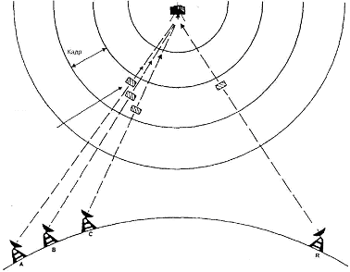

Frame

The position of the currently transmitted packet

Earth Terminals Control station

Figure 1.2 - TDMA Network Configuration

The third category of multiple access systems, in which the signals use the entire bandwidth of the repeater at the same time: these systems use spread spectrum methods, they are called CDMA systems. With this transmission method, a specific code is assigned to each signal transmitted to the satellite. At the reception, from all the received signals, the station extracts the signal intended for it according to the code and extracts the basic information. For this operation, when it is necessary to identify one signal among several others that share the same frequency band at the same time, the correlation method is usually used.

30. Write about the satellite orbits and service areas in the satellite communications system

Orbit is the trajectory of the motion of an artificial Earth satellite.

After the satellite is put into orbit, rocket engines are turned off, and the satellite, like any celestial body, moves by inertia and under the influence of gravitational forces, the main of which is Earth's gravity.

If we accept that the Earth is an ideal ball and only the Earth's gravitational force acts on the satellite, then the satellite’s motion obeys Kepler’s laws known from astronomy. The orbit has the shape of an ellipse (Figure 2.1), in one of the foci (and not in the center) of which the Earth is located. The orbital plane passes through the center of the earth and remains stationary in time. Since energy is not consumed when moving in airless space, the total mechanical energy of the satellite (kinetic and potential) does not change for a long time. This leads to the fact that when moving away from the Earth, the speed of the satellite and its kinetic energy decrease, while approaching the Earth they increase. Equation of the satellite elliptical orbit in the polar coordinate system

r = p / (l + ecosq) (2.1)

where r -is the modulus of the radius vector (i.e., the distance from the satellite to the center of the earth);

q -is the angular coordinate of the radius vector (astronomers call this angle “true anomaly”);

e- is the eccentricity of the orbit;

p = b2 / a = a (1 - e2) - focal parameter;

a, b - major and minor semiaxes of the ellipse.

The eccentricity e can have values ​​in the range 0 <e <1. At e = 0, the ellipse turns into a circle, the foci merge with the center, r = p. The orbit point corresponding to the minimum distance to the center of the earth is called the perigee point of the orbit (r = rп); the maximum point of apogee (r = ra). The angles are counted from the direction to the perigee in the direction of satellite motion, i.e. perigee corresponds to qп = 0, and apogee - qа = 180 °.

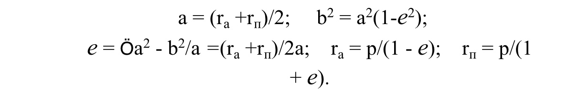The parameters of the ellipse are interconnected by the relations

The focal points of the ellipse are distant from its center by a distance ae. Altitude of the orbit (satellite height above the Earth's surface) H = r - R, where R is the radius of the Earth.

Figure 2.2 - Orbital plane

An important characteristic of the satellite’s orbit is the inclination of its plane to the plane of the Earth’s equator, characterized by the angle i between these planes (Figure 2.2). The inclination distinguishes equatorial (i = 0), polar (i = 90 °), inclined (0 <i <90 °, 90 ° <i <180 °) orbits.

Figure 2.3 - Geocentric system OXYZ

The point at which the orbit crosses the equatorial plane as the satellite moves north is called the ascending node of the orbit (point A in Figure 2.2). The point of intersection of the radius vector with the Earth’s surface, drawn to the satellite’s location from the center of the Earth, is called the sub-satellite.

Obviously, from the sub-satellite point C (Figure 2.3), the satellite is seen at its zenith, i.e. the axis axis of the AP antenna when pointing it at the satellite should

be perpendicular to the surface of the earth.

At any other point N of the earth's surface, the position of the axis NB of the beam of the AP antenna differs from zenith and is characterized by two angular magnitudes: azimuth A and elevation angle g.

Figure 2.3 shows two coordinate systems - geocentric and topocentric.

The OXYZ geocentric system originates in the center of the Earth, the ХОY plane coincides with the equatorial plane, the OZ axis is directed from the center to the north pole, the ОX axis is directed to the spring equinox (in the case of the so-called inertial geocentric system shown in the figure 2.3) or lies in the plane of the initial meridian, for example, Greenwich (then it is a relative geocentric system that preserves the same position relative to points on the Earth's surface); the OY axis complements the system to the right. The topocentric system NxhV has a beginning at point N on the Earth's surface. The xNV plane (tangent to the Earth’s surface at point N, the Nx axis is directed north, that is, along the tangent to the meridian passing through N, the Nh axis is normal to the Earth’s surface, i.e., along the radius ON, in side from the center of the Earth, the axis NV complements the system to the right. The direction from the N point of the satellite is shown in Fig. 2.3 by the NB line. The projection of NV onto the NxhV plane is the ND line, the NBD plane is perpendicular to the tangent plane NxhV.

Now you can define the elevation angle (elevation angle) as the angle BND between the direction to the satellite BN and the projection ND of this direction on the plane tangent to the Earth’s surface, and the azimuth as the angle between the direction to the north Nx and the projection ND of the direction to the satellite on the tangent plane. The position of point N on the earth's surface is characterized by its longitude lN, the angle between the Greenwich meridian plane and the plane of the meridian passing through N and latitude j N, the angle between the radius ON and the equator plane.

Knowing the coordinates of the satellite in a geocentric system, we can calculate the azimuth A and elevation angle g for any point N. In this case, we must take into account the non-ideal surface of the Earth, the height of the point N above the surface of an ideal globe [3]. If we consider the Earth as an ideal ball, the station’s elevation above sea level is zero, with the satellite’s orbital period exactly equal to stellar days, then the azimuth and elevation angle for an AP antenna working with a geo-stationary satellite can be calculated from:

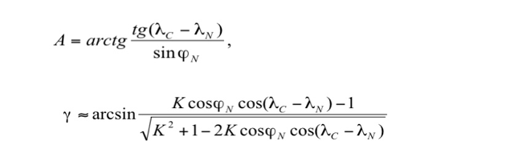

where lс is the satellite longitude;

lN is the longitude of the earth station;

К = Н + RЗ = 42,170 km is the radius of the orbit relative to the center of the Earth;

RЗ = 6.63 thousand km - the radius of the Earth;

H = 36 thousand km - the height of the orbit;

a = A + 1800 for earth stations located in the Northern Hemisphere and satellites located west of the earth station;

a = 1800- A for earth stations located in the Northern Hemisphere and satellites east of the earth station;

a = 3600- A for earth stations located in the Southern Hemisphere and satellites located west of the earth station;

a = A for earth stations located in the Southern Hemisphere and satellites east of the earth station;

g is the geometric elevation angle of the point in the geostationary orbit;

jN is the latitude of the earth station.

By a certain value of the elevation angle you can find the boundary of the satellite visibility zone.

A satellite’s visibility zone is understood to mean the Earth’s surface, from which the satellite can be seen at an elevation angle greater than some acceptable value. In reality, in order to avoid shadowing of the satellite by terrestrial objects, elevations, as well as an increase in noise due to reception of noise radiation from the Earth, the boundary of the radio visibility zone is determined from the condition g> 5 ° or g> 10 °.

The minimum elevation angle is primarily affected by the attenuation of radio signals in the atmosphere (due to heavy rainfall). For frequencies above 10 GHz, the signal attenuation level significantly affects the required elevation angle, transmitter power reserves or system design. For example, a system having a 6/4 GHz band can operate with a minimum elevation angle of 50, while a system with a 14/12 GHz band requires a minimum elevation angle of about 100.

31. Describe the geostationary orbit (GSO) in a satellite communications system

The orbit of the geostationary satellite is circular (eccentricity e = 0), equatorial (inclination i = 0 °), synchronous orbit with a rotation period of 24 hours, with the satellite moving eastward at an altitude of about 36,000 km.

The GSO orbit was calculated and proposed in 1945 by the English engineer Arthur Clark, later known as a science fiction writer, for communication satellites. In England and many other countries, the geostationary orbit is called the Clark Belt.

Most existing CCSs use the geostationary orbit, which is most advantageous for satellite placement, whose main advantages are:

- the possibility of continuous round-the-clock communication in the global service area and the almost complete absence of a frequency shift due to the Doppler effect;

- three satellites are enough to cover almost the entire territory of the Earth;

- no antenna movement system is needed to track the satellite.

The Doppler effect is a physical phenomenon consisting in a change in the frequency of high-frequency electromagnetic waves during the mutual movement of the transmitter and receiver. If the satellite moves in orbit, the Doppler effect will depend on the radial component of the velocity. This effect can also occur when the satellite moves in orbit. On communication lines through a strictly geostationary satellite, the Doppler shift does not occur, on real geostationary satellites it is little significant, and on highly elongated elliptical or low circular orbits it can be significant. The effect is manifested as the instability of the carrier frequency of the oscillations relayed by the satellite, which is added to the hardware instability of the frequency that occurs in the equipment of the onboard repeater and earth station. This instability can significantly complicate the reception of signals, leading to a decrease in the noise immunity of the reception.

The relative change in frequency at the receiver will be equal to

Δf/f0 = V× cosψ / с

where c is the speed of light;

V is the speed of the transmitter relative to the receiver;

Vr is the radial component of the speed of the transmitter relative to the receiver;

ψ is the angle between the velocity vector and the direction of communication.

Geostationary satellites, located at an altitude of about 36 thousand km and moving with the speed of rotation of the Earth, seem to “hang” above a certain point on the earth’s surface, which is located at the equator (the so-called sub-satellite point). In fact, the action of forces associated with the ellipticity of the Earth’s equator, the gravitational attraction of the Sun and the Moon, and also the pressure of solar radiation cause the satellite to drift in longitude and move north and south of the equator along the track in the form of the number “8”. To counter these forces, “station hold” systems are used on board the satellites. The main parameters that determine the angular spacing of neighboring spacecraft in orbit are the spatial selectivity of onboard and ground antennas, as well as the accuracy of spacecraft retention in orbit: the greater the deviation, the lower the potential capacity of the orbit. According to modern requirements, the accuracy of station longitude retention should be ± 0.10.

Communication through a geostationary spacecraft has no service interruptions due to the mutual movement of the satellite and the ground station. The orbital resource of modern geostationary spacecraft is also quite high and is about 15 years.

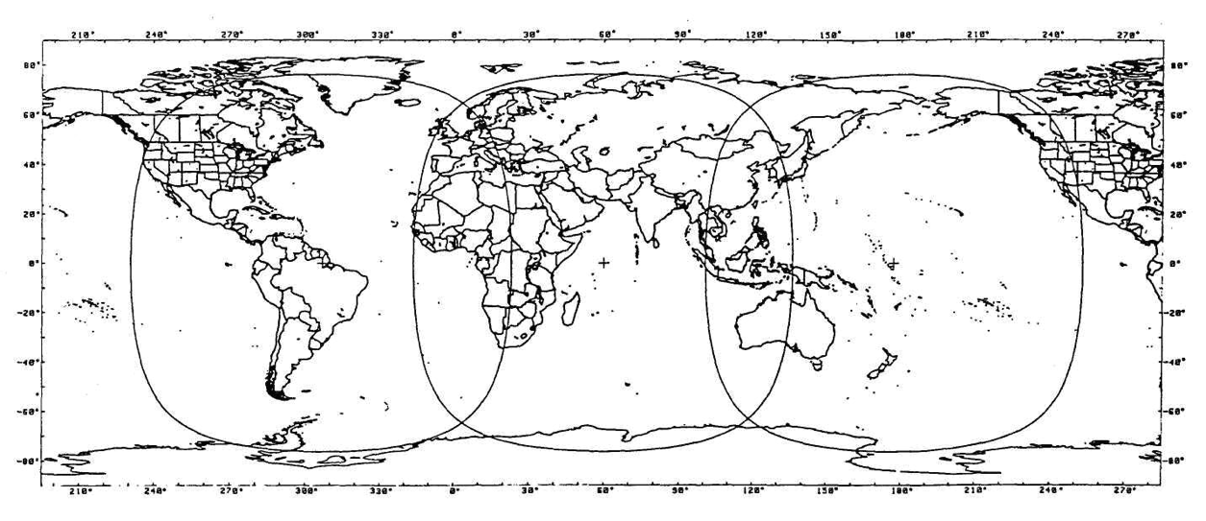

Figure 2.7 - The satellite coverage area of ​​the world on GSO

(The INTELSAT system with three global beams in the regions of the Atlantic, Indian and Pacific Oceans. –Satellite points).

However, such systems have several disadvantages, the main of which is signal delay. Satellites in geostationary orbits are optimal for radio and television broadcasting systems, where delays of 250 ms (in each direction) do not affect the quality characteristics of the signals. Radiotelephone communication systems are more sensitive to delays, and since the total delay in systems of this class is about 600 ms (taking into account the processing and switching times in terrestrial networks), even modern echo cancellation techniques do not always allow for high-quality communication. In the case of a "double hop" (relay through the ground station-gateway), the delay becomes unacceptable for more than 20% of users.

The geostationary spacecraft coverage area does not include high latitude areas (above 76.50 north latitude and south latitude).

The distance of a satellite repeater to a distance of 36,000 km requires high energy costs.

32. Describe the mid-altitude orbits in the satellite communications system

Satellites in mid-altitude orbits were the first to develop companies traditionally producing geostationary spacecraft. Medium-altitude systems provide better service characteristics for mobile subscribers than geostationary ones, since a larger number of spacecraft is simultaneously in the subscriber’s field of view. Due to this, it becomes possible to increase the minimum visibility angles of the spacecraft to 25-300.

So, the radio visibility of two satellites in the ICO system is provided for 95% of the daily time, and at least one of its spacecraft is visible at an angle of more than 300. And this, in turn, allows you to reduce the additional energy reserve of the radio line, necessary to compensate for propagation losses in the near zone (in the presence of trees, buildings and other obstacles in it).

When choosing the location of a non-geostationary orbital constellation (OG), it is necessary to take into account the natural limitations - these are the Van Allen radiation belts, they are grayed out in Figure 2.6. The first stable belt of high radiation begins at an altitude of 1,500 km and extends to several thousand kilometers. The second belt of equally high intensity (10 thousand imp./s) is located at altitudes from 13 to 19 thousand km.

The mid-altitude satellite route passes between the first and second van Allen belts, i.e., at an altitude of 5 to 15 thousand km. The service area of ​​each spacecraft is significantly smaller than the geostationary one, therefore, for global coverage with a single coverage of the most populated areas of the globe and shipping areas, it is necessary to create an exhaust gas of 8-12 satellites. The total signal delay during communication through mid-altitude satellites is not more than 130 ms, which allows them to be used for radiotelephone communications.

Thus, medium-altitude satellites outperform geostationary satellites in terms of energy performance, but lose out to them in terms of the spacecraft’s stay in the radio-visibility zone of ground stations (1.5 - 2 hours).

As for the orbital resource of medium-altitude spacecraft, it is only slightly less than that of geostationary ones. The satellite’s period of revolution around the Earth for medium-high circular orbits is about 6 hours (at an altitude of 10,350 km), of which only a few minutes are in the shadow of the Earth. This makes it possible to significantly simplify the technological solutions used in the onboard power supply system, and, ultimately, to bring the spacecraft life to 12-15 years.

The structure of systems in mid-altitude orbits (ICO, Spaceway NGSO, Rostelestat) differs slightly. In all these systems, the orbital grouping is created at approximately the same altitude (10 352-10 355 km) with similar orbital parameters.

33. Describe the low circular orbits in the satellite communications system.

Systems with equatorial and polar orbits have existed for about 30 years and are used mainly for research purposes, remote sensing, navigation, meteorological observations, photographing the Earth's surface. For the organization of mobile and personal communications, these systems began to be used only in the last 5-7 years. Today, the most intensively mastered are low inclined and polar orbits with a height of 700-1500 km, as well as equatorial ones with a height of 2 thousand km.

Satellites in low orbits have significant advantages over other spacecraft in terms of energy characteristics, but they lose to them in the duration of communication sessions, the coverage area and the active life of the spacecraft. If the satellite’s rotation period is 100 minutes, then on average 30% of the time it is on the shadow side of the Earth. Rechargeable on-board batteries experience approximately 5 thousand charge / discharge cycles per year, as a result of which their service life, as a rule, does not exceed 5-8 years.

The choice of a range of heights from 700 to 2 thousand km for low-orbit systems is not accidental. On the one hand, in orbits with an altitude of less than 700 km, the atmosphere density is relatively high, which causes eccentricity fluctuations and orbit degradation (a gradual decrease in apogee altitude). In addition, a decrease in the height of the orbit leads to an increase in the number of regular maneuvers to maintain a given orbit, therefore, to an increase in fuel consumption.

On the other hand, in orbits above 1.5 thousand km, where the first Van Allen radiation belt is located, long-term operation of electronic on-board equipment is practically impossible unless special methods of protection against radiation are used. The use of these methods leads to a significant complication of on-board equipment and an increase in the mass of spacecraft.

However, the smaller the orbit, the smaller the instantaneous coverage area, therefore, a much larger number of satellites is required for global coverage. If a low-orbit system should provide global communication with continuous service, it is necessary that the orbital constellation includes at least 48 spacecraft. The orbital period of the satellite in these orbits is from 90 minutes to 2 hours, and the maximum spacecraft stay in the radio visibility zone does not exceed 10 - 15 minutes.

34. Describe elliptical orbits in a satellite communications system

The main parameters characterizing the type of elliptical orbit are the period of the satellite’s revolution around the Earth and eccentricity (an indicator of the ellipticity of the orbit). Currently, several types of elliptical orbits with a large eccentricity are used - Borealis, Archimedes, "Lightning", "Tundra" (table 2.2). All of these orbits are synchronous, that is, a satellite launched into such an orbit rotates at the speed of the Earth and has a period of revolution that is a multiple of the time of day.

Table 2.2 - Types of elliptical orbits and their main parameter

|  |  |  |  |
| --- | --- | --- | --- |
| Type of orbit | Height  apogee, km | Period  treatment, h | The number of turns per day |
| Borealis | 7840 | 3 | 8 |
| Archimedes | 28000 | 8 | 3 |
| Lightning | 40000 | 12 | 2 |
| Tundra | 71000 | 24 | 1 |

is characteristic of satellites in elliptical orbit that their velocity at the apogee is much lower than at the perigee. Consequently, the spacecraft will be in the visibility range of a certain region for a longer time than the satellite, whose orbit is circular.

So, the Molnia spacecraft launched into orbit (apogee 40 thousand km, perigee 460 km, inclination 63.50) provides communication sessions lasting 8-10 hours, and the system of only three satellites supports global round-the-clock communication. Elliptical orbits with a lower apogee, for example, Borealis (apogee 7840 km, perigee 520 km) or Archimedes (apogee 26 737 km, perigee 1000 km), are designed to provide regional communication.

The Doppler effect has a negative effect on the operation of satellites in a highly elliptical orbit. For example, for a highly elliptical orbit of the Lightning type, Δf / f0 (2.2) in the perigee region reaches a value of 0.002, therefore, the equipment is switched on only at an altitude of 15 ... 20 thousand km, i.e. 1.5 - 2 hours after the passage of perigee.

Spacecraft with a lower apogee beat satellites in highly elliptical orbits in energy characteristics, losing to them in the duration of the sessions. To ensure continuous round-the-clock communication using synchronous-solar orbits, Borealis will require at least 8 spacecraft (located in two orbital planes, four satellites in each plane). They will allow serving subscribers at angles of radio visibility of the spacecraft of at least 250.

Systems with spacecraft in elliptical orbits are also not devoid of "natural" restrictions. The constant location of the spacecraft in an elliptical orbit is ensured only with two values ​​of the inclination of the orbit plane to the equator - 63.40 and 116.60. This is due to the influence of the inhomogeneities of the Earth's gravitational field, due to which the major axis of the elliptical orbit experiences a torque, which leads to fluctuations in the latitude of the sub-satellite point at the apogee. Another factor affecting the choice of parameters of elliptical orbits is associated with the need to take into account the dangerous effects of the Van Allen radiation belts, which the spacecraft inevitably crosses during its orbit.

35. Describe the space segment in the satellite communications system

The space segment of the satellite communications system consists of satellites and ground-based equipment that provide the functions of monitoring, telemetry and telecommand (TTS) and satellite logistics.

The satellite subsystem, known as payload or onboard repeater, includes all communication repeaters and antennas.

The equipment supporting the normal operation of the SPACECRAFT main subsystems for spatial orientation, thermal control, telemetry control, navigation (GPS/GLONASS receivers, etc.) is structurally not part of the payload, but belongs to the space platform.

36. Describe space platforms in a satellite communications system

The space platform is the basic part of the SPACECRAFT on which the payload (on-Board relay complex), the power supply substation and the on-Board control complex are distributed, ensuring the normal operation of the SPACECRAFT during orbital flight during the entire period of its active existence.

The onboard control system consists of several subsystems. One of them provides the correct orientation and stabilization of the satellite in space. It is known that the effective mode of operation of solar panels and radio lines depends on the direction of the solar panel (they should always be oriented to the Sun) and antenna systems (all-Gda directed to the Earth).

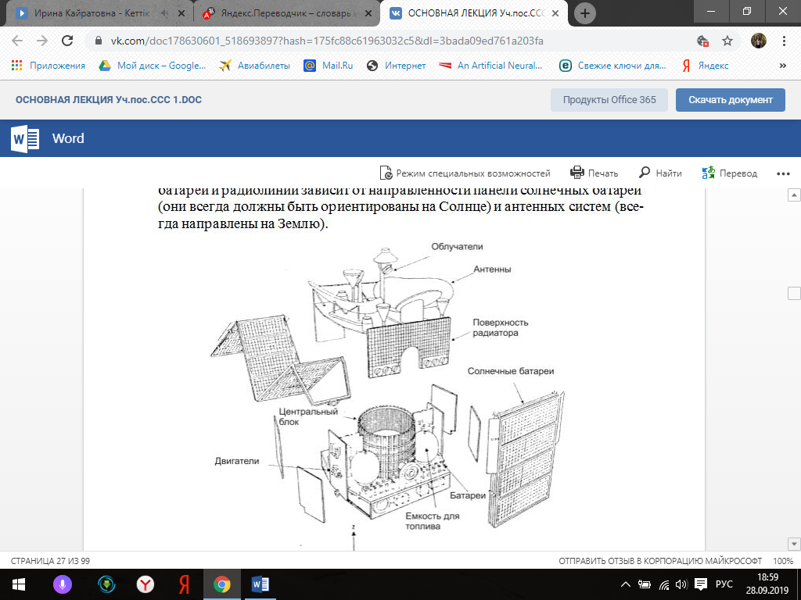

Figure 3.1 - Satellite FSS (expanded view). Telecom I

The onboard control system also contains a telemetry system. The telemetry and telecontrol system is designed to monitor and control the operation modes of all CS systems and transmit this information to the CS. The rate of transmission of information on the command and telemetry radio lines is usually from a few hundred bits to 100 kbit / s.

Important functions are performed by the thermal control subsystem, which ensures the maintenance of the thermal regime of the payload (satellite equipment) within the specified limits. The usual operating temperature range of onboard equipment is from -20 to + 50 C

The main characteristics of the platform are its weight and size, the power of the on-Board power supply system (BOT) and the period of active existence (SAS).

The mass of the space platform is characterized by at least four indicators:

- the launch mass (mass at launch) is the mass of the entire SPACECRAFT (space platform) together with the payload and fuel reserve;

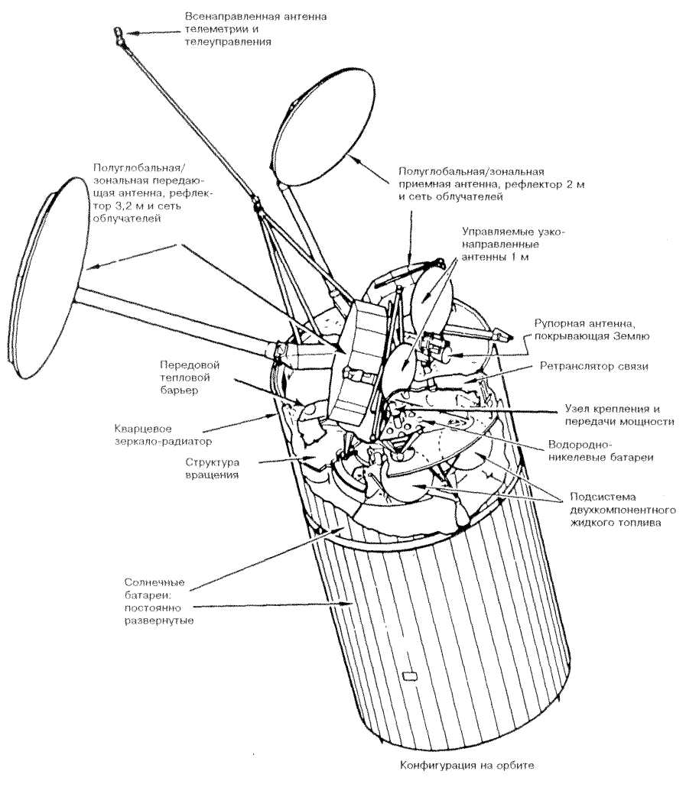

Figure 3.2 - Intelsat VI satellite (rotation stabilization)

- the mass of SPACECRAFT in orbit (mass in orbit) - depends on the type of space platform. If special propulsion systems are installed on Board the satellite, which require a fuel reserve, the mass can be determined both for the beginning of the active life (BOL, beginning of life) and for its end (EOL, end of life);

- dry mass (dry mass) is the mass of SPACECRAFT without fuel;

- payload mass-includes the mass of an onboard relay complex with buffer power supplies and an antenna placed on a space platform.

The term of active existence of the platform is defined as the time of SPACECRAFT operating time for failure or degradation of its main characteristics (reduction of communication channel capacity, etc.).

37. Write about the on-board relay complex in the satellite communications system

The complex of relay equipment that a spacecraft puts into orbit is called a payload or on-Board repeater.

The structure of the onboard relay complex (brtc) is determined by its purpose, or the scale of coverage of territories (global or regional communication), the method of information processing on Board the CS, the number of relay channels (receiving, transmitting or transmitting), the speed of information exchange, as well as the selected technical solutions and technologies used. The brtc may include not only so-called subscriber repeaters (intended for the formation of "consumer" rays), but also re-translators of feeder and/or inter-satellite lines (service communication).

Inter-satellite lines provide communication between SPACECRAFT in adjacent positions in the same orbit or in adjacent orbits. It is implemented in low-orbit systems (Iridium).

The payload subsystem must be reliable enough for the satellite to perform its tasks, which implies adequate back-up capabilities of the system. The choice of launch vehicle and the characteristics of the spacecraft impose limitations on size, mass and electrical power consumption. The requirements for compatibility with other satellite subsystems, including design, power supply, thermoregulation, telemetry, remote control, distance measurement, position control and their electro-magnetic compatibility under operating conditions, should also be taken into account.

Types of repeaters

Repeaters without signal processing on Board

Basically, satellite repeaters receive different communication signals, amplify them, convert their frequencies and transmit back.

Both broadband and divided into channels of construction of repeaters can be applied. Most of the existing satellite re-translators in the fixed satellite service are built on the basis of broadband receivers and subsequent channel transmitters.

With regard to connections between different RF channels (radio frequencies), there are two main cases, depending on whether the repeaters are connected to one or more transmission beams.

Consider a simple case where the received signal is sent to only one transmitting beam. Signals in the receiving band are amplified and translated into the transmission band. Two types of frequency conversion can be used:

- unified system that converts the frequency bands of reception directly in frequency the transmission bands ;

- a dual conversion system in which the frequencies of the received signals are first converted to intermediate frequencies for partial amplification and then converted back to the frequencies of the transmitted signals.

The block diagram of the onboard repeater with direct frequency conversion for the 6/4 GHz band is shown in figure 3.4.

Frequency conversion in this repeater is carried out once. For frequency conversion, a mixer (Cm) is used, to which a signal from a highly stable heterodyne is applied. The gain provided by this unit is indicated in parentheses. Amplification is provided by two series-mounted amplifiers. 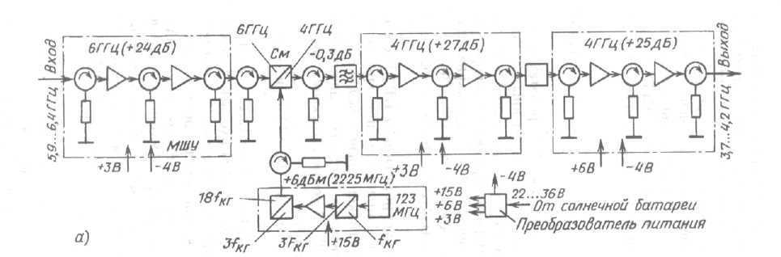

Figure 3.4 - Block diagram of the onboard repeater with direct frequency conversion.

The second type, that is, double conversion, is sometimes preferred because of the following advantages:

- eliminates potential instability due to the feedback in the amplifier circuit with high gain;

- excluded components of crossmodulation or harmonics to adopt Maemo signals and the local oscillator of the frequency Converter within the frequency band of the useful signal;

- is provided by the intermediate frequency, convenient switching and cross-connections between the payloads operating in different frequency bands of transmission and reception. The disadvantage is that two heterodynes and two frequency converters are required.

The repeater provides approximately 100-110 dB of gain (maybe even more, 120 dB on broadcast satellites) in two stages: low-level gain in the wideband receiver, followed by high-level gain in the power amplifiers in the channel-split subsystem. Attention should be paid to electromagnetic compatibility (EMC) due to the use of high gain factors and wide bandwidths.

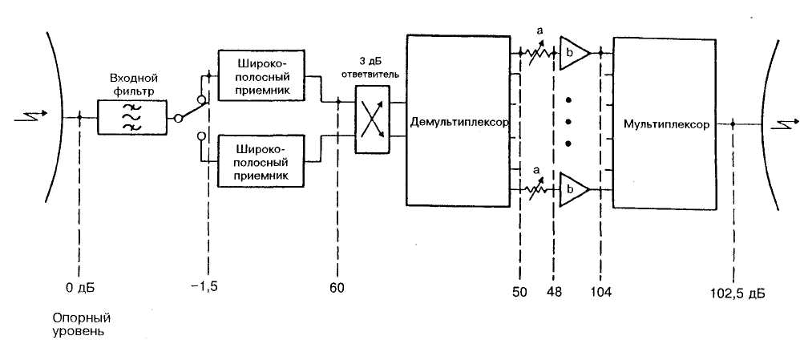

Figure 3.5 - A typical diagram of relative levels in the repeater. a: switchable attenuator; b: high power transmission amplifier

38. Explain and describe the launch of the satellite in the satellite communications system

Launch vehicles and spacecraft. Reliable delivery of spacecraft (SC) into orbit is a complex matter and involves significant financial costs. Thus, putting one SPACECRAFT into geostationary orbit can cost $ 45-200 million., which is a significant part of the cost of the entire project.

Currently, the choice of a particular launch technology is usually determined by three factors: the cost of launch, reliability and technical capabilities of the missile.

The market for rocket and space technology is very extensive. It presents both traditional disposable carriers such as ELV (expendable launch vehicle), and rockets created by new technologies, such as RLV (reusable launch vehicle) - reusable means of launching satellites to or-bit.

The criteria for selecting launch vehicles are usually the purpose of the satellites, the payload mass, the requirements for the design of the SPACECRAFT, and, accordingly, the method of its delivery to orbit.

Depending on the mass of the payload carriers are divided into classes: heavy and light. Heavy able to output in any Orbi-the satellites with a payload exceeding 1 tonne Rockets light class-sa is intended primarily for output SPACECRAFT in low earth orbit. Members of a family of launch vehicles (modifications of the same series) may differ in design number of stages (usually from 2 to 4) or the type of upper stage.

As for the methods of delivering satellites into orbit, they are also not-how many. Traditional launch methods are from open-air launch sites and from mine launchers. In the near future, launches from sea or air launch facilities may constitute a serious contention for them. An important role is also played by the method of launching the SPACECRAFT into orbit.

Today, the most commonly used scheme is the following: first, the satellite is put into a reference orbit (the so-called geostationary transition orbit - GTO), and from it the energy optimal flight to a given orbit is carried out. It should be borne in mind that this scheme can be implemented only in the presence of a special propulsion unit or upper stage as part of the launch vehicle with the possibility of at least twofold activation of the main engine in zero gravity.

The "direct" scheme of launching SPACECRAFT into orbit is energetically less profitable.

Accuracy characteristics of the delivery of the satellite at the estimated point of or-bits is now quite high: the error positioning KA on you-cell may be 5-15 km, and the error of the inclination is usually not more than 0.05-1°.

Heavy-class launch vehicles include such families as Ariane, Delta, Atlas, Long Mach, proton and Zenit (tabica 3.4). They provide a launch to geostationary, medium and low okolatem-wide orbit as single satellites and groups of KA.

A group launch, in which up to 12 satellites are simultaneously launched into orbit, is the most effective, since it reduces the cost of creating an orbital grouping, as well as the total load on the launch complex.

Figures 3.13 and 3.14 show the launch vehicle and the payload placed on it: KazSat and Express AM.

In addition, stricter requirements for the number of missile launches is of great importance for the ecology of space and the planet (to solve the problem of "space debris").

The Ariane launch vehicle from the very beginning was conceived as a "European", i.e. providing satellite launches for European countries. In her co-building was attended by many leading aerospace companies: Aerospatiale (France), Matra Marconi Space (England, France), Fiat-BDR Difea Spazio (Italy), DASA (Germany).

In June 1988, Ariane 40 was launched, which belongs to the 4th generation of launch vehicles. Currently, almost half of all commercial launches are carried out with its help.

Table 3.4-heavy-duty launch Vehicles

|  |  |  |  |  |
| --- | --- | --- | --- | --- |
| Type of booster* | First-run | Max. load for different orbits, kg | | Cost, million dollars |
| LEO | GTO/GEO |
| "Протон-К" (Россия) | 11 апр. 1994 г. | 20000 | 3900/2600 | 65 |
| Ariane 5 (ESA) | 4 июня 1996 г. | 18000 | 6800 | 125 |
| Delta III (США) | 27 авг. 1998 г. | 8346 | 3810 | Нет данных |
| H2A222 (Япония) | После 1999 г. | 18000 | 7500 | Нет данных |
| Long March CZ-3B (Китай) | 14 февр. 1996 г | Нет данных | 4850 | 70 |
| Titan 4B (США)2 | 23 февр. 1997 г | 21640 | 18600/8620 | 350 |
| Note  1 the country in which the manufacturing company is registered is indicated in parentheses.  2 the most expensive booster. | | | | |

Development of Delta carriers has been conducted since the mid-50s by McDonnell Douglas (USA). The first launches (since 1960) production were mainly in the interests of the military departments and Federal services of the United States, and the commercial launch took place in August 1989 RA-chum family Delta as one of the most reliable. The most famous mi-re RN Delta II model 7925 helped to launch 24 satellites of the GPS, 50 KA 8 Iridium and Globalstar. Russian rocket "proton" created GKNPTs them M. V. Khrunichev. It provides a sufficiently high reliability of starts-0.96 (data for the last 10 years). "Proton" brought into orbit Russian satellites Gorizont, gals, Express, foreign Aaiasat 3 satellites, Astra 2A, 4 Echostar, Panamsat 8 and 21, the satellite Iridium (3 starting at 7 KA), etc. All launches carried out from the cosmodrome "Baikonur".

Small-capacity launch vehicles are designed for the creation of low-orbit groups. They perform both group and single runs. Light low-orbit satellites can be launched into orbit using traditional fixed or mobile launch kits, including from aircraft. Since the launch of light satellites does not require significant material costs, it is such satellites that countries that do not have their own spaceports prefer to use.

A geostationary satellite is usually launched by a multistage rocket through an intermediate orbit. Modern RA-keta-carrier is a complex space flying APPA-rat, which is driven by the reactive force of the rocket propulsion.

The structure of the launch vehicle includes a missile and head units. The rocket unit is an Autonomous part of a composite rocket with a fuel compartment, propulsion system and elements of the stage separation system. The propulsion unit includes a payload and a fairing that protects the design of the spacecraft from the force and thermal effects of the incoming air flow during flight in the atmosphere and serves for mounting on its inner surface elements that participate in the preparation for the launch, but do not function in flight. The main fairing makes it possible to simplify the design of the spacecraft and is a passive element, the need for which disappears after the launch vehicle exits the dense layers of the atmosphere, where it is discharged. The payload of the spacecraft consists of relay communication and broadcasting equipment, radio telemetry systems, the actual spacecraft body with all auxiliary and supporting systems.

The principle of operation of a one-time multi-stage booster is as follows: while the first stage is operating, the rest can be considered together with the true payload as the payload of the first stage. After its separation, the second one begins to work, which together with the subsequent stages and the true payload forms a new independent missile. For the second stage, all subsequent (if any), together with the true payload, play the role of a payload and so on, that is, a payload. its flight is characterized by several stages, each of which is like a stage for the message initial speed of another single-stage missile within its co-becoming. Rejection of the first and subsequent stages of the carrier is carried out after complete combustion of fuel in the propulsion system.

The path that the launch vehicle passes when launching the spacecraft into orbit is called the flight path. It is characterized by active and passive areas. Active leg of the flight - a flight of steps of the carrier with the engine running, passive part - the flight of spent RA-chetnych blocks after the separation from the launch vehicle.

The time and place of the launch vehicle launch play an important role in placing the spacecraft into the appropriate orbit. It is estimated that the cosmodrome is more advantageous to be located as close as possible to the equator, since when accelerating in the Eastern direction, the launch vehicle receives an additional velocity. This speed is called the circumferential speed of the cosmodrome VC, i.e. the speed of its movement around The earth's axis due to the daily rotation of the planet.

For a particular latitude  speed of the cosmodrome V is determined by a formula that is on the equator it is equal to 465 m/s, and at the latitude of the Baikonur cosmodrome - 316 m/s. Practically, this means that at the equator the same booster can be started heavier satellites.

The final stage of the launch vehicle flight is the launch of the satellite into orbit, the shape of which is determined by the kinetic energy reported by the rocket, that is, the final speed of the carrier. In the event that a satellite is given enough energy to be taken to GEO, the launch vehicle must take it to a point 35,875 km away from Earth.

The orbital velocity of the geostationary satellite is easy to calculate. You honeycomb GEO above the Earth surface of 35 786 km, the GSO radius 6366 km (the average radius of the Earth), i.e. 42 241 km by Multiplying the radius value of the bonds on 2 (6,28), get the length of the circumference 265 of 409 km If you divide it into the length of day in seconds (86 400 s), we get the orbital speed of the satellite is - an average of 3,075 km/s, or 3075 m/s.

Typically, the satellite launch vehicle is carried out in four stages: exit to the initial orbit; exit to the orbit of "waiting" (Parking orbit); exit to the transition orbit; exit to the final orbit (figure 3.15)

Figure 3.15 Phase (phases) a practical scheme of removing satellites 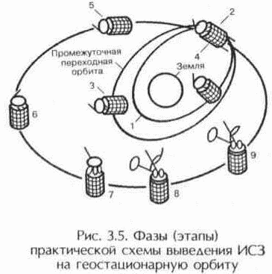

in geostationary orbit

1-initial transition orbit;

2-first activation of apogee engine to enter intermediate transition orbit;

3-determination of orbital position;

4-second activation of apogee engine to enter initial drift orbit;

5-reorientation of the orbit plane and error correction;

6-orientation perpendicular to the orbit plane and error correction;

7-stop the satellite platform, opening panels, full undocking with the rocket;

8 - erection of antennas, the inclusion of gyrostabilizer;

9 - stabilization of the position: the orientation of the antenna on the desired point on the Earth, orientation of solar panels in the Sun, the inclusion of airborne Retrans-tor and the establishment of the nominal operation mode.

39. Explain and describe the earth segment in a satellite communications system

The term "earth segment" refers to the part of a satellite communications system that is formed by earth stations used to transmit and receive any kind of communications traffic signals transmitted to and from the satellite and forming a junction with terrestrial networks.

The main element of the earth segment is the Earth station (AP), which is the terminal transmitting and receiving link of a communication line via satellite.

The various types of communications and services that the equipment of the earth segment should provide, have predetermined a huge number of technical solutions necessary for the implementation of specific tasks.

The nomenclature of earth stations and terminals is very extensive. There are two reasons for this diversity:

- More than 100 major manufacturers of communications equipment for satellite systems are represented on the world market (with the advent of personal satellite communications, leading companies traditionally producing equipment for cellular and trunking networks, such as Alcatel, Ericsson, Motorola, Panasonic and other);

- an extremely wide range of services (voice, data, video, etc.) and various purpose of the AP, and hence the variety of their design (stationary, portable, automobile, rail, sea, airplane).

In addition, earth stations differ in their role in the structure of the earth segment: trunk, VSAT stations, as well as interface nodes and coordinating stations that provide for the organization of communications in the region. Depending on the method of organizing communications, earth stations are divided into:

- receiving stations of distribution systems (receiving stations of television and television broadcasting for individual and collective use and pagers);

- transmitting stations (satellite broadcasting systems, beacons and radio beacons);

- transceiver (including central control station, HUB and gateways);

- control - stations that monitor the operation mode of the space station repeater, over the observance by the earth stations of the network of the most important parameters: radiated power, operating frequencies, etc .;

- Earth stations of the satellite control and monitoring system — stations that control the operation of the entire space segment (space station).

The lock station (gateway) consists of several transceiver complexes (usually at least three), each of which has a tracking parabolic antenna.

Transceiver complexes operate as follows:

- The 1st complex enters into communication with the i-th spacecraft;

- the 2nd complex enters into communication with the i +1 th spacecraft;

- then the 1st complex, after leaving the visibility of the 1st spacecraft, enters into communication with the i + 2nd spacecraft;

- the 2nd complex, after leaving the zone i + 1 of the spacecraft, enters into a relationship with the i + 3th spacecraft, etc.

- The 3rd complex, as a rule, is in reserve and, if necessary, can replace the 1st or 2nd complex.

Another classification of the AP by belonging to the type of satellite service: fixed - FSS, broadcasting - RSS or mobile - MSS.

In many respects, the structure and characteristics of the spacecraft will depend on the type of orbit of the spacecraft with which the given spacecraft works (GEO, MEO, LEO), and the corresponding degree of distance of the spacecraft from the repeater.

APs for the 6/4 GHz and 14 / 11-12 GHz bands are often classified only by the size of their antennas:

- Large stations: antennas from about 33 m to 15 m;

- middle stations: antennas from about 15 m to 7 m;

- small stations: antennas from about 7 m to 3 m or less;

- Microstations for VSAT networks: antennas from 4 m to 0.7 m.

40. Write the main characteristics of the AP in the satellite communication system

The general block diagram of a typical satellite communications satellite is shown in Figure 4.1.

The station includes the following main subsystems:

- antenna system;

- low noise receiver amplifiers;

- transmitter power amplifiers;

- communication equipment (frequency converters and modems);

- sealing / decompression equipment;

- equipment for connecting to a terrestrial communication network;

- auxiliary equipment (control and monitoring equipment, measuring equipment, service channel equipment);

- power supply equipment (network power supply with redundancy and uninterruptible power supplies);

- general-purpose infrastructure (all premises, buildings and structures).

Figure 4.1 - General block diagram of a typical satellite communications satellite

Consider a brief information on the subsystems of the AP.

ZS should be designed in such a way that high-quality indicators, and therefore the cost of the subsystems included in the station, correspond to each other. Low-noise amplifiers (LNAs) of the ES receiver are necessary in order to receive a very weak signal from the satellite. At present, LNAs with an effective noise temperature of 45 K at 4 GHz and 150 K at 11 GHz are quite acceptable (achieved under stabilization at ambient temperature). The LNA is usually broadband: it amplifies simultaneously all carriers coming from the receiving port of the antenna diplexer. Typically, a backup amplifier is also installed (1 + 1 redundancy).

The receiving device pre-amplifies the signals using the input low-noise amplifier (LNA) and converts them to an intermediate frequency. A design feature of the main LCs is the location of the LNA not in the main room, but next to the antenna feed, which reduces losses in the feeder path and thereby increase the sensitivity of the station. In modern LNAs operating in the C and Ku bands (bandwidth from 500 MHz to 1 GHz), the equivalent noise temperature is 50-150 K, and the gain is 30-40 dB.

The output power of the transmitter is up to 1 W, 1 kW for a television carrier. Two types of microwave devices are used in power amplifiers ЗС - traveling wave tubes (TWT) and klystrons.

For small stations of small capacity, it may be sufficient to use solid-state amplifiers on transistors with a field effect. Currently, the output power of this type of amplifier on the market is several watts, but it can be expected that an improvement in the parameters of transistors or other solid state devices will lead to their widespread adoption at small stations.

The main advantage of klystrons is high stability and low noise level, while TWT provides a large (compared with them) bandwidth. In amplifiers with a power of 0.5-1 kW, they usually use TWT, and in more powerful (1-3 kW) - klystrons.

Connected equipment is usually equipment that modulates the microwave carrier with low-frequency signals (group frequency band) for radiation and extracts (demodulates) these low-frequency signals during reception. Communication equipment consists of frequency converters, modulators and demodulators, signal processing equipment. Signal processing is required, in particular, when using multiple access with time division multiplexing (TDMA). Digital data stream is being formatted: on the transmitting side, this equipment converts a continuous input digital data stream for transmission via satellite using a modulator. This data is entered into the system frame with TDMA, for which it is converted (using the buffer memory) into a very fast data stream consisting of short packets entered into the frame. Thus, a station can transmit packets to a number of addresses in the same way as a multicast carrier in the case of FDMA.

Even if all the transmissions are analog and the interface to the terrestrial network is also analog, the compaction / decompression operations are almost always required due to the need to change the distribution of telephone channels (for example, primary groups) within the group frequency band. In digital satellite transmission, the telephone signals to be transmitted, or more often the standard group signals received from the terrestrial network, are regrouped and converted into a data stream for transmission from the station (for example, after grouping into packets for transmission using the TDMA method). At the reception, the reverse process is used to isolate the streams destined for the given station (from packets transmitted by corresponding stations in the case of transmission using the TDMA method).

In the case of telephony, the earth station is usually connected to the terrestrial network through a switching center. This can be a transit center in the case of an international station, or a large or medium-sized national network station, or, possibly, a telephone exchange in the case of small local stations of national networks.

Specific equipment that is usually required for such a connection:

- land line between the earth station and the switching center. A coaxial cable can be used on this line, although more often according to the terrain it is necessary to use a radio relay line;

NOTE In the case of small stations in the national network, the station and the switching center can be located on the same site,

- echo cancellers (or echo cancellers) and various peripheral signaling equipment.

In the case of television, the earth station is connected:

- with the studio where the program is being formed, while performing the transfer functions;

- with a local broadcast transmitter when performing reception functions.

The connection is usually made using a radio link. Small receiving stations are often directly connected to the local television distribution network.

The auxiliary equipment of the AP consists of: control and monitoring equipment; measuring equipment; service channel equipment.

Uninterrupted operation of a power supply unit primarily depends on the correct design of power sources (this is usually a network power source, with the possibility of redundancy and an uninterruptible power supply (UPS)). For large stations, the UPS power can reach 50 - 100 kVA.

The general-purpose infrastructure of the AP includes all premises, buildings, structures and services. Its dimensions depend on the type of station and the number of antennas used on it.

The main characteristics of the AP should include:

a) frequency ranges for reception and transmission.

AP operate at frequencies allocated to satellite communications systems.

Most earth stations of satellite communication systems (SSSS) operate in the 4 and 11 GHz bands for reception and 6 and 14 GHz for transmission, which corresponds to the accepted symbols C and Ku.

  The allocation of frequency bands between various radiocommunication services is dealt with by the International Telecommunication Union (ITU). Currently, such a allocation of frequency bands is made from 9 kHz to 275 GHz. In addition to radio services, the allocation of frequency bands also provides for the division of the globe into 3 Regions:

1) Region 1 (Europe, Africa, Russia, Kazakhstan, Mongolia, etc.);

2) Region 2 (North and South America);

3) Region 3 (Asia, Oceania, Australia);

b) the quality factor of the station for receiving GA / T (measured in dB / K), GA is the gain of the receiving antenna, T is the effective noise temperature of the receiving path. The values ​​of Q-factors for reception for ES are in the range of 20 ... 40 dB / K;

The quality factor is calculated by the formula

GA / T = 10 * log (GA / T), dB / K.

c) the diameter of the antenna DA determines the size and cost of the ES, its spatial selectivity.

The range of diameters is very wide (from about 0.45 m to 32 m).

In addition to the diameter of the antenna, it is important to know the polarization characteristics of the antenna, the characteristic of the side lobes, a full-circle antenna that can be sent to any point in the sky, or part-turn (limited guidance area), or fixed (for working with geostationary satellites).

At present, VSAT type (Very Small Aperture Terminal) - a terminal with a very small diameter antenna is widespread;

d) effective radiated isotropic power (EIRP) is the product of the transmitter power, the efficiency of the waveguide path and the antenna gain.

The values ​​of this parameter for various SSSS are in the range of 50 - 95 dBW.

In contrast to airborne antennas, in which the shape of the radiation pattern must be “consistent” with the served earth's surface (global, narrow, profiled beam, etc.), antenna antennas of the main grounding stations do not have such requirements, since they are oriented strictly towards specific spacecraft.

The main parameters of the antennas are: amplification, effective aperture area (aperture), radiation patterns and beam width, side lobes, polarization and noise temperature.

The antenna noise temperature (or “antenna temperature”) should be kept as low as possible by appropriate

design for high quality.

The ZS antenna transceiver system includes a reflector (mirror), an irradiating system, a waveguide path (VT), a rotary support device with drive equipment and guidance equipment.

At the AP, mirror types of various types are used. Since these antennas have high antenna gain, low levels of side lobes, good polarization cleanliness, low noise temperature and good matching of impedances are maintained throughout the wide frequency band for reception and transmission. For example, in the 6/4 GHz band of INTELSAT-VI, the total antenna band starts at 3.625 and goes up to 6.425 GHz (more precisely, from 3.625 to 4.2 GHz, plus the range from 5.850 to 6.425 GHz).

41. Describe station in the international communications system INTELSAT

To enter a new earth station into the INTELSAT Global Communications System, that is, to service international traffic, the concerned administration should refer to the general document of the INTELSAT system called Procedures governing the use, approval, verification and operation of earth stations in the INTELSAT system Eight standard types of earth stations are allowed to work in the INTELSAT Global System, although other (“non-standard”) types (for temporary work) on an individual basis can be taken into consideration. pecifications requirements Intelsat system, these eight types of stations designated as standards A, B, C, D, E, F, G and Z.

The main characteristics of APs corresponding to various standards are given in Table 4.2.

In the technical conditions, the requirements for the composition and parameters of the antenna system are defined.

The gain of the antenna system for transmission should be more than 52.65 dB, and for reception - more than 50.52 dB. The antenna system together with the waveguide path must provide isolation between the

receiving and transmitting paths of at least [80 + Pp], where Pp is the transmitter power, dBW. AP transmitters must provide the transmission of one or more

bearing in trunks allocated for work. Operating frequencies are determined by the system and satellite used. The operating range of the transmitter — the main characteristic of the ES — determines the requirements for the possibility of tuning the modulator and the upconverter. The maximum level of spurious emissions should be no less than 50 dB lower than the level of the main signal, but not exceed 100 mW.

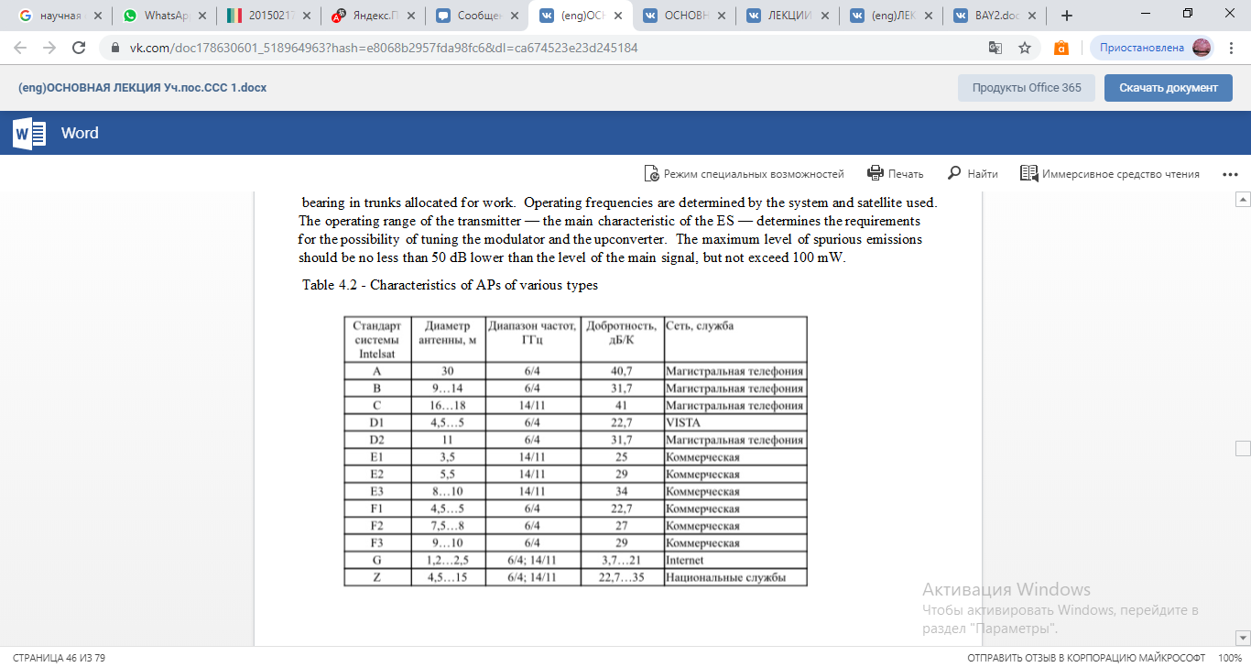

AP receivers should provide reception of one or several non-existent trunks allocated for operation. The operating frequency range of the receiver is the main characteristic of the station and determines the requirements for tuning the demodulator and the buck converter. The selectivity of the receiver on the adjacent and mirror channels should be at least 30 dB and 50 dB, respectively. The output signal level of the demodulator should be in the range from minus 35 to minus 5 dBm.

The AP modem is interfaced with channel-forming equipment (COA) at the joints in accordance with ITU-T Recommendations G-703 and G-704. As part of the KOA, the use of information protection equipment is allowed. The standards for various types of terminal equipment (transcoder, transmultiplexer, codec) are determined by ITU-T Recommendations.

The characteristics of the channels being organized must comply with the requirements of international documents (ITU-R and ITU-T), interstate and state standards.

42. Describe the earth stations of regional or national systems

Several types of earth stations are intended for regional and national use. The choice of one type or another depends on the general organization of the system and on the characteristics of the connected payload of the satellite. These stations, which typically use medium-sized antennas, can be divided into categories according to the following criteria:

a) stations operating through the space segment - 6/4 GHz trunks leased on INTELSAT satellites.

These stations are usually similar to standard B stations (see table 4.2,), but with the following differences:

- the diameter of the antenna is usually from 7 to 15 m;

- communication modes (modulation and compaction methods) can be different and are usually chosen in order to optimize the operation of the entire system. In particular, telephony is usually transmitted using the OKN-FM method with companding or PDA-FM (with or without companding).

Specific options for optimizing the transmission parameters and the energy budget of communication lines allow the use of cost-effective medium-sized earth stations for the transmission of a fairly large number of channels.

To make it easier to obtain approval from INTELSAT, it is recommended that these stations meet the specifications of the new “standard Z” of INTELSAT to earth stations.

Z standard stations operate in the 6/4, 14/11 or 14/12 GHz bands. The antennas of national earth stations can have different sizes in a wide range, and the minimum requirements are presented to the owner of the earth station. The following parameters are not included in the required characteristics of the stations (see table 4.1): maximum eirp on the carrier; modulation method; G / t; transmission gain; channel quality.

b) stations operating in the 6/4 GHz bands within dedicated satellite systems, such as the Indonesia PALAPA system, the ARABSAT system and others: these stations are also often similar to INTELSAT standard B stations. The reason is that the required limited land coverage allows for high eirp trunks operating on directional satellite dishes. Due to this, a large number of channels can be transmitted during operation to rather simple earth stations equipped with medium-sized antennas;

c) stations in the 14/11 GHz bands: the 14/11 GHz (14/12 GHz) bands are increasingly being used for regional and national satellite systems.

The EUTELSAT system is an example of a regional system whose operation is based solely on the use of these ranges.

**43. Describe VSAT earth stations**

VSAT (Very Small Aperture Terminal) station - a satellite communications station with a small diameter antenna, on the order of 0.45 ... 2.4 m. VSAT stations are used to exchange information between ground points, as well as in acquisition systems and data distribution. CCC with a network of earth stations such as VSAT provide telephone communications with digital voice transmission, as well as the transmission of digital information.

The class of earth stations VSAT (Very Small Aperture Terminal) includes satellite communication stations, the technical characteristics of which satisfy the following requirements of Rec. ITU-R S.725 “VSAT Technical Specifications” [ITU VSAT Systems and Earth Stations Handbook, 1994]:

- control and management of VSAT stations in the network is carried out centrally, but local station monitoring and control systems can be additionally used;

- VSAT stations belong to the Fixed Satellite Service (FSS) and must satisfy the requirements of the Radio Regulations and ITU-R Recommendations, like all FSS earth stations;

- VSAT stations are usually used in dedicated networks (private, business) to transmit data and telephony in digital form in operating modes only for reception (simplex) or for reception / transmission (duplex);

- VSAT antennas usually have a diameter of 1.8 ... 3.5 m, but in separate systems large antennas (up to 6 m in diameter) can also be used;

-data transfer rate in digital form from VSAT stations usually does not exceed 2 Mbps;

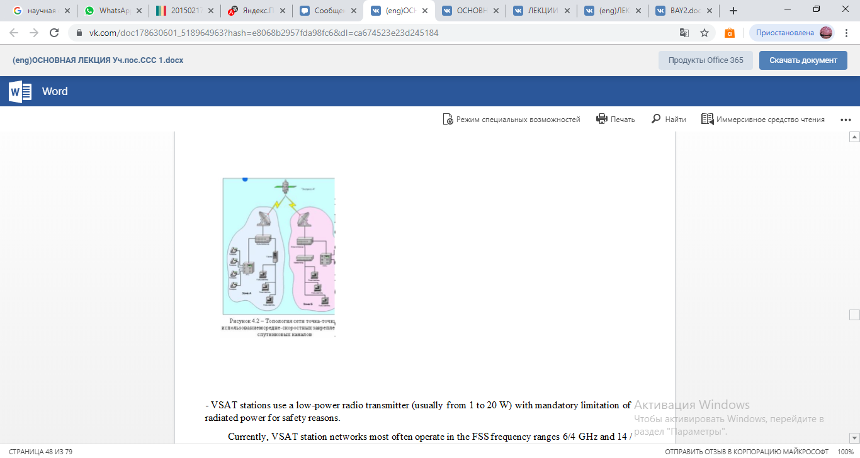

- VSAT stations use a low-power radio transmitter (usually from 1 to 20 W) with mandatory limitation of radiated power for safety reasons.

Currently, VSAT station networks most often operate in the FSS frequency ranges 6/4 GHz and 14 / 11-12 GHz.

The technical parameters of VSATs during transmission should satisfy the requirements of the following ITU-R Recommendations:

Rec. ITU-R S.726 “Maximum permissible spurious emissions level VSAT”;

Rec. ITU-R S.727 “Cross-polarization isolation for VSAT”;

Rec. ITU-R S.728 “Maximum permissible level of off-axis density of the EIRP VSAT”;

Rec. ITU-R S.729 “Monitoring and control of VSAT stations”.

An attractive feature of VSAT stations is the possibility of placing them in close proximity to users, which, due to this, can do without land lines.

By design, a VSAT-type satellite station consists of a high-frequency (OutDoor Unit –ODU) external module and a low-frequency (InDoor Unit –IDU) internal module. An ODU consisting of an antenna and a transceiver is located outside the building, in which an IDU consisting of a modem and a multiplexer (channel forming apparatus) is installed. ODU and IDU are interconnected by radio frequency cables. Goes on them

intermediate frequency signal. The intermediate frequency is 70 MHz or 140 MHz.

An external, or as it is sometimes called a high-frequency unit, consists of an antenna and a transceiver unit that is installed on this antenna. The transmitter-receiver unit provides the conversion of the low-frequency

signal, its amplification and transmission “up”, as well as the reception of the high-frequency signal from the satellite, its conversion into an intermediate frequency signal and transmission to the indoor unit.

Depending on the distribution of traffic between subscribers, the architecture of satellite communications networks differs in the following ways: in terms of traffic configuration and management structure.

The point-to-point network allows direct duplex communication between two remote subscriber stations via dedicated channels. Such a communication scheme is most effective with a large load of channels (at least 30 - 40%).

The advantage of such an architecture is the simplicity of the organization of communication channels and their complete transparency for various exchange protocols.

In addition, such a network does not require a control system.

Figure 4.3 shows an example of creating point-to-point satellite channels for combining and / or expanding telecommunication networks, as well as for solving telephony problems in remote regions based on VSAT stations.

One station is installed in the immediate vicinity of the main telephone network node and interfaces with the central exchange, and the second is installed in a remote region and interfaces with the local exchange. A remote station can be a slave (all its settings are set and controlled from a central node).

A star network is the most common architecture for building CCC with subscriber stations of the VSAT class. Such a network provides multidirectional radial traffic between the central earth station (DSS or HUB) and remote peripheral stations (terminals) according to an energy-efficient scheme: a small DSS is a large DSS equipped with a large diameter antenna and a powerful transmitter.

A drawback of the star architecture is the presence of a double jump in communication between network terminals, which leads to noticeable signal delays. VSAT networks of this architecture are widely used to organize information exchange between a large number of remote terminals that do not have significant mutual traffic, and the company's central office, various transport, manufacturing, and financial institutions.

**44. Write about the method of measuring the parameters of the earth station**

The list of measured parameters of the ES and the participants in the measurements are given in table 4.3.

Verification measurements of the characteristics of the ES, which should be carried out using the space segment and with the participation of the Control Station (CRS), are carried out under the CRS program. At the same time, by the beginning of testing, service communication lines and instrumentation should comply with technical requirements.

Measurements should be carried out in accordance with the technical documentation for the AP equipment in accordance with the procedures.

Figure 4.3 - Functional diagram of the central control center of the telephone network VSAT:

AVT-antenna-waveguide path; AC antenna system; IF power divider;

OKN - one channel per carrier; ACS-common signaling channel;

PV switch waveguide; FCT provision of channels on demand; RF frequency converter; Power amplifier

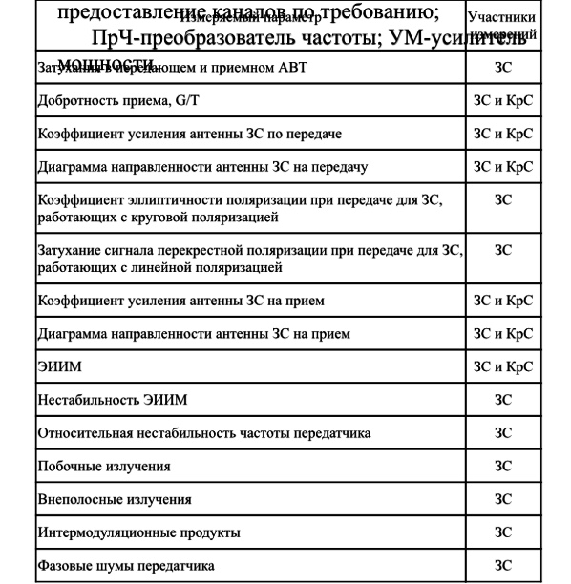

All actions in the process of measuring the characteristics of equipment using the space segment should be coordinated by the CRC operatively through the channel of official communication with the AP.

AC access to the space segment is made with permission and under the control of the Control Station of the corresponding region.

Immediately before going to the satellite, the personnel of the AP should check the equipment for receiving and transmitting, check the coordinates of pointing to the satellite and accurately point the antenna of the station using the pilot signal or the control carrier from the CS, and also check the working polarizations and frequencies of the test signals for transmission and reception.

At the initial exit of the AP by satellite power, the AP personnel must adhere to the following order:

- control the frequency and power of the signal, the levels of spurious and off-band emissions at the output of the transmitter;

- make sure the accuracy of the station’s antenna pointing at the satellite;

- make sure that there are no unwanted signals from the onboard transponder in the reception in the frequency band allocated for measurement;

- establish operational communication with KRS through the channel of general use or the channel of system-wide official communication;

- set the necessary frequency and EIRP of the carrier of the test signal at the command of the KRC;

- go out to a satellite with a power only at the command of the CRC and at the initial moment with a level of 10 dB below the established EIRP rating (usually 50 ... 55 dBW);

- set the nominal value of the EIRP carrier under the control of the CRC;

- operational personnel should be present at the AP for the entire time of measurements;

- at the end of the measurements, turn off the transmitter.

When making measurements, it must be taken into account that the accuracy of the measurement results to a certain extent depends on weather conditions, especially for the Ku range. The preferred measurement conditions are clear sky conditions in light winds. When conducting measurements under other conditions, it is necessary to take into account the correction for possible additional attenuation in the atmosphere.

AP personnel should verify that the measuring equipment used complies with the recommendations of the CRS and / or ITU recommendations and is certified (verified) by the metrological service.

The use of modern measuring instruments is allowed while maintaining the required measurement accuracy.

The requirements for the characteristics of the measuring equipment are given in table 4.4.

Table 4.4 - Specifications for measuring equipment

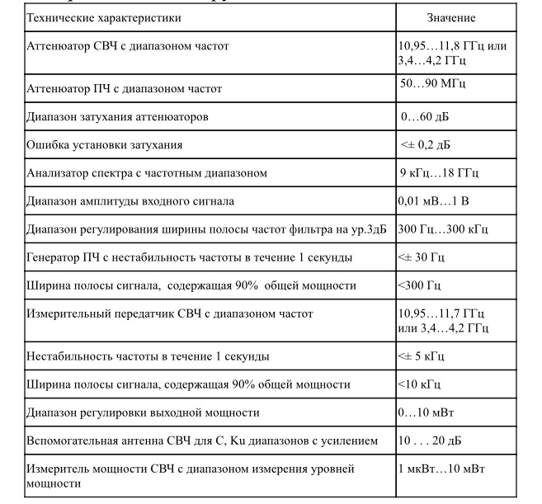 After completion of verification measurements of the characteristics of the AP equipment, separate protocols are drawn up by the AP and KS, which give the test results. If the measured parameters deviate from the technical requirements of the Regulation, the owner of the AP prepares the AP for re-testing.

Measurement of the attenuation in the transmitting (receiving) antenna-waveguide path.

The composition of the measuring equipment ZS:

- attenuation meter and VSWR panoramic (reflectometer);

- waveguide short circuit.

To measure the attenuation in the transmitting antenna-waveguide path (AWT), assemble the measurement scheme according to Figure 4.4.

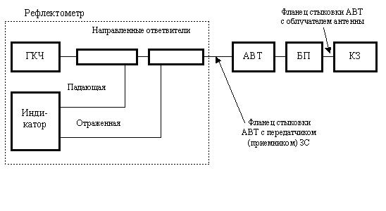 Figure 4.4 - Structural diagram of measurements in the antenna-waveguide path ZS

The measurement of the Q-factor of the G / T GC reception is made by the Spectrum Analyzer using a satellite in geostationary orbit and the Control Station.

To confirm the correctness of the results obtained, it is recommended to carry out measurements in the range of receiving frequencies and intermediate frequencies.

G / T = LFS + LATM + B + K - EIIIMSAT / ЗС + (PC - PN)

where LFS - loss in free space in the direction of the AP, dB

LFS = 92.45 + 20 logS + 20 log F;

F is the reception frequency, GHz;

S - oblique range, km;

km;

b - elevation angle of the AP, deg .;

LATM - losses in the atmosphere with a clear sky in the direction of the AP, dB (0.2 dB for 11 GHz; 0.25 dB for 12 GHz);

B - equivalent noise frequency band (analysis band) in which measurements are taken, dBHz;

K - -228.6 dBJ / K - Boltzmann constant, expressed in dB;

EIIMSAT / ЗС - EIIM of the satellite in the direction of the AP, dBW, calculated from the measured value of the EIIM of the satellite in the direction of the COP

EIIIMSAT / ЗС = EIIIMSAT / КС + LКС - LЗС,

where LKS, LZS - contour losses, dB;

(PC - PN) - ratio of measured power levels;

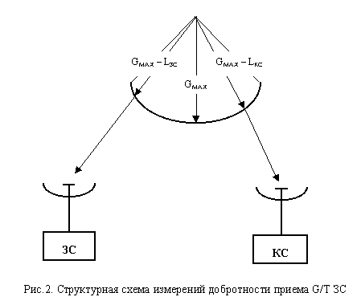 10lg [(signal + noise) / noise], dB.

Figure 4.5 - Block diagram of measurements of the quality factor of receiving G / T AP

Measurement procedure

1. CRC transmits the reference carrier at a frequency and at the level specified in the test plan. If necessary, the Central network control station provides regulation of the gain of the repeater at the request of KPC.

2. CRS measures the level of EIRP provided by the satellite during transmission of the reference carrier, and calculates the corresponding level of EIRP in the direction of the ES.

3. When installing the antenna in the direction of the satellite, the AP measures the level of the reference carrier at the high and intermediate frequency interfaces. When measuring with a beacon, the resolution band used must be consistent between the CRC and the AP. ZS reports the measured values ​​of KpS.

4. With a small frequency shift relative to the reference carrier (for example, 100 kHz), the ES measures the noise level.

5. AP removes the antenna from the direction to the satellite, preferably in azimuth, by an angle of at least 5 °. When turning the antenna, the noise level is controlled. The movement of the antenna should be stopped when the noise level stops decreasing.

6. The measured value of the noise level is reported by the CRC.

7. ZS connects the spectrum analyzer to the high-frequency interface, and, conducting operations, measures the noise level. ZS reports the measured value on KpS.

8. The operation of claim 7 is repeated when the spectrum analyzer is connected to the intermediate frequency interface.

9. AP reports the appropriate correction factors and frequency band to the SC. AP returns the antenna to the position of the bearing to the satellite.

10. The CS reports the EIRP level of the satellite in the direction to the ES and calculates the G / T ratio.

Since in the general case measurements are performed using a spectrum analyzer, it is necessary to introduce corrections for the noise level displayed on the screen in the analysis frequency band and for detection. In modern spectrum analyzers, such correction is achieved through software that allows you to directly read the normalized noise level (noise marker). If such a function is not available, the operator must refer to the appropriate instructions for using the measuring device to obtain the correct values.

Typical are the following values ​​used to correct the noise level observed on the screen:

conversion from a resolution band to a noise frequency band of -0.8 dB;

combined correction for detector characteristics and logarithmic curve detection + 2.5 dB.

A typical total correction is +1.7 dB. In this case, the actual noise level is 1.7 dB higher than that observed on the screen.

**45. Describe earth stations for TV reception**

In the field of television, satellites are currently used for the international exchange of television programs, for the distribution of television programs among broadcasting organizations, terrestrial television transmitters for relay, among cable networks, as well as for direct television broadcasting (NTV), which allows direct reception.

In recent years, thanks to the successes achieved in the development of microwave technology, it has become possible to create relatively simple and inexpensive installations with antennas of acceptable sizes for the individual reception of television broadcasts not only in broadcasting, but also in the fixed service. Therefore, many viewers from different countries purchase installations for receiving television broadcasts from FSS satellites. In this regard, those FSS satellites whose transmitters operate at frequencies adjacent to the frequencies of the BSS (11.7 ... 12.5 GHz) are of most interest. These are the frequency bands 10.7 ... 11.7 and 12.5 ... 12.75 GHz. The satellites of the international satellite communications organization IntelSat, the European satellite communications organization EutelSat, as well as satellites belonging to the commercial associations Telecom (France), Kopernicus (Germany), Astra (Luxembourg) and others operate within these frequency bands.

In television systems, television radio signals emitted by satellite transmitters are significantly different from signals emitted by terrestrial centers. The brightness signal of the image is transmitted by a satellite repeater with frequency modulation of the carrier frequency. A feature is also the use in satellite systems of direct television broadcasting of a carrier frequency located in the centimeter wave range, which includes the 12 GHz band, in contrast to terrestrial television operating on meter waves. At such high frequencies, transmitting a received signal from an antenna to a television receiver using a coaxial cable, as is common in terrestrial television, is simply impossible. These features require the appropriate construction of a television receiver circuit or an additional device (set-top box) to a standard television designed for receiving terrestrial television.

In analogue satellite television systems, FM modulation of the luminance signal is used. The advantages of FM are also low requirements for linearity of the amplitude characteristic of the path and the possibility of the output stage of the satellite transmitter in saturation mode, in which a high efficiency is achieved.

Another type of processing that has found application only in satellite broadcasting systems is the introduction of an additional low-frequency modulating signal to the TV signal on the transmitting side, which provides more uniform dispersion (dispersion) of the TV signal energy in the barrel frequency band in order to reduce interference to other communication systems, in first of all radio relay lines. In case of unfavorable scenes of the image (uniformly illuminated field), almost all signal power can concentrate in a narrow frequency band and lead to multiple excesses of the norm for radiated power. The addition of a sawtooth or triangular signal with a frequency from units of hertz to tens of kilohertz allows effective scattering, regardless of the plot. The deviation of the carrier dispersion by the signal depends on the required degree of scattering and is chosen equal to from 600 kHz (CCIR recommendation for all satellite TV systems) to 4 MHz (in the Moscow system).

The exception of the dispersion signal at the reception is achieved by the use of schemes for fixing the level of the video signal: with deviation of more than 1 MHz, special tracking devices are additionally used. The sound signal of television in traditional FM systems is usually transmitted together with the image signal at a subcarrier frequency located above its spectrum. To achieve the necessary noise immunity, the transmission is carried out by the method of frequency modulation of the subcarrier, and the deviation of the subcarrier frequency is chosen, as a rule, greater than in terrestrial television - up to 100 and even 150 kHz. The subcarrier value is also higher and amounts to 7.0 ... 7.5 MHz with a video signal band of 6 MHz, 5.8 ... 6.8 MHz with a band of 5 MHz and 5 ... 6 MHz with a band of 4.2 MHz, which allows to reduce crosstalk from the image channel to the sound channel and ease the requirements for filtering signals.

If it is necessary to transmit more than one audio signal together with the image signal (audio broadcasting, sound in foreign languages, stereo sound), several subcarrier frequencies located above the spectrum of the video signal are used. Their number is limited by the occurrence of crosstalk and the deterioration of the quality of the TV image due to a decrease in the proportion of carrier deviation attributable to the video signal. Almost with satisfactory quality, it is possible to transmit two to four additional signals. For example, in satellite TV channels organized through the European satellites Eutelsat II and Astra, along with the main sound channel, up to four more high-quality sound channels are formed that are used to transmit monophonic or stereo programs. The transmission is carried out by the FM method at subcarrier frequencies of 7.02, 7.20, 7.38, 7.56 MHz, the sound signal is subjected to adaptive pre-distortion and companding (Wegener Panda 1 system).

Companding is used to increase the noise immunity of sound transmission. It involves compressing the dynamic range of the transmitted signal in accordance with the change in the envelope of the audio signal and restoring the original dynamic range at the reception. There are distinguished “managed” companders, in which information about the initial dynamic range is transmitted in a separate control channel (with a frequency of 11000 ± 125 Hz), and “uncontrolled”, in which this information is contained in the transmitted signal. With controlled companding of audio signals, the influence of changes in the residual attenuation of the channel is reduced, and the conventional compander system reduces the level of intra-channel interference of the transmission channel (the dynamic range of the signals at the compressor output DVY.K and at the input of the expander DVX.E are the same and are associated with the dynamic range of the signals at the input and the output of the DC channel by the ratio DC / DВХ.Э = β = 1 / α,

where β is the expansion coefficient, α is the compression coefficient.

The gain in noise immunity due to companding reaches an average of 12 ... 13 dB in the presence of a signal and a 20 dB pause in the signal. A managed compander was used in the Moscow system, an unmanaged compander in the Moscow-Global system.

A more efficient way to transmit multiple audio signals energetically and free from crosstalk is to transmit on a subcarrier in discrete form. The signals of individual channels are converted into digital form and combined (multiplexed) into a common digital stream, which modulates in phase the subcarrier frequency located above the spectrum of the video signal. This method, for example, is used in the Japanese NTV BS-3 system. The 5.73 MHz subcarrier is modulated by a digital stream at a speed of 2.048 Mbps, containing PCM audio signals, error correction pulses, control pulses. The system produces either four sound channels with a band of 15 kHz, or two channels of very high (studio) quality with a band of 20 kHz.

A method is used to transmit audio signals in the spectrum of a video signal with their separation in time - in the interval of the backward beam or in free lines. The considered method was used in the Orbit system, in which using pulse-width modulation provided the formation of one channel with a band of 10 kHz or two channels with a band of 6 kHz. The current level of discrete circuitry can significantly increase the throughput of the method. These features are implemented in the MAC standard.

In MAC-type systems, analog luminance and color signals are compressed in time and transmitted alternately, which helps to avoid cross-distortion of luminance and color signals, reduces noise in the color channel due to its translation in the low-frequency region, and increases the image resolution due to a wider signal frequency band brightness and color. Compression of the analog signal is performed by gating the signal with a certain clock frequency, converting the samples to digital form, accumulating them in the buffer memory, accelerated reading with a new, higher clock frequency and the reverse conversion to analog form.

Sound signals are converted to digital form and transmitted in the interval of the reverse beam. The highest frequency in the spectrum of the audio signal is 15 kHz; the sampling frequency is chosen to be 32 kHz. Depending on the requirements for sound quality, linear analog-to-digital conversion with an accuracy of 14 bits / count or almost instantaneous companding with an accuracy of 10 bits / count is used, noise-resistant two-level encoding provides effective error protection. The digital stream speed in different versions is from 352 to 608 Kbps.

Digital broadcasting systems. The main coding algorithm has become the MPEG standard. The algorithm underlying MPEG standards includes a certain basic set of sequential procedures.

The component TV signal RGB is used as the source signal, then it is matrixed into the YUV signal; sampling, as in the digital standard "4: 2: 2" is carried out with a clock frequency of 13.5 MHz for the luminance signal and 6.76 MHz for color difference signals. At the pre-processing stage, information that impedes coding, but not significant in terms of image quality, is deleted. A combination of spatial and temporal nonlinear filtering is usually used.

The main compression is achieved by eliminating the redundancy of the TV signal. Three types of redundancy are distinguished - temporary (two consecutive image frames differ little from each other), spatial (a significant part of the image is made up of uniformly colored areas) and amplitude (the sensitivity of the eye is not the same for light and dark image elements).

For satellite television, MPEG2 is certainly more promising, designed for processing an input signal with interlaced scanning and various digital stream speeds (4 ... 10 Mbit / s and more), each of which corresponds to a certain resolution. According to this parameter, the standard defines four levels: low (at the level of a domestic video recorder), primary (studio quality), high-definition television with 1,440 elements per line, and a full HDTV with 1920 elements.

It can be calculated that in a satellite channel with a bandwidth of 20 ... 25 Mbit / s, you can transmit four to five programs of good quality corresponding to the main channels of program delivery, or 10. .12 programs with quality corresponding to a VHS standard VCR.

Part of the MPEG1 and MPEG2 standards includes algorithms for transmitting audio signals with digital compression, which can reduce the digital stream speed by six to eight times without subjective deterioration in sound quality. One of the widely used methods is called MUSICAM.

The DVB standard uses cascaded noise-resistant coding. The external code is the shortened Reed-Solomon code (204.188) with t = 8, which provides an "error-free" reception (the probability of an output error is less than 10-10) with an input error probability of less than 10-3. The internal code is ultra-precise with a relative speed of 1/2, 2/3, 3/4, 5/6 or 7/8 and a code restriction length of K = 7, decoding is performed using the Viterbi algorithm with a soft solution. The type of modulation is a four-position FM.

On the receiving side, the decoder performs all the above operations in reverse order, restoring the output image is very close to the original.

High-definition television (HDTV) refers to image transmission with a number of lines approximately twice that of existing standards, and a frame format (ratio of frame width to height) 16: 9. The amount of information contained in each frame of the HDTV image increases by five to six times in comparison with conventional television. Image signals are transmitted in the satellite channel using the FM sound signal - using the four-position FM method.

In the near future, the adoption of the national HDTV standard in the United States, suitable for use in both terrestrial and satellite systems, is expected.

The adoption by each group of countries of its own HDTV standard may impede international TV exchange, as has happened in the past with black-and-white TV standards and color television systems. Recently, under the auspices of the International Telecommunication Union, efforts have been made to create a unified world standard for HDTV.

The digital compression methods developed under the MPEG-2 standard are fully applicable to the HDTV and today they can transmit an HDTV signal with a digital stream speed of 20 ... 30 Mbit, which roughly corresponds to the throughput of a satellite RF barrel with a bandwidth of 27 ... 36 MHz.

The satellite television system "Moscow" was commissioned in 1980 and used five satellites of the type "Horizon" (according to the international classification "Stationary"), placed in a geostationary orbit. C4 satellite with the coordinate of 140 west It is designed to serve Europe; C5 at 530 East served the central part of Russia with a time shift of 2 hours; C13 with a coordinate of 800 east - Trans-Urals with a shift of 6 hours; C7 at 900 East - Eastern Siberia with a shift of 6 hours; C7 with coordinate 1400 east - Chukotka, Kamchatka and Sakhalin Island with a shift of 8 hours.

**46. Write about the plans of space services in the satellite communication system**

Already at the beginning of space exploration, the communications Administrations of the international telecommunication Union considered ways of using the geostationary orbit for communications and broadcasting and decided that, given the different technological levels of development of the world, it was desirable to reserve some frequency resource, as well as individual sections of the geostationary orbit, in order to ensure equitable access to that orbit for all countries. A proven approach of such redundancy, repeatedly used for various terrestrial communications services, is the development of appropriate plans that take into account advances in communication technology and the requests of Administrations (within reasonable limits). Thus, in 1977, the first Plan of the broadcasting satellite service (RCC) appeared. In the early 1980s, along with the broadcasting satellite service, the fixed satellite service (FSS) was actively developed, so the Administrations, members of the International telecommunication Union, concluded that it was necessary to develop a FSS Plan in addition to the RSS Plan

**5.1 Plan BSS**

The original version of the Plan was adopted at WACR-77 for Regions 1 and 3, and for Region 2 in the frequency band 12.2-12.7 GHz at RAKR-83.

The plan for Regions 1 and 3 was revised 20 years later at WRC-97 (Switzerland, Geneva), and then at the next WRC-2000 conference (Turkey, Istanbul). In essence, this Plan consists of two parts: the Plan of lines Cosmos - Earth and the Plan of lines Earth - Cosmos (Plan of feeder lines).

The Plan for Regions 1 and 3 (Space-to-Earth), which covers the frequency bands 11.7-12.2 GHz in Region 3 and 11.7-12.5 GHz in Region 1, is a detailed a priori Plan in which the satellites are uniformly distributed in orbit (usually every 6º), ensuring that in each broadcasting service area there is an equal number of channels. The entire frequency band in this Plan is divided into 40 frequency channels with a width of 27 MHz. The value of the carrier frequency of each channel can be determined by the formula

11708,30 **+** 19,18**×** n

where n – channel number.

The BSS Plan for Regions 1 and 3 provides for the output of satellites to 73 orbital positions:

**W**: 0,80; 1,00; 1,20; 4,00; 7,00; 12,80; 13,00; 13,20; 18,80; 19,20; 24,80; 25,00; 25,20; 30,00; 33,50; 36,80; 37,00; 37,20; 160,00; 178,00;

**E**: 4,80; 5,00; 9,00; 11,00; 16,80; 17,00; 17,20; 20,00; 22,80; 23,20; 28,20; 29,00; 33,80; 34,00; 34,20; 36,00; 37,80; 38,00; 38,20; 42,00; 42,50; 44,50; 50,00; 52,50; 56,00; 56,40;62,00; 68,00; 74,00; 80,20; 86,00; 88,00; 91,50; 92,20; 98,00; 104,00; 107,00; 109,85; 110,00; 116,00; 121,80; 122,00; 122,20; 128,00; 134,00; 140,00; 146,00; 152,00; 158,00; 164,00; 170,00; 170,75; 176,00.

In addition to the nominal position of the satellite on the civil defense and the numbers of the assigned frequency channels, the following are recorded in the Plan:

- EIIM onboard transmitter;

- Class of radiation;

- BR antenna parameters (gain, polarization, aiming point, beam parameters, etc.

The frequency assignments for the Republic of Kazakhstan are as follows:

KAZ 06600 – beam number

- orbital position 56.40 E;

- channel numbers 1; 3; 5; 7; 9; eleven; 13; fifteen; 17; 19;

- aiming point 65.73E; 46.40N;

- beam parameters (4.58º / 1.76º / 177.45º);

- polarization CR (right circular);

- BR antenna gain 35.38dB;

- EIIM BR 58.9 dBW;

- radiation class 27M0G7W

where 27M0 is the radiation bandwidth of 27 MHz;

G - modulation of the main carrier (phase);

  7 - the nature of the signal modulating the main carrier (two or more channels with digital or quantized information);

W - type of information transmitted (combination of different types of information).

**The Plan's feeder links for Regions 1 and 3 use different frequency bands of 14.5-14.7 GHz (only for Administrations outside Europe) and 17.3-18.1 GHz.**

**5.2 Plan FSS**

The FSS World Plan was put in place at WACR-88. In this Plan, not every Administration has a frequency band of 800 MHz in two sub-bands:

- 6 GHz (6.725 - 7.025 GHz) - uplink (feeder line); 4 GHz (4,500 - 4,800 GHz) - downlink (C - band);

- 13 GHz (12.75 - 13.25 GHz) - uplink (feeder line); 10 - 11 GHz (10.70 - 10.95 GHz and 11.20 - 11.45 GHz) - downlink (Ku - band).

The FSS plan consists of two parts:

- Part A: national allotments, according to which each Administration has at least one frequency allotment (800 MHz with access to the orbital position);

- Part B: which includes networks using the planned bands that have already been announced in the ITU before the date of development of the Plan (“existing systems”).

The Republic of Kazakhstan does not have an allocation in Part A of the FSS Plan, but may receive it. For this, it is necessary to submit a request to the ITU Radiocommunication Bureau with the following information:

a) geographical coordinates for no more than 10 control points for determining an ellipse covering a national territory;

b) altitude for each control point;

c) other requirements, except for a fixed orbital position.

47. Write how to design satellite communication systems

Initial data :

- the required service area (territory, or individual points);

Bandwidth of the communication system (it is necessary to provide for a possible increase in requirements for the life of the system from 6 ... 7 to 20 ... 25 years), here there should also be a list of the types of transmitted information and requirements for the quality of transmission, additional requirements for classifying messages;

- reliability of communication channels (and in connection with this, the necessary amount of backup equipment on the SSSS and on the satellite, the number of satellite)

- parameters of the used satellite or its barrels (EIRP, frequency band, etc.), if the development of a new satellite is not required;

- during the development of a new satellite, the maximum mass and overall dimensions of the spacecraft are set, the requirements are set for the onboard repeater, and the accuracy of the satellite’s retention in orbit;

- the permissible period for the implementation of the system is determined;

- the maximum allowable cost of creating the system is determined.

System design procedure:

- selection of the satellite's standing point at the GSO;

- calculation of the parameters of the satellite’s onboard antennas (beam parameters are needed: aiming point, angular dimensions of the beam, orientation relative to the orbit plane, the use of a beam of a special shape is possible), with known aperture angles of the antenna beam, you can determine the gain of the onboard antenna

GКС = 44,4 – 10 lg α**1** – 10 lg α**2,**db

where α**1,** α**2 –** aperture angles of the antenna beam, degrees.

and equivalent isotropically radiated power:

EIIM = PКС× η ×GКС, Вт

where PКС – transmitter power KS, W;

η – transmission coefficient of the waveguide path;

GКС – antenna gain of the KS.

There are recommendations on the optimal ratio between power and trunk bandwidth: for a trunk band of 35 ... 40 MHz for a duplex communication system, its power (RKS × η) should be 5 ... 20 W; EI-IM = 23 ... 31dBW with a Q factor of 25 ... 39 dB / K (if the Q factor is reduced, it will be necessary to proportionally increase the EIRP).

  From the selected value of EIRP, it is possible to determine the power flux density created at the Earth's surface

W=10lg[EIIM/(4πd²LДОП)], dBW / m².

Signal strength at receiver input

РС = PАПРМ= W×SЭ= W× q ×SA, Вт

where q – aperture utilization (0,6-0,8);

SA – antenna aperture area, m2.

From here, the size of the antenna is selected. Choosing the diameter of the antenna ZS, it is possible to change (RS / PSh) VX, achieving the desired value of this ratio. The noise power at the input of the ES receiver is determined by the well-known formula: Pш = k T∑ ∆fш. Typically, the value obtained by this formula is increased by 20 ... 30% (the stock takes into account interference from other systems and barrels). Practically, for receiving different signals with different modulation and reliability of reception, they accept (RS / PSh) BX = 10 ... 20dB.

**48. Explain and describe the energy calculation of satellite lines**

The energy calculation of satellite lines is carried out at the design stage.

The purpose of the calculation: to determine the values of the transmitter power of the ground transmitting station RPRDZS and the transmitter power of the on-board repeater RPRDB, in which the satellite channel works reliably in the conditions of interference and does not contain excessive energy reserves. We derive the calculation formulas.

Effectively Isotropically Radiated Power:

EIIM(or Рэ) = РПРД ηПРД GПРД.

The gain of a parabolic antenna can be calculated by the formula



where q – aperture utilization (0,6-0,8);

DA- antenna diameter, m;

λ – wavelength, m

Decibel antenna gain can be calculated

G=20(lg DA(м)+lgf(ГГц))+18,35, дБ.

Signal attenuation due to spherical divergence of the wave front

Lo =16π²d²/λ²

where d – distance between transmitting and receiving antennas, m;

λ – длина волны, м.

The distance from the earth station to the geostationary satellite depends on the geographical coordinates of the ES and CS and is calculated by the following formula



where ϕЗС – geographical latitude of the AP, city .;

βЗС – geographic longitude of the AP, city .;

βКС – geographic longitude of the COP, city

Complete attenuation of the signal along the propagation path

LР(дБ) = Lo + LДОП

where LДОП – additional path losses (absorption of signal energy in the atmosphere, losses due to refraction, losses due to inconsistent polarization of antennas, etc.) do not significantly affect the satellite line energetics. When designing, the average value of LDOP = 5dB is taken.

Signal strength at receiver input

РПРМ = РЭGПРМ ηПРМ/LР=РПРДλ²GПРДGПРМηПРДηПРМ**/**(16π²d²LДОП) . (6.1)

When calculating the line, it is often not the signal power at the input of the receiver that is set, but the signal-to-noise ratio, therefore, it should be substituted into formula (6.1)

РПРМ = РШ (РС/РШ)ВХ, W

where РШ=k T∑ ∆fШ– total noise power at the receiver input, W;

k=1,38×10E-23, Вт/Гц×К- Boltzmann constant;

∆fШ- noise band of the receiver, Hz;

Т∑=ТА+Т0[(1-η)/η]+TПРМ/η - equivalent noise temperature of the receiving path, K;

ТА - noise temperature of the antenna (includes cosmic radio emission, radiation of the atmosphere, the earth's surface, intrinsic noise of the antenna), K;

To ≈290K;

ТПРМ - own noise temperature of the receiver, K.

Substituting РПРМ and solving equation (6.1) regarding the transmitter power, we obtain:

.

Of practical interest is not one site, but two (Earth-satellite and satellite-Earth). Each section will have its own expression:

1) ;

2) 

To move from the equations of individual sections to the general equation for the entire line, it is necessary to establish a relationship between the signal-to-noise ratios at the output of the line and at each of the sections. In the absence of signal processing on board, the noise of each of the sections is added, and the total noise / signal ratio at the end of the communication line

(РШ/РС)∑=(РШ/PC)ВХБ+(РШ/PC)ВХЗ (6.2).

Obviously, the signal-to-noise ratio in each of the sections should be higher than at the end of the line:

(PC/PШ)ВХБ = а (РС/PШ)∑ (6.3)

(PC/PШ)ВХЗ = b (PC/PШ)∑ . (6.4)

Having solved the system of equations (6.3.6.4), we obtain

a = b/(b-1).

Given b = 1.26 (1dB), we find the necessary excess on the Earth-satellite section a = 5 (7dB).

Based on the foregoing, the equations for the satellite communication line, consisting of 2 sections, will finally take the form

,

.

The block diagram and level diagram of the satellite communication line, consisting of two sections, are shown in Figure 6.1.

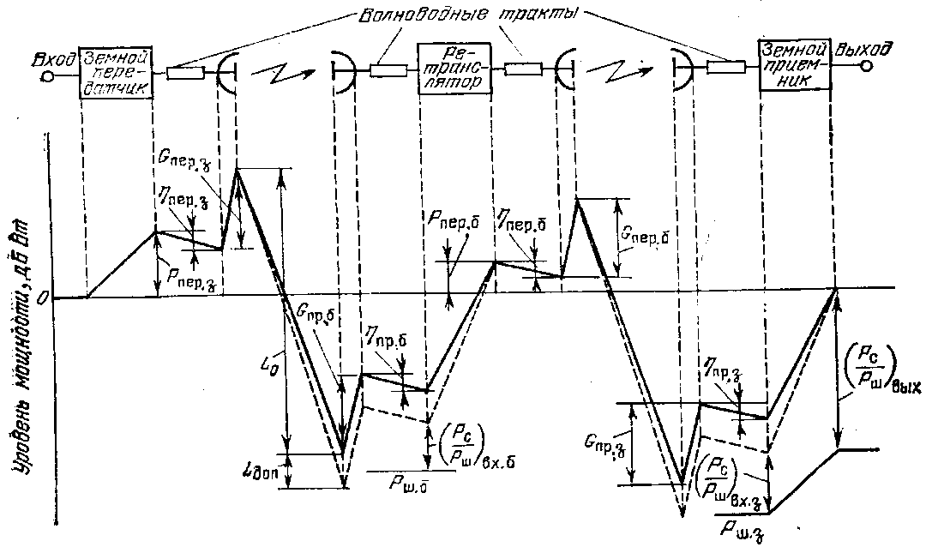

Figure 6.1 - Block diagram and level diagram of the communication line from two sections

The final stage of the calculation is recalculation (PC / PCH) ∑ to the LF channel. Consider the example of the transmission of television by FM

(PC/PШ)НЧ= (РС/PШ)∑ gТВ ВВ ∆ k1

where где gТВ = 1,5∆fЧМ ∆fД²/FВ³ - modulation gain

∆fЧМ = ∆fШ spectrum width;

∆fД- peak deviation;

FВ- high frequency of the signal spectrum;

BВ- gain due to the visometric coefficient;

∆ - gain from the introduction of pre-emphasis;

k1=9db – conversion factor of the amplitude of the sinusoidal signal into an effective value;

BВ ∆ = 14…18db.

**49. Explain and describe electromagnetic compatibility of satellite and terrestrial communication systems**

In the frequency bands allocated for the operation of satellite systems, a fairly large number of terrestrial communication systems operate (in particular, direct-visibility RRL).

To reduce interference in terrestrial systems from satellite emissions, the maximum signal power flux density developed at the Earth's surface is limited W. W (dBW / m²) must satisfy the following conditions:

W = W**0** at ε ≤ 5°,

W = W**0** + 0,5 (ε – 5°) at 5°**<** ε ≤25°,

W = W**0** + 10 at 25°**<**ε ≤90°,

where ε - elevation angle;

W**0**= − 152 dBW / m² for 3,4-7,75 GHz

W**0** = − 150 dBW / m² for 10,7-11,7 GHz

W**0** = − 148 dBW / m² for 12,2-12,75 GHz

W**0** = − 115 dBW / m² for 17,7-19,7 GHz and 31-40,5 GHz.

W is determined within the conditional control frequency band: 1 MHz for the ranges 17.7-19.7; 31-40.5 GHz and 4 kHz for the rest (lower frequency).

The power flux density can be determined by the formula

W= PАПРМ/SЭ=РЭGПРМ/LРSЭ=РЭ 4π/LPλ² , W / m²

where РАПРМ,- power at the output of the receiving antenna ZS, W;

SЭ – effective area of the antenna that directly determines the energy flow intercepted by the antenna, m2;

GПРМ = 4πSЭ/λ² - the gain of the receiving antenna ZS;

РЭ – EIIM of an onboard repeater, W;

LР - attenuation of the signal along the propagation path.

The formula in the logarithmic form

W = PЭ−LР+20lg f +21,5 , dBW / m²

where f- frequency, GHz;

РЭ – EIIP of onboard repeater, dBW;

LР – signal attenuation along the propagation path, dB.

For the broadcasting-satellite service in the frequency band 620-790 MHz, the power flux density (in dBW / m²) in other countries is limited by:

−129 at ε ≤ 20°;

− 129 + 0,4(ε−20) at 20°<ε≤60°;

− 113 at 60°<ε≤90°.

Limitations are introduced, but verification for EMC systems is nevertheless carried out. When the systems are deployed on their territory, it is possible to really assess the degree of interfering influence. When a satellite communication satellite is located in the border regions of its territory, there is a need to build coordination zones (short-circuit for both the transmitting and the receiving satellite). The procedure for calculating the short circuit is established in Rec. CCIR 847. Documents for these APs with the appendix of KZ are sent to neighboring states for coordination (coordination). For real GLs, the coordination distances (RCs) —distance from the location of the LCs in azimuthal directions to the coordination contour (CC) —are 200 ... 500 km.

**50. Describe the EMC of geostationary satellite communication networks**

The administration intending to create an MSS should not earlier than 6 years and no later than 2 years before the planned launch date of the system send to the Radiocommunication Bureau for publication information about the MSS being created. The administration of the existing MSS sends its comments to the notifying administration if it considers that its existing services may be subject to unacceptable interference. Both parties must find a mutually acceptable solution in the coordination process. The need for coordination is calculated by the method described below in Appendix 29, Volume 2 of the ITU Radio Regulations, 1990.

Figure 6.2 - Assessment scheme for the interfering effect of the designed CCC2 on the current CCC1

The calculation method is based on the notion that when exposed to interfering signals, the effective noise temperature of a system subjected to noise increases.

According to this method, the apparent relative increase in the noise temperature of the existing line ∆Т∑ / Т∑ due to the influence of interfering signals created by the designed system is calculated and compared with a threshold value of 6%.

Let us evaluate the interfering influence of the designed system 2 (see Figure 5.2) on the current system 1, therefore, we will be interested in receiving paths in system 1, and transmitting paths in system 2. The following notation is used in the diagram:

d1…d4 – distance between stations;

θ1, θ2 – topocentric angles;

α1, α2- exocentric angles;

g - the geocentric angular separation between the satellites.

γ – a coefficient numerically equal to the transmission coefficient of the path from the output of the receiving antenna KS1 to the output of the receiving antenna ZS1 (usually less than 1);

Т∑ - effective noise temperature of the receiving path ZS2 (without taking into account the disturbing effect).

So, the compatibility criterion

∆Т∑/T∑ ≤ 0,06. (6.5)

Formulas used for calculations

∆T∑ = γΔT↑/Y + ΔT↓/Y (6.6)

where ΔТ↑,ΔT↓ - increment of noise temperature in the section up and down;

Y – the attenuation coefficient of the interfering signal due to polarization mismatch (1 for coinciding polarizations, 4 for circular polarizations with the opposite direction of rotation, and 1.4 in other cases).

ZS of the designed system, using the same frequency band as the ZS of the current system, will cause increments in the noise temperature of the current CS ΔT ↑.

ΔТ↑= SЗС2GЗС2(θ2)GБР1(α1)/( Lp↑), K

where SЗС2 [W / Hz], is the spectral power density of ЗС2;

LР↑ - weakening of interfering signals along the propagation path upward;

GЗС2(θ2) – the antenna antenna gain of the designed system, depending on the topocentric angle θ2;

GБР1(α1) - the antenna gain of the CS of the existing system, depending on the exocentric angle α1;

k = 1,38*10-23 – Boltzmann constant W / (HzK).

The CS of the designed system using the same frequency band as the CS of the current system will cause noise temperature increments of the active CS ΔT↓ .

ΔT↓= SБР2GБР2(α2)GЗС1(θ1)/(kLp↓),K

SБС2– power spectral density of BR2, W / Hz;

LР↓ - attenuation of interfering signals along the propagation path in the downward section;

GЗС2(θ2) – the antenna antenna gain of the designed system, depending on the topocentric angle θ2;

GБР1(α1) - the antenna gain of the CS of the existing system, depending on the exocentric angle α1;

k = 1,38*10-23 - Boltzmann constant W / (HzK).

It is more convenient to use for calculating formulas in which the values are expressed in decibels.

ΔT↓= SБР2+GБР2(α2)+GЗС1(θ1)-k-Lp↓ ,dbK,

ΔT↑= SЗC2+GКС1(α1)+GЗС2(θ2)-k-Lp↑, dbK.

SБР2, SЗС2 – power spectral densities of BR2 and ZS2 in technical specifications are usually indicated in dBW / Hz;

k– Boltzmann constant (-228.6), dB.

Attenuation in free space is determined by the following formula:

Lp = Lo = 20 (lg f + lg d) + 32,45 [db]

where f – frequency, MHz; d – distance, km.

The distance is calculated as in the energy calculation.

GC antenna gain factors are determined by the actual measured characteristic or if such information is not available The Radio Regulations recommends the use of the following reference radiation patterns

For DA **/** λСР ≥ 100

G (θ) = Gmax – 2,5*10-3 (θ DA **/** λСР), db at 0< θ< θm;

G (θ) = G1, db at θm < θ< θr;

G (θ) = 32 – 25 lgθ, db, at θr < θ< 480;

G (θ) = -10, db, at 480< θ< 1800

Where DA – antenna diameter, m; θ is the angle (in degrees), measured from the axis of the antenna, equal to θt;

G1= 2+15*lg*(DA **/** λ) – antenna gain in the direction of the maximum of the first lobe, dB;

Θm= (20 λ/ DA)√ Gmax- G1  - width of the first petal, degrees;

Θr=15,85DA/λ)-0,5, degree.

For DA**/** λср < 100

G (θ) = Gmax – 2,5*10-3 (θ DA **/** λСР), dB at 0< θ < θm;

G (θ) = G1, dB at θm ≤ θ < 100λ/ DA;

G (θ) = 52 – 10 lg DA/ λср –25lgθ, dB at 100λ/ DA ≤ θ < 480;

G (θ) = -10, dB at 480 ≤ θ < 1800

The topocentric angle at earth stations is determined by the following formulas:

θ1= arc cos B1,

,

θg=│βКС1−βКС2│- geocentric angle.

θ2 defined in a similar way.

If CSs have global coverage antennas, then the antenna gain of the onboard repeater GBR (α) will not depend on the exocentric angle α, GBR (α) = GBRMAX.

Under other conditions, the exocentric angle is determined from the cosine theorem, determining the distance between earth stations

d ²зс**1**зс**2** = d**1**² + d**2**² - 2 d**1 ×** d**2 ×** cosα**1,** (6.7)

x**1** = R**З** × cos φ**1** × cos β**1,**

y**1** = R**З** × cos φ**1** × sin β**1**,

z**1** = R**З** × sin φ**1**,

where the radius of the Earth RЗ = 6370 km; φ1, φ2- latitude of the GC;

β**1,** β**2 –** longitude ZS.

We similarly define x**2**, y**2,** z**2.**

d ²зс**1**зс**2** = ( x**2 -** x**1** )² + ( y**2** - y**1**)² + (z**2** - z**1**)². (6.8)

Calculating d ²зс1зс2 and solving equation 6.7 with respect to α1 we get:



Similar calculations are performed for α2 using the distances d3, d4. Thus, to determine exocentric angles, it is first necessary to determine the distance between them from the coordinates of the CS, and then use the cosine theorem.

The antenna gain of the COP is determined by the formulas (in dB):

G(α)=Gm−12(α/αo) at 0,5αo≤α<1,3αo,

G(α)=Gm−20 at 1,3αo≤α<3,15αo,

G(α)=Gm−7−25lgα/αo at 3,15αo≤α<α1,

G(α)=−10 at α1≤α

where αo – half power beam width;

Gm = 44,4−20lgαo – maximum gain.

If the values ΔT ↑ and ΔT ↓ were calculated in decibels, then before substituting into formula (6.6) it is necessary to express them in Kelvin.

Substituting ΔT∑ into inequality (6.5) to determine whether coordination is required.

**51. Write about satellite communication of the Republic of Kazakhstan " KazSat»**

KazSat is the first spacecraft for Kazakhstan, with the launch and operation of which the implementation of space programs of the republic began.

The prelaunch preparation of the components of the launch vehicle, the upper stage and the spacecraft at the launch site was carried out by specialists from the MV Space Research and Production Center Khrunichev (hereinafter - GKNPTS im. MV Khrunichev) and the Italian company Alcatel Alenia Spazio Italia. The on-board relay complex of the KazSat satellite was manufactured by Alcatel Alenia Spazio Italia using advanced satellite technologies.

The Russian side, which at the time of the launch of the KazSat satellite, had temporarily free orbital-frequency resources in geostationary orbit, provided the Kazakh side on a temporary basis (for the period of satellite’s existence in orbit, but no more than 15 years) a coordinated orbital frequency resource.

The KazSat satellite was successfully launched into geostationary orbit on June 18, 2006 from the Baikonur Cosmodrome of the Proton launch vehicle in the presence of the Presidents of Russia and Kazakhstan.

KazSat will allow providing modern types of telecommunication services to the most remote and inaccessible regions of Kazakhstan and other countries. It is also planned to lease satellite communication channels to operators of the CIS countries. “KazSat” - designed for 864 MHz. Thus, Kazakhstan has a resource for transferring operators to a domestic satellite.

**52. Describe the technical appearance and main characteristics of " KazSat-103**

More than 15 foreign and domestic companies participated in the creation of the KazSat space system, including leading manufacturers of on-board telecommunication equipment - Boeing, Alcatel Alenia Spazio Italia, ComDev.

The creation of the KazSat space system was carried out by the MV Khrunichev State Scientific and Technical Center on the basis of a small spacecraft for communication and television broadcasting in a geostationary orbit of 103 degrees east longitude belonging to the Russian Federation. The construction of the ground control complex (NKU) and the monitoring system (SMS) is carried out on the territory of Kazakhstan. General view of the spacecraft “Kazsat” is presented in Figure 7.1. Its main characteristics are in table 7.1. The block diagram of the BRSK ICA Kazsat repeater is shown in Figure 7.2, the Kazsat frequency plan in Table 7.2, the EIRP calculation results and the BRTK Q factor according to the simulation data in Table 7.3.



Figure 7.1 - Appearance of the spacecraft “Kazsat”

The Kazsat spacecraft, located in the geostationary orbit, carries out communication and television broadcasting through 12 transponders, covering the entire territory of the Republic of Kazakhstan and part of the adjacent state forces.

Table 7.1 - Main characteristics of the KazSat spacecraft

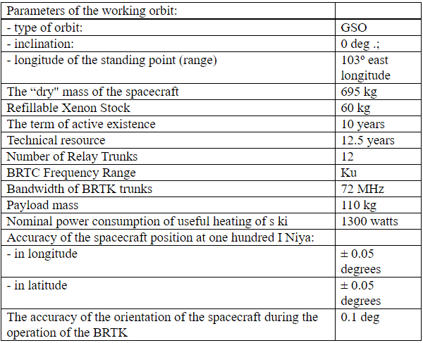

Table 7.2 - Frequency plan of KazSat ICA.

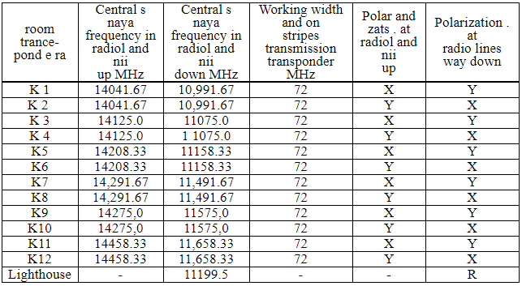

The dimensions of the service area are shown in Figure 7.2. The service area is provided by a combined transmitting and receiving antenna with a radiation pattern of 2.5 x 3.6 degrees formed by a two-mirror system with a profiled main mirror.

Republic of Central Asia, the Caucasus, central parts of the Russian Federation, including the Moscow region, fall into the zone of reliable satellite signal reception.

Table 7.3 - Results of calculations of the EIRP and Q-factor of the FCS “KazSat” ICA according to simulation data.

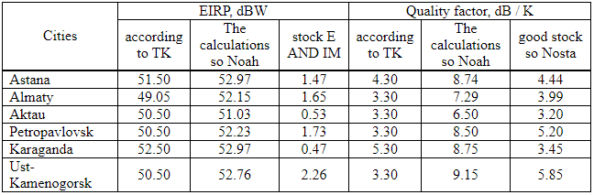

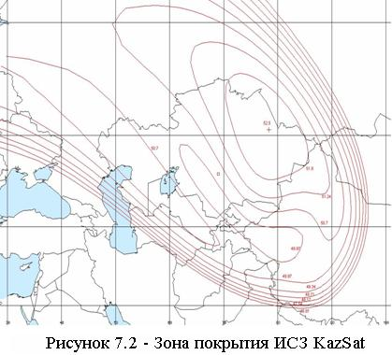

KazSat is intended for the organization of television and radio broadcasting channels, telephone communications, data transmission, broadband access to the Internet, the creation and development of VSAT networks, the creation of departmental and corporate communication networks, and the provision of a multimedia services package.

7.2 Ground control system

Navigation of the KazSat satellite will be carried out in the Terrestrial spacecraft control complex (NKU), which is located one hundred kilometers from Astana in the city of Akkol, Akmola region. The total area of ​​NKU is 6,916 square meters. km The Complex has the most modern equipment to date, which complies with international standards. NKU consists of three main divisions - a monitoring center, a control center and a payload department.

The ground-based control complex (GCC) and the communication monitoring system on the territory of the Republic of Kazakhstan provide the solution to the problems of managing, controlling and maintaining the given characteristics of the spacecraft at the stage of its regular operation. The functioning scheme of the NKU “Kazsat” spacecraft is shown in Figure 7.3.

**53. Describe the features of the propagation of radio waves**

An essential feature of the propagation of radio waves in terrestrial conditions is the dependence of the propagation characteristics on the wavelength. The propagation of radio waves along the earth's surface depends on its topography and physical properties. The most important electrical parameters of the soil are its electrical conductivity and permittivity. These characteristics determine the parameters of reflected and refracted waves at the interface between two media. The electrical conductivity of the soil also determines the energy loss during the propagation of waves along the Earth's surface.

An equally important influence on the propagation of radio waves in near-Earth space is played by the Earth's atmosphere (the gaseous shell of the Earth). According to the complex of physical features, the atmosphere is usually divided into three characteristic layers: the troposphere, stratosphere and ionosphere.

Figure 1.1 shows the simplified structure of the Earth’s atmosphere, and table 1.3 shows the main methods of propagation of radio waves.



Figure 1.2 - The structure of the Earth’s atmosphere

The troposphere is the lower layer of the atmosphere, located from the surface of the Earth to heights of the order of 10 - 20 km. The properties of the troposphere are determined by a mixture of gases (nitrogen, oxygen, etc.) and water vapor. With altitude, the temperature and air pressure, as well as the water vapor content in the troposphere decreases. Thus, the troposphere is heterogeneous in its electrical properties.

The stratosphere - an atmosphere layer lying above the troposphere, extends to heights of the order of 60 - 80 km. The density of gases in the stratosphere is much lower than in the troposphere. The electrical properties of the troposphere are practically unchanged, and radio waves propagate in it in a straightforward and almost lossless manner.

The ionosphere is the upper layer of the ionized atmosphere surrounding the Earth (up to heights of the order of several thousand kilometers). Under the influence of cosmic radiation and ultraviolet rays of the sun, electrons are knocked out of the gas atoms that make up the atmosphere, resulting in the formation of positive gas ions and free electrons. Ionized gas has electrical conductivity and is able to change the propagation characteristics of electromagnetic waves. The higher the concentration of free electrons, the stronger they affect the propagation of radio waves.

Figure 1.3 shows the main propagation paths of radio signals

**УКВ**

**Ионосфера**

**КВ, СВ, ДВ**

**УКВ ,** **КВ**

**СВ, ДВ, СДВ**

**1**

**2**

**3**

**4**

**5**

**6**

*θ0*

**Мертвая зона**

**Тропосфера**

Figure 1.3 - The main modes of propagation of radio waves.

Four types of waves are distinguished by the propagation method: direct, surface (terrestrial), tropospheric and spatial (ionospheric).

Within the line of sight, signals of all ranges propagate, in Figure 1.3 line 5.

Radio waves propagating in the immediate vicinity of the Earth’s surface, partially enveloping the convexity of the globe due to diffraction, are called surface or earth waves. Figure 1.3 shows the trajectory of the surface wave of signals at medium, long, and super long waves (NE, LW, SDE) by curve 6. It is known from the physics course that diffraction is observed when the size of the obstacle is commensurate with the wavelength. In this case, the ball segment is an obstacle. The height of the latter depends on the distance between the correspondents, therefore it is clear that the longer the working wavelength, the greater the distance it can propagate due to diffraction. Diffracting around the spherical surface of the Earth, the surface wave is partially absorbed by semiconducting earth, the degree of absorption of which depends on the structure of the soil (sand, clay, stones, etc.) and its moisture content. The atmosphere of the Earth has little effect on the propagation conditions of this wave. Ranges are used in marine and terrestrial radio navigation systems.

Radio waves propagating over long distances and even enveloping the globe as a result of multiple reflections from the ionosphere and the earth's surface (in the wavelength range longer than 10 m, NE and LW ranges), are called spatial, or ionospheric waves. In Figure 1.3, curves 2.4.

Radio waves propagating over considerable distances (up to 1000 km) due to scattering on inhomogeneities of the troposphere, as well as due to the phenomenon of tropospheric refraction, are called tropospheric waves. Note that the troposphere affects only electromagnetic waves, the length of which is less than 10 m, of HF radio waves. In Figure 1.3, curve 3.

UHF, microwave and EHF radio waves propagate into outer space, bypassing the ionosphere. These radio frequency ranges are used in direct visibility radio communication systems, in satellite and space systems.

Total losses on any radio link are the sum of the main losses and additional ones. The main losses are determined by the attenuation of the signal in free space due to the divergence of the rays due to the spherical wave front. Additional losses are determined by losses in the propagation medium as a result of absorption, scattering of wave energy by the inhomogeneities of the medium, changes in the initial polarization of the wave under the influence of a magnetic field, etc.

When waves propagate shorter than 3 ... 4 cm (f> 7 ... 10 GHz) in the Earth's atmosphere, the greatest contribution is attenuation in water vapor and oxygen contained in the atmosphere and in atmospheric formations (rain, fog, wet snow).

**54. Describe the classification of the radio system**

The purpose of the lecture: to consider the features of radio wave propagation and the classification of radio communication systems.

The influence of the radio wave propagation medium imposes a limitation on the wavelengths used in various radio communication systems. The influence of external factors on radio waves with different wavelengths is not equally affected. Therefore, it is advisable to consider the properties of radio waves in the ranges within which the waves exhibit approximately the same properties.

Radio Regulations - an international treaty that establishes the regulatory framework for the use of radio frequencies and satellite orbits. A Radio Regulations is being developed by the International Telecommunication Union.

The International Telecommunication Union (ITU) is the United Nations specialized body, an international organization within which governments and the private sector coordinate global telecommunication networks and services. The ITU includes: ITU-R Radiocommunication Sector (ITU-R) and Telecommunication Development Sector (ITU-D), Telecommunication Standardization Sector - ITU-T. Standards ITU-T covers almost the entire field of telecommunications.

In accordance with the Radio Regulations, it is customary to divide the radio range into separate bands, guided by the decimal principle. Figure 1 shows the frequency ranges and their applications.



Figure 1.1 - Radio frequency ranges

**55. Explain and describe the General principles of RRL**

The purpose of the lecture: To study the type of RRL stations, frequency plans.

Types of RRL stations, frequency shift, multi-barreled work, span.

Radio relay communication lines are based on the principles of multiple signal relaying. There are two types of microwave links:

- tropospheric microwave links based on the principle of distant tropospheric propagation (DTR),

- direct-line radio-relay lines, which are a chain of transceiver stations located at stable communication distances within the line-of-sight of antennas (the name comes from the English “relay”).

б)

а)

20-30km (50km)

250 km

Figure 3.1- Organization Principles:

a) RRL radio-relay lines of direct visibility (RRL);

b) tropospheric radio relay lines (TRL).

 DTR occurs due to reflection and scattering of radio waves by turbulent and layered inhomogeneities of the troposphere. features, the distance between stations is chosen more often within 200 ... 400 km. Due to the significant attenuation of signals on the spans, it is necessary to significantly increase the energy potential of the system. The use of powerful transmitters, large antennas significantly reduces the possibility of using TRL. In the future, we will consider direct line of sight radio links that are widely used at present.

The combination of technical means and the medium for the propagation of radio waves to provide radio-relay communication forms a radio-relay communication line. Transceiver stations are called radio relay stations (RRS).

The line-of-sight distance (span length) is the distance between adjacent RRS, which can be determined by an approximate formula for the case of a smooth spherical earth's surface:

R0,км ≈ 3,57× (√h1 +√h2),

where h1 and h2 are the antenna suspension heights in meters.

The most common antenna mount heights are 20 ... 80m. This ensures a line of sight from 30 to 60 km.

For RRL operation in accordance with the recommendations of ITU-R F-series, frequency bands in the ranges: 7; 8; 10; 11; 12; 13; fourteen; fifteen; eighteen; 23; 27; 31; 38; 55 GHz.

Functional radio relay stations are divided into:

- terminal (OPC), carry out the input and allocation of the transmitted information of the transmitted information, and provides information distribution to consumers (telecentre, long-distance telephone exchange, company office);

- intermediate (PRS), the transmitted signals are relayed at an intermediate frequency, if necessary, it is possible to extract TV signals or part of the telephone group spectrum;

- nodal (URS), here the transmitted information is re-accepted with the ability to enter and highlight information to consumers, it also provides for branches or intersections of the RRL.

Stations are arranged in a zigzag pattern - this allows eliminating interference from stations located three to five spans with existing plans for the distribution of radio frequencies.

Figure 3.2 - Diagram of a radio relay communication line

Terminal stations are installed at the extreme points of the communication line and contain modulators and transmitters in the direction of signal transmission and receivers with demodulators in the direction of reception. In Figure 3.2, terminal stations are designated OPC1 and OPC4. For transmission and reception, one antenna is used, connected to the transmission and reception paths using an antenna splitter (duplexer).

Modulation and demodulation of signals is carried out at one of the standard intermediate frequencies (70 - 1000 MHz). Modems can work with transceivers using different frequency ranges. The transmitters are designed to convert the intermediate frequency signals into the microwave operating range, and the receivers are designed for the inverse conversion and amplification of the intermediate frequency signals.



Figure 3.3 - Block diagram of a radio relay communication line

Intermediate stations are located at a line of sight and are intended for receiving signals, amplifying them and transmitting them over the communication line. Reception and transmission of signals at intermediate stations should be carried out at different frequencies to eliminate spurious connections in transceivers. The difference between the transmit and receive frequencies is called the shift frequency (fsdv) or duplex frequency spacing (FTX-RX).

Also, to eliminate the influence of the signal from the transmitter on the received signal during operation, a duplexer is installed on one antenna.

 Nodal stations perform both the functions of intermediate stations and the functions of input and output of information. Therefore, they are installed in large settlements or at the points of intersection (branch) of communication lines.

The gap between the terminal station and the nearest nodal or between nodal stations is called the RRL section or section, and the set of transceiver equipment forms the RRL trunk.

Frequency plans for RRL, designed to reduce the effect of the transmitted signal on the received, when working with one antenna on the reception and transmission, and address the issue of electromagnetic compatibility with other radio communication systems.

2-frequency and 4-frequency systems are applied.

    Figure 3.4 - Used frequency plans:

Transmission f1B

ПРС

Receiver f1H

Transmission f1B

Receiver f1H

Transmission f2B

ПРС

Receiver f2H

Transmission f2B

Receiver f2H

a) dual frequency; b) four-frequency.

The 2-frequency system (Figure 3.4 a) is economical in terms of using the frequency band, but requires the use of antennas with good protective properties (at frequencies above 10 GHz, parabolic antennas with additional screens - collars are used). On the RRL when using a two-frequency plan, there is a repetition of transmission frequencies over the span, as indicated in Figure 3.2. Moreover, in order to reduce mutual interference between RRS operating at the same frequencies, the stations are arranged in a zigzag pattern relative to the direction between points.

Moreover, if a station receives a signal at a frequency f1 and transmits at a frequency f2, then neighboring stations receive at a frequency f2, and transmit at a frequency f1. This pair of frequencies, corresponding to the ITU-R two-frequency frequency plan, forms a radio frequency trunk.

The 4-frequency system (Figure 3.4 b) allows for simpler and relatively cheap antennas, but it is rarely used, only in very complex electromagnetic environments.

To increase economic efficiency and throughput, multi-barrel radio relay systems are used, in which at each station several transceivers operate with different frequencies through a common antenna-feeder path.

Table 3.1 provides an example of carrier frequencies for RRL trunks in accordance with ITU-R Recommendation in the 17 GHz band.

ITU-R Recommendation F385

- duplex frequency spacing (Tx-Rx) 161MHz;

- spacing between the trunks 7 MHz.

Table 3.1 - Carrier frequencies for RRL trunks in accordance with ITU-R Recommendation in the 17 GHz band.

|  |  |  |
| --- | --- | --- |
| trunk | f н, MHz | f в, MHz |
| 1 | 17428 | 17589 |
| 2 | 17435 | 17596 |
| 3 | 17442 | 17603 |
| 4 | 17449 | 17610 |
| 5 | 17456 | 17617 |
| … | … | … |
| 19 | 17554 | 17715 |
| 20 | 17561 | 17722 |

Each trunk of the station has a standard designation, for example: 2ВН, where 2 is the trunk number, В- means reception at the upper frequency, Н- transmission (radiation) at the lower frequency. A set of equipment on the other side of the span will have the designation 2HB, respectively.

When combined to work on one antenna, the odd or even trunks are combined, in order to increase the difference between the frequencies of the combined trunks.

Modern systems use flexible frequency plans. The separation of the frequency channels in such cases is determined by the throughput (the speed of the DRL) and the type of modulation. Most often, the working frequency spacing is 3.5; 7; 14 or 28 MHz.

In order to increase the reliability of communication lines, various redundancy methods n + 1 are used. Where n is the number of workstations for which 1 standby trunk is used. The number of redundant shafts may vary depending on the reliability requirements of the transmission system. Often simple single-barrel communication systems without redundancy are built, given the high reliability of modern equipment.

**56. Describe the principles of construction of equipment relay stations**

The large and medium capacity RRL transceiver equipment is equally suitable for transmitting multichannel telephony signals and transmitting television signals. Only the terminal equipment of telephone and television trunks is different.

Modern microwave equipment very often consists of indoor and outdoor modules connected by one or more cables. Cable lengths can be several hundred meters.

Internal module, access node containing input and output interfaces for source digital streams, modems and monitoring and control devices. The input and output interfaces can be electrical (EI) or optical (OI), and some types of equipment contain both interfaces or they are installed on request.

In the interfaces, the signals received via cables from the equipment for multiplexing digital streams are matched, the codes are converted (quasi-ternary to NRZ and vice versa) and the clock frequency is allocated (in input devices).

The main signal processing before modulation and after demodulation is carried out in the respective digital processors.

 In the transmitting part of the internal module, the digital processor performs the following operations:

interleaving of code sequences (to protect against long packet errors);

Error Correction (FEC) using convolutional or block correction codes;

scrambling (to improve the statistical properties of digital signals);

the formation of digital streams in-phase (I) and quadrature (Q) channels for subsequent multilevel modulation.

In a digital-to-analog converter (DAC), multi-level signals are generated from the digital streams of I and Q channels in accordance with the applied modulation type. For example, with 4FM modulation, 2-level signals are used, and with 16KAM - four-level signals. These signals enter the modulator (MD), where they control the oscillations of the intermediate frequency. The service signal modulator (MDSS) adds to the traffic signal service signals allocated in the external unit, necessary to control its operation.

The modulated intermediate frequency signal passes through a coaxial cable to an external unit through a filtering device (UV). Previously, the intermediate frequency signal is additionally modulated by various overhead information and digital system control data.

In the receiving part of the internal module, operations are performed that are opposite to those performed in the transmitting part. The input signal of the receiving part receives an intermediate frequency signal from an external unit via a coaxial cable. To eliminate mutual influences in the cable, the signals of the intermediate frequency of transmission and reception are selected different (for transmission - 300 - 800 MHz, for reception, most often, 70 MHz).

The central core and the braid of the same cable are supplied with power (20 - 80 V DC) to the external equipment module.

The external module contains a transmitter and a receiver and is mounted on the antenna mount in the immediate vicinity of the antenna or docked to it.

The transmitter converts the intermediate frequency signal into the operating frequency range and provides the necessary output radiation power. In this example of a structural diagram, the transmitter path begins with a service communication demodulator, in which signals are allocated to control the operation of an external module and control its parameters. The main intermediate frequency signal is fed through a powerful IF amplifier (MUCH) to the input of a frequency converter, consisting of a mixer (SM) and a master oscillator. Oscillations of the master oscillator are formed in the block of heterodyne frequencies.

The signal obtained during the conversion process, consisting of the carrier frequency of the master oscillator and two side bands, is fed through a band-pass filter (PF) to the microwave amplification unit (UHF). The bandpass filter extracts one of the sidebands from the converted signal. Typically, in modern equipment, a controlled attenuator is installed in front of the UHF, designed to control the radiated power of the transmitter. Often this attenuator provides the adaptive power control system of the transmitter (ARMP), depending on the propagation conditions of the signal on the track.

To improve the linearity of the amplitude characteristic of the transmitter, distortion compensators for the third harmonic are used, which can be installed in the IF path (PsK) or in the microwave path (LNZ).

 The signal from the output of the transmitter passes to the antenna through blocks of separation filters (RF), performing the following functions:

- Separation of signals of different radio frequencies during multilateral operation;

- ensuring the operation of receivers and transmitters through one antenna;

- separation of signals of different polarizations with co-channel frequency plans;

- Ensuring harmonization of receivers, transmitters and antennas.

The receiver converts the signal from the operating frequency range to the intermediate frequency and amplifies this signal to the desired level.



Figure 4.2 - NEC PASOLINK outdoor unit

Figure 4.2 shows the Pasolink radio relay outdoor unit. The parabolic antenna has a diameter of 45 cm and is connected to the transceiver unit directly without a waveguide. Elements for mounting the module to the antenna mount are located on the antenna unit and have alignment devices in the vertical and horizontal planes. The transmitter-receiver unit can be easily disconnected from the antenna unit for replacement, adjustment and maintenance. Larger diameter antennas (0.6 and 1.2 m) can be connected to the transceiver.

The external unit is connected to the indoor unit located in the room with a coaxial cable. Modern modem equipment is an easily transforming complex that operates under the control of a central or local computer.

.

The internal unit (IDU) contains the baseband signal processing units, including multiplexing, switching, and all user interfaces.

An example of the spectrum of a group signal of a telephone trunk is shown in Figure 4.4.

Figure 4.4 - Linear spectrum of a group signal of a telephone trunk:

1 - CC (intercom signals, in the lower part of the group spectrum a separate narrow-band channel); 2 - MTFS (multi-channel telephone message); 3, 4 - SZV1, SZV2 (sound broadcasting signals 1, 2);

5 - PS (pilot signal); f is the frequency

Pilot signal - allows you to control the acceptable signal level when deciding on the use of a backup channel.

57. Write about the purpose of the external unit in the RRS

Modern microwave equipment very often consists of indoor and outdoor modules connected by one or more cables. The length of the cables can be several hundred meters.

Internal module installed in the room, access node containing input and output interfaces for the original digital streams, modems and control devices. Input and output interfaces can be electrical (EI) or optical (OI), with some types of equipment containing both interfaces or being installed on request.

The interfaces coordinate signals received via cables from the multiplexing equipment of digital streams, code conversion (quasi-binary to NRZ and Vice versa) and clock frequency allocation (in the input devices).

The main signal processing before modulation and after demodulation is carried out in the corresponding digital processors.

The digital processor performs the following operations in the transmitting part of the internal module:

- alternation of code sequences (to protect against long-term batch errors);

- error pre-correction (FEC) using convolutional or block correction codes;

- scrambling (to improve the statistical properties of digital signals);

In the receiving part of the internal module, the reverse operations are performed in the transmitting part. The input of the receiving part receives an intermediate frequency signal from the external unit via a coaxial cable. To eliminate mutual influences in the cable signals, the intermediate frequency transmit and receive are selected are different (for transmission - 300 - 800 MHz, to the reception, often 70 MHz).

Power (20 - 80 V DC) is supplied to the external equipment module via the Central core and the braid of the same cable.

The outdoor unit is connected to the indoor unit, located in the room, coaxial cable. Modern modem equipment is an easily transformable complex operating under the control of a Central or local computer.

**58. Write about the purpose of the internal unit in the RRS**

Internal module, access node containing input and output interfaces for source digital streams, modems and monitoring and control devices. The input and output interfaces can be electrical (EI) or optical (OI), and some types of equipment contain both interfaces or they are installed on request.

In the interfaces, the signals received via cables from the equipment for multiplexing digital streams are matched, the codes are converted (quasi-ternary to NRZ and vice versa) and the clock frequency is allocated (in input devices).

The main signal processing before modulation and after demodulation is carried out in the respective digital processors.

 In the transmitting part of the internal module, the digital processor performs the following operations:

interleaving of code sequences (to protect against long packet errors);

Error Correction (FEC) using convolutional or block correction codes;

scrambling (to improve the statistical properties of digital signals);

the formation of digital streams in-phase (I) and quadrature (Q) channels for subsequent multilevel modulation.

In a digital-to-analog converter (DAC), multi-level signals are generated from the digital streams of I and Q channels in accordance with the applied modulation type. For example, with 4FM modulation, 2-level signals are used, and with 16KAM - four-level signals. These signals enter the modulator (MD), where they control the oscillations of the intermediate frequency. The service signal modulator (MDSS) adds to the traffic signal service signals allocated in the external unit, necessary to control its operation.

The modulated intermediate frequency signal passes through a coaxial cable to an external unit through a filtering device (UV). Previously, the intermediate frequency signal is additionally modulated by various overhead information and digital system control data.

In the receiving part of the internal module, operations are performed that are opposite to those performed in the transmitting part. The input signal of the receiving part receives an intermediate frequency signal from an external unit via a coaxial cable. To eliminate mutual influences in the cable, the signals of the intermediate frequency of transmission and reception are selected different (for transmission - 300 - 800 MHz, for reception, most often, 70 MHz).

The central core and the braid of the same cable are supplied with power (20 - 80 V DC) to the external equipment module.

The internal unit (IDU) contains the baseband signal processing units, including multiplexing, switching, and all user interfaces.

An example of the spectrum of a group signal of a telephone trunk is shown in Figure 4.4.

Figure 4.4 - Linear spectrum of a group signal of a telephone trunk:

1 - CC (intercom signals, in the lower part of the group spectrum a separate narrow-band channel); 2 - MTFS (multi-channel telephone message); 3, 4 - SZV1, SZV2 (sound broadcasting signals 1, 2);

5 - PS (pilot signal); f is the frequency

Pilot signal - allows you to control the acceptable signal level when deciding on the use of a backup channel.

**59. Write how to design RRL**

The purpose of the lecture: to consider the stages of RRL design, to make a reasonable choice of technical characteristics of RRL equipment

The construction of a line-of-sight RRL begins with the design of a communication line.

Design can be divided into the following stages:

1) determination of operating frequencies (permission, EMC assessment);

2) route selection (station locations, terrain accounting, availability of power supply, etc.).);

3) determination of the height of the antenna suspension (construction of the span profile);

4) equipment selection (technical specifications, maintenance);

5) check the stability of communication (implementation of standards for errors);

6) analysis of the results.

If the project is approved by the customer proceed to the installation of equipment and commissioning.

The frequency of the signal determines the maximum span that can be achieved when the transmitter power is limited. The higher the frequency, the greater the attenuation in free space and the effect of rain on the propagation of the radio signal.

Currently, the following frequency bands are widely used for RRL:

7-8 GHz (the average length of the span of RRL is 30-40 km, the antennas have a high gain with diameters of about 1.5-2.5 m, weak influence of hydrometeors (rain, snow, fog, etc.), but in this frequency range is a very complex electromagnetic environment, there are many RRL and difficult to obtain permission for these frequencies);

10.7-11.7, 12.7-13.2 GHz (span length of 15-30 km, antenna have small dimensions (0.6 m) and weight, which provides a relatively inexpensive antenna supports, increasing the impact of the hydrometeors, adverse pleasant electromagnetic environment);

14.5-15.35, 17.7-19.7 GHz (span length reaches 20 km, typical parabolic antennas have diameters of 0.45; 0.6, the propagation of signals is strongly influenced by hydrometeors, electromagnetic environment is calm). The attenuation in rain can be 1-12 dB / km at a rainfall intensity of 20-160 mm / h.

21.2-23.6 GHz 25.25-27.5 GHz (average span 15 km, antennas have a diameter of 0.3; 0.6 m, attenuation in the rain 3-24 dB / km, range zones are allowed to be used in satellite communication systems, so the calculations must take into account the possibility of interference).

The frequencies above are rarely used, as the span length is not more than 10-12 km and strong attenuation in hydrometeors and atmosphere.

Taking into account the above information, the operating frequencies of the equipment are selected and, knowing the average length of the span, the locations of the station are selected on a topographic map. The masts on which the antennas will be placed are placed on the hills, so that there are no obstacles (hills, buildings, forest) within the line of sight of the neighboring stations.



Figure 5.1-RRL Route on the topographic map

**60. Write how to determine the height of the antenna supports**

The main part of the transmitter energy is distributed in the direction of the receiving antenna within the minimum Fresnel zone, which is an ellipsoid of rotation, at the edges of the major axis of which the transmitting and receiving antennas are installed. The radius of the minimum Fresnel zone at any point of the span can be determined by the formula:

,m (5.1)

where - is the relative coordinate of the highest elevation point on the span;

R0-span length, m;

λ-wavelength, m;

Rj - distance to the obstacle point, m.

In the atmosphere, due to its inhomogeneous structure and the change in the refractive index with height, the curvature of the trajectories of radio waves occurs, called refraction. The phenomenon of refraction has a significant impact on the propagation of radio waves within the line of sight of RRL antennas. The nature of refraction in spherical-layered planetary atmospheres is determined by the altitude gradient of the refractive index of the atmosphere, which is defined as g= dN/dh, where N is the refractive index of the atmosphere.

Random changes in the vertical gradient of the refractive index of the atmosphere lead to the curvature of the trajectory of the radio beam, which in some cases may touch the earth's surface, and thus there are diffraction effects that reduce the level of the received signal. Due to ground obstacles, even complete loss of mutual visibility of antennas (lack of communication) is possible.



Figure 5.2-radio beam trajectories at different refraction:

1) g>0 negative refraction; 2) g=0 no refraction;

3); g<0 positive refraction

4) the emergence of the Earth - ionosphere waveguide channel.

Therefore, when designing the RRL, it is important to ensure sufficient clearance of the route by selecting the heights of the antenna suspension.

Span refers to the crossed, if the height of the earth's surface irregularities Δhj ≥ 2H0.

0

2

4

6

8

10

12

14

16

R, км

h2, м

h1,м

H0

ΔH(g+σ)

Zj

Y

S

M

O

D

C

R0, км

Rj, км

A1

A2

rП

Figure 5.2-RRL flight Profile (vertical section of the terrain passing through the antenna installation sites)

The following designations were adopted:

A1, A2-receiving and transmitting antennas RRL;

h1,h2 – the height of the suspension antennas;

CD, MO, SY-elevation of the terrain;

M-critical point (top of the obstacle);

Zj – the real curvature of the Earth, which can be determined by the approximate formula

,m (5.2)

where R0 – span length, km;

a = 6370 km-radius of the Earth;

H(0) - clearance on the span in the absence of refraction, m;

ΔH (ĝ+σ) - the average value of the change in the lumen due to refraction, existing for 80% of the time (ĝ, σ-respectively, the average value and standard deviation of the vertical gradient of the dielectric permittivity of the troposphere), m;

H (ĝ +σ) - the gap in the span, existing for 80% of the time, which is usually chosen to be H0.

m (5.3) m.            (5.4)

After selecting the radio path and the locations of antenna supports, building a profile of the span taking into account the relief and curvature of the earth. Taking into account by examining the terrain, the height of vegetation and buildings, you can begin to determine the height of the suspension antennas. Additional constructions are performed on the calculated values of H0 , and H (0).

On the profile of the flight from the critical point M is postponed to the scale value H(0) and through the upper point of the segment H (0) spend the beam connecting the antenna.

The height of the antenna suspension is determined by formulas, if the beam passes horizontally, in cases of complex terrain, the height of the antenna suspension is determined by the figure in accordance with the scale.

h1 = ON+OM+H(0) – CD, m, (5.5)

h2 = ON+OM+H(0) – SY m (5.6)

The calculation of the suspension height of the antennas except the few exceptions are common for both analogue and digital radio relay lines. For radio relay line of sight defined criteria for the quality of communication in accordance with the rules of ITU-R. design Tasks – to check the conformity of parameters of the designed RL these criteria.